

**Online Virtual Book Club**

By

**Marwa Zehri**

**Kawthar Chokor**

**Graduation Project Report**

**Submitted in Partial Fulfillment of the Requirements for the Degree of**

**Bachelor of Science in Computer Science**

**Department of Computer Science**

**Faculty of Sciences & Arts**

2022-2023



**Online Virtual Book Club**

By

**Marwa Zehri**

**Kawthar Chokor**

**Graduation Project Report**

**Submitted in Partial Fulfillment of the Requirements for the Degree of**

**Bachelor of Science in Computer Science**

**Department of Computer Science**

**Faculty of Sciences & Arts**

**Supervised by**

Dr. Bassel Dhaini

**Jury Members:**

**Prof. /Dr**………………………

Position and title

**Prof. /Dr**………………………

Position and title

2022-2023



**The Report Defense Committee for Marwa Zehri and Kawthar Chokor Certifies**

**that this is the approved version of the following report**

**Online Virtual Book Club**

**APPROVED BY:**

**Supervisor Signature: _______________________________________**

Dr. Bassel Dhaini

**Examiner Signature: ________________________________________**

(Name typed under the line)

**Examiner Signature: ________________________________________**

(Name typed under the line)

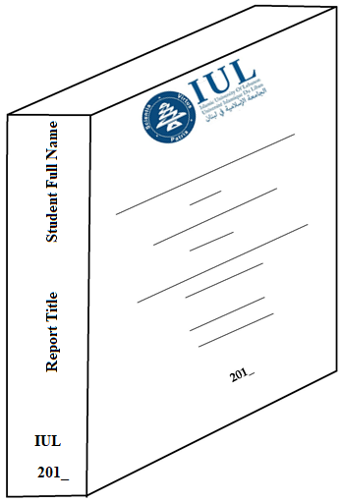

**CS**

**Acknowledgement**

We would like to thank the administration of the Islamic University of Lebanon, and the Faculty of Sciences and Arts represented by Dean, Dr. Ali Raad, and Head of Department of Computer Science and coordinator Dr. Kassem Danach. We wish to express our sincere gratitude to project supervisor, Dr. Bassel Dhaini, for his guidance, constant support and encouragement throughout the completion of our final year project. Our completion of this project could not have been accomplished without the support of Dr. Bassel Dhaini. A warm thank is extended to Dr. Bassel for sharing his resources, opinions, knowledge experience and skills in programming and development methodology, so generously.

**Abstract**

This report focuses on the development and implementation of an online virtual book club, which comprises a website and a complementary chat mobile app. The motivation behind this project is to provide book enthusiasts with a platform to connect, share, and discuss their favorite books. Additionally, the project includes a chat mobile app that complements the website, offering members an enhanced experience and the ability to connect with more book lovers.

The problem addressed by this project is the lack of a centralized and interactive space for book lovers to engage with each other, share book recommendations, and participate in meaningful discussions. By creating the website and mobile app, we aim to solve this problem by offering a comprehensive platform that caters to the diverse needs of book club members.

To tackle this problem, we adopted a user-centric approach. The website was designed to allow users to view book posts created by other club members, containing essential information such as the book's title, author, category, and description. Additionally, users have the ability to search for books based on their title, author, or category, and have the ability to display all book posts related to a specific author. Moreover, users can post books of their own and have full control over them, including editing, deleting, hiding, or publishing.

Furthermore, the website allow users to rate books and assign reading statuses on books, such as "Add to currently books I am reading," " Add to books I have read," or "Add to books I want to read." These statuses help users keep track of their reading progress and preferences, also, users can post reviews for books, reviews provide valuable insights, personal thoughts, and recommendations to other club members. Additionally, each book post on the website is associated with links where the book can be purchased. When users post a book, they have the option to include relevant purchase links. This functionality allows users to easily access and purchase the books they are interested in, providing a seamless experience for book acquisition. The website also facilitate communication among club members through the club messaging feature, enabling users to post messages, comment on them, and reply to comments.

To enhance the book club experience, the website incorporates club meetings. Users can organize online meetings focused on specific books, providing a platform for in-depth discussions. User can attend meetings posted by other club members and create meetings including the meeting details such as the book for discussion, meeting date and time, meeting duration, meeting link, and notes for club members if needed, and collect RSVPs to ensure effective planning. Moreover, users have control over their account settings and preferences.

The chat mobile app complements the website, enhancing user interaction and book discussions. The chat app fosters real-time conversations, promoting engagement and deeper book discussions. Users can connect with like-minded individuals, expanding their book club experience beyond the website. This enables members to discover more people who love reading books, make friends, receive personalized recommendations, and engage in discussions conveniently through their smartphones. In addition to complementing the website, it is important to note that the chat mobile app operates independently in terms of user membership. While users can join the book club through the website, becoming a member of the website does not automatically make them a member of the chat mobile app .To join the chat mobile app, users need to install the app separately and then log in using their credentials. This approach was implemented to give users the freedom to choose whether they want to participate in the chat app or not. We understand that not all users may be interested in joining the chat app, and we respect their preferences .By providing this optional feature, users have the flexibility to decide if they want to engage in real-time conversations and discussions through the chat mobile app. This approach ensures that users have control over their participation and can tailor their book club experience based on their preferences and interests.

The results of this project are promising. The website and mobile app have successfully provided book enthusiasts with a user-friendly and interactive platform to connect, share book recommendations, engage in discussions, organize club meetings, and foster a sense of community.

In conclusion, the development of the online virtual book club, consisting of the website and mobile app, addresses the problem of creating a centralized space for book lovers to connect, share, and discuss books. The project's approach focused on user needs and resulted in a comprehensive platform that allows users to interact with each other, share book posts, rate books, assign reading statuses, participate in club meetings, and personalize their settings etc. The inclusion of the mobile app complements the website, providing members with additional convenience and opportunities to connect with more book lovers. The implications of this project are far-reaching, as it fosters a sense of community among book enthusiasts and promotes reading engagement in the digital age.

**Table of Contents**

**Title Page**

**Signature Page**

**Acknowledgement**

**Abstract** vi

**General Introduction** 1

**Chapter: 1 System Planning** 5

**1.1 Introduction** 5

**1.2 Project Aims and Objectives** 5

**1.2.1 Aim: Promoting Reading Habits and Community Engagement** 5

**1.2.2 Objectives:** 5

**1.3 Project Scope:** 6

**1.3.1 User Subsystem:** 6

**1.3.2 Admin Subsystem:** 6

**1.4 Development Environment** 7

**1.4.1 Introduction: Programming Languages, Database, and Software** 7

**1.4.2 Programming Languages** 7

**1.4.3 Database** 8

**1.4.4 Software** 8

**1.5 Summary** 9

**Chapter 2: Related Work** 10

**2.1 Introduction** 10

**2.2 Existing Online Book Clubs** 10

**2.3 Social Networking Platforms for Readers** 10

**2.4 Summary** 10

**Chapter 3: Requirements Analysis** 12

**3.1 Introduction** 12

**3.2 Requirements Collection** 12

**3.2.1 Research** 12

**3.2.2 Observation** 13

**3.3 Use Case Diagrams** 17

**3.3.1 Website: Use Case Diagrams** 18

**3.3.2 Mobile App: Use Case Diagram** 20

**3.4 Class Diagrams** 21

**3.4.1 Website: Class Diagrams** 21

**3.4.2 Mobile App: Class Diagram** 25

**3.5 Data Flow Diagrams (DFD)** 26

**3.5.1 Context Diagram (DFD level-0)** 26

**3.5.2 DFD Level 1 Diagram** 29

**3.6 Summary** 32

**Chapter 4: System Design** 33

**4.1 Introduction** 33

**4.2 Data Dictionary** 33

**4.2.1 Website: Data Dictionary** 33

**4.2.2 Mobile App: Data Dictionary** 41

**4.3 ER Diagram** 42

**4.3.1 Website: ER Diagram** 44

**4.3.2 Mobile App: ER Diagram** 45

**Chapter 5: Implementation** 46

**5.1 Tools and Techniques** 46

**5.1.1 Website Tools and Techniques:** 46

**5.1.2 Mobile App Tools and Techniques:** 47

**5.2 Discussion about Languages** 47

**5.3 Database Procedures** 48

**Chapter 6: Testing and Results** 62

**6.1 User’s Test** 62

**6.1.1 Website: User’s Test** 62

**6.1.2 Mobile App: User’s Test** 109

**6.2 Website: Admin test** 116

**General Conclusion and Future Recommendations** 132

Figure 1: Website User Use Case Diagram 18

Figure 2: Website Admin Use Case Diagram 19

Figure 3: Mobile App Use Case Diagram 20

Figure 4: Website User Class Diagram 22

Figure 5: Website Regular Admin Class Diagram 23

Figure 6: Website Super Admin Class Diagram 24

Figure 7: Mobile App Class Diagram 25

Figure 8: Website Context Diagram (DFD Level-0) 27

Figure 9 Mobile App Context Diagram (DFD Level-0) 28

Figure 10: Website user DFD Level 1 Diagram (part 1) 29

Figure 10.1: Website user DFD Level 1 Diagram (part 2) 30

Figure 11: Website admin DFD Level 1 Diagram 31

Figure 12: Mobile App DFD Level 1 Diagram 32

Figure 13: Website ER Diagram 45

Figure 14: Mobile App ER Diagram 45

Figure 15: The navbar layout for guest users 62

Figure 16: The navbar layout for logged-in users 63

Figure 17: The footer layout 63

Figure 18: User registration page 65

Figure 19: Login page 66

Figure 20: First part of the Home page 69

Figure 21: Second part of the Home page 70

Figure 22: Third part of the Home page 71

Figure 23: The first part layout of the join club page for the guest users 72

Figure 24: The first part layout of the join club page for the logged-in users 73

Figure 25: List of book posts 74

Figure 26: Book details page 75

Figure 27: ABOUT OUR CLUB PAGE 77

Figure 28: POST A BOOK PAGE 78

Figure 29: Create Book Post page 80

Figure 30: Edit Book Post page 82

Figure 31: Track Reading Status 86

Figure 32: Club messages 89

Figure 33: Club meetings 93

Figure 34: Post meetings 94

Figure 35: Edit meetings 96

Figure 36: User settings and sign out 98

Figure 37: User settings page 99

Figure 38: Placing a profile image 100

Figure 39: Edit Profile page 102

Figure 40: Change Password page 104

Figure 41: Delete Account 106

Figure 42: Our Chat App page 108

Figure 43: Splash Screen 109

Figure 44: Login Phone Number Activity 110

Figure 45: verification code page 111

Figure 46: Username login Activity 112

Figure 47: Search User activity 113

Figure 48: Profile Activity 114

Figure 49: Chat Activity 115

Figure 50: Admin Panel 116

Figure 51: Manage Admin page 118

Figure 52: Manage Category 120

Figure 53: Manage Book Posts page 122

Figure 54: Display all review on a book post 123

Figure 55: Manage Message Posts page 125

Figure 56: Preview all Comments on a message 126

Figure 57: Preview all replies on a Comment 127

Figure 58: Manage User 129

Figure 59: Banned User Notification Page 130

**General Introduction**

The background of this project lies in the need for a centralized and interactive platform for book enthusiasts to connect, share, and discuss their favorite books. The increasing popularity of online communities and the digital age necessitate a space where book lovers can engage with one another, exchange recommendations, and participate in meaningful discussions. The project focuses on developing an online virtual book club, consisting of a website and a complementary chat mobile app, to address these needs. Additionally, the website includes an admin panel with various administrative functionalities to ensure content quality and user management.

The problem being addressed in this project is the lack of a comprehensive and user-friendly platform that caters to the needs of book club members. Existing platforms often lack features such as centralized book posts, efficient communication channels, and adequate moderation mechanisms. This project aims to fill that gap by creating a platform that not only allows users to connect and share book recommendations but also provides robust administrative control to maintain content quality and user behavior.

The development process for this project follows a systematic approach. It begins with requirement gathering, where the needs and preferences of book club members are identified. This process includes establishing the features and functionalities of the website and mobile app, as well as defining the administrative capabilities for the admin panel. Once the requirements are gathered, the design and development phase commences, involving the creation of a user-friendly interface, seamless navigation, and the incorporation of search and moderation functionalities. The testing and evaluation phase ensures the quality and usability of the platform, followed by user feedback incorporation and iterative improvements. The project concludes with a comprehensive evaluation of the outcomes, implications, and recommendations for future enhancements.

**Summary of Chapters Included in the Report:**

**1-System Planning:** Chapter 1 provides a comprehensive overview of the project aim, objectives, scope, subsystems, and development environment. It sets the foundation for the subsequent chapters, laying out the groundwork for the successful implementation of the online virtual book club.

**2-Related Work:** Chapter 2 provides an overview of existing online book clubs and social networking platforms for readers. It explores how these platforms facilitate book-related interactions and engagement among users. The chapter highlights the similarities and differences between these platforms and our online virtual book club project. It also introduces a unique feature of our project, which is the inclusion of website links for purchasing books recommended by club members. Overall, Chapter 2 sets the foundation for understanding the context and inspiration behind our project within the landscape of online book clubs and social networking platforms.

**3-Requirements Analysis:** Chapter 3, "Requirements Analysis," is dedicated to gathering and analyzing the essential requirements for our online virtual book club project. It emphasizes the significance of this process in driving the design and development of a high-quality system. Through techniques like research and observation, we gain valuable insights into the project's needs and complexities. The chapter also introduces visual representations such as use case diagrams, class diagrams and DFDs to aid in requirements validation and communication. By prioritizing requirements analysis, we ensure the alignment of our solution with the client's vision and objectives, setting the stage for successful system design and development.

**4-System Design**: Chapter 4 delves into the system design aspect of the project. It outlines the process of defining the system's architecture, components, modules, interfaces, and data to meet the specified requirements. The chapter provides an overview of the data dictionary, which showcases the database structure, including field names, data types, descriptions, keys, and references.

Furthermore, the chapter presents the Entity-Relationship (ER) diagrams for both the website and the mobile app. These diagrams illustrate the flow of data and depict the relationships between the various tables in the system. The ER diagrams highlight the connections, such as one-to-one, one-to-many, and many-to-many relationships, which are determined based on specific project requirements.

The chapter concludes by showcasing the ER diagrams for the website and the mobile app, providing a visual representation of the data structure and table relationships.

In summary, Chapter 4 provides a comprehensive understanding of the system design process, including the data dictionary, ER diagrams for the website and mobile app, and the overall architecture of the project

**5- Implementation**: Chapter 5 focuses on the implementation of the online virtual book club project, covering the tools, techniques, and languages used for website and mobile app development. The chapter emphasizes the importance of selecting appropriate tools for a seamless user experience.

The website utilizes React.js for interactive interfaces, HTML/CSS for structure and design, Node.js for server-side logic, and SQL for efficient data management. Security measures like hashed passwords and authentication/authorization mechanisms are implemented.

For the mobile app, Java is used for Android development, XML for data structure, and Firebase Database for cloud storage. Similar to the website, authentication and authorization mechanisms are in place to protect user data.

The chapter also discusses the languages employed. HTML, CSS, JavaScript, and React.js are used for the website's frontend, while Node.js handles server-side logic. The mobile app is developed using Java and XML for data structuring.

In addition, the chapter includes code snippets and explanations. These snippets demonstrate database procedures such as user registration and book retrieval and other, offering insight into the project's functionality.

Overall, Chapter 5 provides a concise overview of the implementation process, highlighting the tools, techniques, languages, and database procedures used to create a secure and user-friendly online virtual book club.

**6**- **Testing and Results:** Chapter 6 of this project focuses on Testing and Results. It includes User's Tests conducted on both the website and the mobile app. The website's User's Test covers various tested pages and their performance. In the User's Test section of the mobile app, we evaluated the various activities and features of the app. We examined how users interacted with the app, their experience in navigating through different screens. Additionally, the Admin Test examines the admin panel pages of the website. Overall, this chapter provides valuable insights into the functionality, usability, and user experience of the website and mobile app, aiding in further improvements if needed.

**Chapter: 1 System Planning**

**1.1 Introduction**

This chapter serves as an introduction to the project's aims, objectives, and scope. It provides an overview of the project's modules.

**1.2 Project Aims and Objectives**

An online virtual book club, aims to create a platform where users can engage in a vibrant reading community. The main objectives of the project are to promote reading habits, encourage community engagement, and facilitate book discussions and recommendations.

**1.2.1 Aim: Promoting Reading Habits and Community Engagement**

The primary aim of the project is to promote reading habits and foster community engagement. By providing an online platform for book lovers to connect, share recommendations, and participate in book discussions, the project aims to create an interactive and enriching reading community.

**1.2.2 Objectives:**

**1.2.2.1 Developing a Website and Mobile App for Virtual Book Club**

To achieve the project's goals, a website and a mobile app will be developed. These platforms will serve as a virtual book club where users can access a diverse collection of books, join discussions, and connect with fellow readers.

**1.2.2.2 User-Friendly Interface for Book Browsing and Discussions**

The website and mobile app will feature a user-friendly interface that allows users to easily browse through the virtual book collection. They will be able to search for specific books, view book details, read reviews, view the average rate of a book, and participate in discussions related to the books.

**1.2.2.3 Book Recommendations and Reviews**

The project will provide a platform for users to share their book recommendations and write reviews. Users will be able to rate books, assign reading status on books, and engage in constructive discussions with other members of the virtual book club through the club messages and through the club meetings where the club members posts meetings to discuss books.

**1.2.2.4 Admin Panel for Content Management and User Moderation**

To ensure smooth operation and user safety, an admin panel will be implemented. The admin panel will allow administrators to moderate user-generated content, and enforce community guidelines to maintain a positive and inclusive reading environment.

**1.3 Project Scope:**

The project aims to develop an online virtual book club platform that facilitates book sharing, discussions, community engagement, and meeting organization. The platform consists of the following modules:

**1.3.1 User Subsystem:**

- User Registration: Users can create an account and become members of the book club.

- Book Recommendations: Members can recommend books to others and share their reading experiences.

- Book Discussions: Members can participate in book discussions, share insights, and engage in literary conversations.

- Book Ratings and Reviews: Members can rate books they have read, leave reviews, and read reviews from other members

-Users can assign a reading status to each book, to keep track of their reading progress and organize their bookshelf.

-Users can connect with club members through the club messaging feature.

- Meeting Organization: Members can organize meetings to discuss specific books and invite other club members to participate.

- User Settings: Members can manage their account settings, update their profiles, and control their personal information.

**1.3.2 Admin Subsystem:**

- Super Admin: Only the super admin has the authority to register new admins or remove existing ones.

- Admin Management: Admins can control book categories that users can select from when recommending.

- Book post Management: Admins can view all book posts, delete inappropriate ones, and manage book-related content.

- Review Management: Admins can view all reviews on book posts, delete inappropriate reviews, and ensure content quality.

- Club Message Management: Admins can view all club messages, delete inappropriate messages, and moderate discussions.

- Comment Management: Admins can view all comments on club messages, delete inappropriate comments, and maintain a respectful environment.

- Reply Management: Admins can view all replies on comments, delete inappropriate replies, and ensure meaningful conversations.

- User Management: Admins can search users by ID, ban or unban users based on their behavior or violation of club rules.

**1.4 Development Environment**

**1.4.1 Introduction: Programming Languages, Database, and Software**

In this section, we will introduce the programming languages, database, and software used to develop the online virtual book club project. These technologies play a crucial role in building both the website and mobile app, ensuring their functionality and performance.

**1.4.2 Programming Languages**

The project utilizes different programming languages for the website and mobile app development. Let's explore each of them:

**1.4.2.1 Website - Frontend: React.js**

For the website's frontend development, React.js is used as the primary programming language. React.js is a popular JavaScript library that allows for the creation of interactive and dynamic user interfaces. It provides a component-based approach and a virtual DOM for efficient rendering, resulting in a smooth user experience.

**1.4.2.2 Website - Backend: Node.js**

Node.js is utilized as the backend programming language for the website. Node.js is a server-side JavaScript runtime environment that enables the execution of JavaScript code outside of a browser. It provides a scalable and event-driven architecture, making it suitable for handling server-side operations, such as managing user authentication, handling API requests, and interacting with the database.

**1.4.2.3 Mobile App - Frontend: XML (Extensible Markup Language)**

XML is used for the frontend development of the mobile app. XML is a markup language thatallows for the structuring and organization of data. It is commonly used for defining user interfaces in mobile app development, providing a standardized format for designing layouts and views.

**1.4.2.4 Mobile App - Backend: Java**

Java is chosen as the backend programming language for the mobile app development. Java is a versatile and widely adopted programming language with a strong ecosystem for Android app development. It offers robust support for object-oriented programming, facilitating the development of efficient and scalable backend functionalities.

**1.4.3 Database**

To store and retrieve data for the online virtual book club, different database technologies are used for the website and mobile app:

**1.4.3.1 Website: SQL Database**

A SQL (Structured Query Language) database is utilized for the website. SQL databases provide a structured and relational approach for managing data. They offer efficient querying capabilities, data integrity, and ACID (Atomicity, Consistency, Isolation, and Durability) properties. This ensures reliable and secure data storage, retrieval, and management for the virtual book club project.

**1.4.3.2 Mobile App: Firebase**

For the mobile app, Firebase is used as the database. Firebase is a comprehensive development platform provided by Google. It offers a real-time NoSQL database, authentication services, cloud storage, and more. Firebase provides a scalable and reliable solution for storing and synchronizing data in real-time, making it well-suited for mobile app development.

**1.4.4 Software**

**1.4.4.1 Website: Visual Studio Code**

For the website development, Visual Studio Code is used as the software platform. It is a lightweight and versatile code editor that offers features such as syntax highlighting, code debugging, version control integration, and a rich set of tools for frontend and backend development.

**1.4.4.2 Mobile App: Visual Studio Code**

For the mobile app development, Android Studio is used as the software platform. Android Studio is the official integrated development environment (IDE) for Android app development. It provides a comprehensive set of tools and resources for designing, building, and testing Android applications.

**1.5 Summary**

In this chapter, the project scope has been described as well as the project aim and objectives. We also presented the development environment by describing the used programming language, database, and the methodology.

**Chapter 2: Related Work**

**2.1 Introduction**

This chapter examines related works that are relevant to our online virtual book club project. We explore similar projects that have been developed for web-based platforms.

**2.2 Existing Online Book Clubs**

There are several existing online book clubs that share similarities with our project. These platforms provide virtual spaces for book enthusiasts to connect, share recommendations, and engage in discussions about books. They offer features such as book rating and reviewing, book recommendations based on user preferences, and the ability to join or create book clubs.

**2.3 Social Networking Platforms for Readers**

Additionally, various social networking platforms cater specifically to readers and book lovers. These platforms enable users to create profiles, connect with other readers, share book recommendations, and participate in reading challenges and discussions. They often include features like personalized reading lists, book tracking, and the ability to follow favorite authors or book clubs.

**2.4 Summary**

In this chapter, we explored related works in the realm of online book clubs and social networking platforms for readers. While these platforms offer similar functionalities and foster book-related interactions, our online virtual book club project aims to provide a unique and immersive experience for users.

By combining elements of book clubs, social networking, and interactive features, our project offers a comprehensive platform where users can not only connect with fellow book enthusiasts but also attend virtual meetings, participate in club messaging, and explore a curated collection of recommended books. Moreover, we have introduced a novel feature that sets our online virtual book club apart from others in the domain: website links for purchasing books.

These website links, contributed by club members, provide convenient access to online platforms such as Amazon, where users can directly purchase the recommended books. This integration of purchase links streamlines the book-buying process for users, allowing them to explore and acquire books seamlessly within our platform.

By offering a diverse range of features, including virtual meetings, club messaging, and integrated book purchasing, our project aims to enhance the overall reading and community-building experience for users. Our tailored approach and innovative features contribute to creating an engaging and interactive space for book enthusiasts to connect, share recommendations, and foster meaningful discussions.

**Chapter 3: Requirements Analysis**

**3.1 Introduction**

This chapter will describe the system requirement specifications and will present its UML diagrams such as Use Case Diagrams, Class Diagrams, Data Flow Diagrams (DFD) level 0 and level

**3.2 Requirements Collection**

Collection requirements is an essential part of any project and project management. It is an essential step to system specification and design as it focuses on features and characteristics of the technical system that will be developed.

This chapter outline both the characteristics of requirements and the requirements analysis in order .So in our requirements analysis process for the online virtual book club project, we have utilized some specific fact-finding techniques to gather relevant information. These techniques have helped us understand the unique requirements of our book club platform. The techniques we have employed are:

**3.2.1 Research**

Conducting thorough research has been a crucial fact-finding technique for our project. We have explored various sources of information related to online book clubs, virtual communities, and book-related platforms. Computer trade journals, reference books, and the internet have served as valuable sources of information. By studying existing online book clubs such as Goodreads and Book Riot, we have gained insights into their features, functionalities, and user interactions. This research has provided us with a clearer understanding of the project requirements specific to an online virtual book club.

**3.2.2 Observation**

Observation has played an essential role in our fact-finding process. We have observed book club members and their activities, both in person and through online book communities. By actively participating in book discussions, attending virtual book club meetings, and monitoring user interactions, we have gained valuable insights into the needs, preferences, and behaviors of book club members. This technique has allowed us to understand the dynamics of book discussions, the importance of user engagement, and the features that promote a vibrant and active book club community.

By incorporating research and observation as fact-finding techniques, we have gathered relevant information specific to our online virtual book club project. These techniques have helped us identify the key requirements, understand user expectations, and design a platform that fosters meaningful book discussions and community engagement. The insights gained from these fact-finding techniques have informed the development of our online virtual book club, ensuring that it meets the needs and interests of book enthusiasts in an online setting.

**-** **Overview Website Description:**

The website consists of two main parts: one dedicated to users and the other to administrators. The user section provides features and functionalities tailored to meet the needs of general users, allowing them to access and utilize various services provided by the website. The admin section, on the other hand, is specifically designed for administrators to manage and oversee the website's operations, including user management, content moderation, and system administration.

**User can be: regular user or logged-in user:**

**Regular User:**

Registration: The regular user can create a new account by registering on the website.

-Login: The regular user can log in to their account using their credentials.

-Browse Book Posts: The regular user can browse the list of book posts on the website.

-View Book Details: The regular user can view detailed information about a specific book.

-Search Books: The regular user can search for books based on title, author, or category.

-View Book Reviews: The regular user can read reviews posted by other club members.

**Logged-In User:**

In addition to the capabilities of the regular user, the logged-in user has the following additional functionalities:

-Rate Books: The logged-in user can assign a rating to a book.

-Assign Reading Status: The logged-in user can indicate their reading status for a book, such as "Currently Reading," “Read," or "Want to Read."

-Post Club Messages: The logged-in user can post messages in the club's messaging system.

-Post Comments: The logged-in user can post comments on club messages.

-Reply to Comments: The logged-in user can reply to comments posted by other club members.

-View Reading Status: The logged-in user can view their assigned reading status for books.

-Post Books: The logged-in user can create new book posts.

-Edit/Delete/Hide/Publish Book Posts: The logged-in user has the option to edit, delete, hide, or publish their own book posts.

-Edit/Delete/Like Club Messages, Comments, and Replies: The logged-in user can edit, delete, or like club messages, comments, and replies.

-Post Reviews: The logged-in user can post reviews for books.

-Edit/Delete Reviews: The logged-in user can edit or delete their own book reviews.

-Like Reviews: The logged-in user can like reviews posted by other club members.

-Post Meetings: The logged-in user can create new meeting posts.

-Edit/Delete Meetings: The logged-in user can edit or delete their own meeting posts.

-Create Attending Status: The logged-in user can indicate their attendance status for a meeting.

-Remove/Edit Attending Status: The logged-in user can remove or edit their attending status for a meeting.

-Edit/Remove Rate: The logged-in user can edit or remove their rating on books.

-Edit/Remove Reading Status: The logged-in user can edit or remove their assigned reading status on books.

-Update Account Information: The logged-in user can update their account information, such as username, email, or profile picture.

-Delete Account: The logged-in user can delete their account permanently from the system.

**Admin can be : Regular Admin or SuperAdmin**.

The SuperAdmin has additional privileges compared to the Regular Admin.

**SuperAdmin:**

Register Admin: The SuperAdmin can register new admins.

Login: The SuperAdmin can log in to the system using their credentials. This allows them to access the administrative functionalities and perform administrative tasks.

Delete Admin: The SuperAdmin can delete existing admins.

View Books Categories: The SuperAdmin can view all books categories in the system.

Add/Delete Categories: The SuperAdmin can add new book category or delete existing category.

View Book Posts: The SuperAdmin can view all book posts.

Delete Inappropriate Book Posts: The SuperAdmin can delete inappropriate book posts.

View Book Reviews: The SuperAdmin can view all reviews for a book.

Delete Inappropriate Book Reviews: The SuperAdmin can delete inappropriate book reviews.

View Club Messages: The SuperAdmin can view all club messages.

Delete Inappropriate Club Messages: The SuperAdmin can delete inappropriate club messages.

View Comments: The SuperAdmin can view all comments on club messages.

Delete Inappropriate Comments: The SuperAdmin can delete inappropriate comments.

View Replies: The SuperAdmin can view all replies on comments.

Delete Inappropriate Replies: The SuperAdmin can delete inappropriate replies.

Search User by ID: The SuperAdmin can search for a user by their ID.

Ban/Unban User: The SuperAdmin can ban or unban a user

**Regular Admin:**

The Regular Admin has similar responsibilities to the SuperAdmin, with the exception of registering and deleting other admins. The SuperAdmin has the authority to manage admins and perform all administrative tasks.

**-** **Overview Mobile App Description:**

The chat mobile app offers a seamless and convenient user experience for connecting with other users in the online virtual book club. The app begins with a simple and secure registration process where users are required to enter their phone number. An OTP (One-Time Password) is sent to their phone via SMS for verification purposes. Once the user enters the correct OTP, they are successfully logged into the app.

After logging in, the user is directed to an activity where they can set up their profile by entering a username. This step completes the login process, and the user gains full access to the chat app's functionalities.

Within the chat app, users have the ability to view a list of all logged-in users. They can search for specific users and initiate conversations through private chat. This allows users to engage in real-time conversations, share thoughts and recommendations about books, and build connections within the online book club community.

Additionally, the app provides users with the option to update their settings, including their username and profile information. This allows users to personalize their chat app experience and ensure their profile reflects their preferences and identity.

Overall, the chat mobile app serves as a valuable platform for users to connect, engage, and interact with other members of the online virtual book club. It offers a convenient way to start conversations, explore shared interests, and enhance the overall book club experience through real-time communication.

**3.3 Use Case Diagrams**

A use case diagram is a graphic depiction of the interactions among the elements of a system. A use case is a methodology used in system analysis to identify, clarify, and organize system requirements. In this section, we will present and describe the use case diagrams of both the website and mobile application of our project.

**3.3.1 Website: Use Case Diagrams**

**3.3.1.1 Overview Users Use Case Diagram**

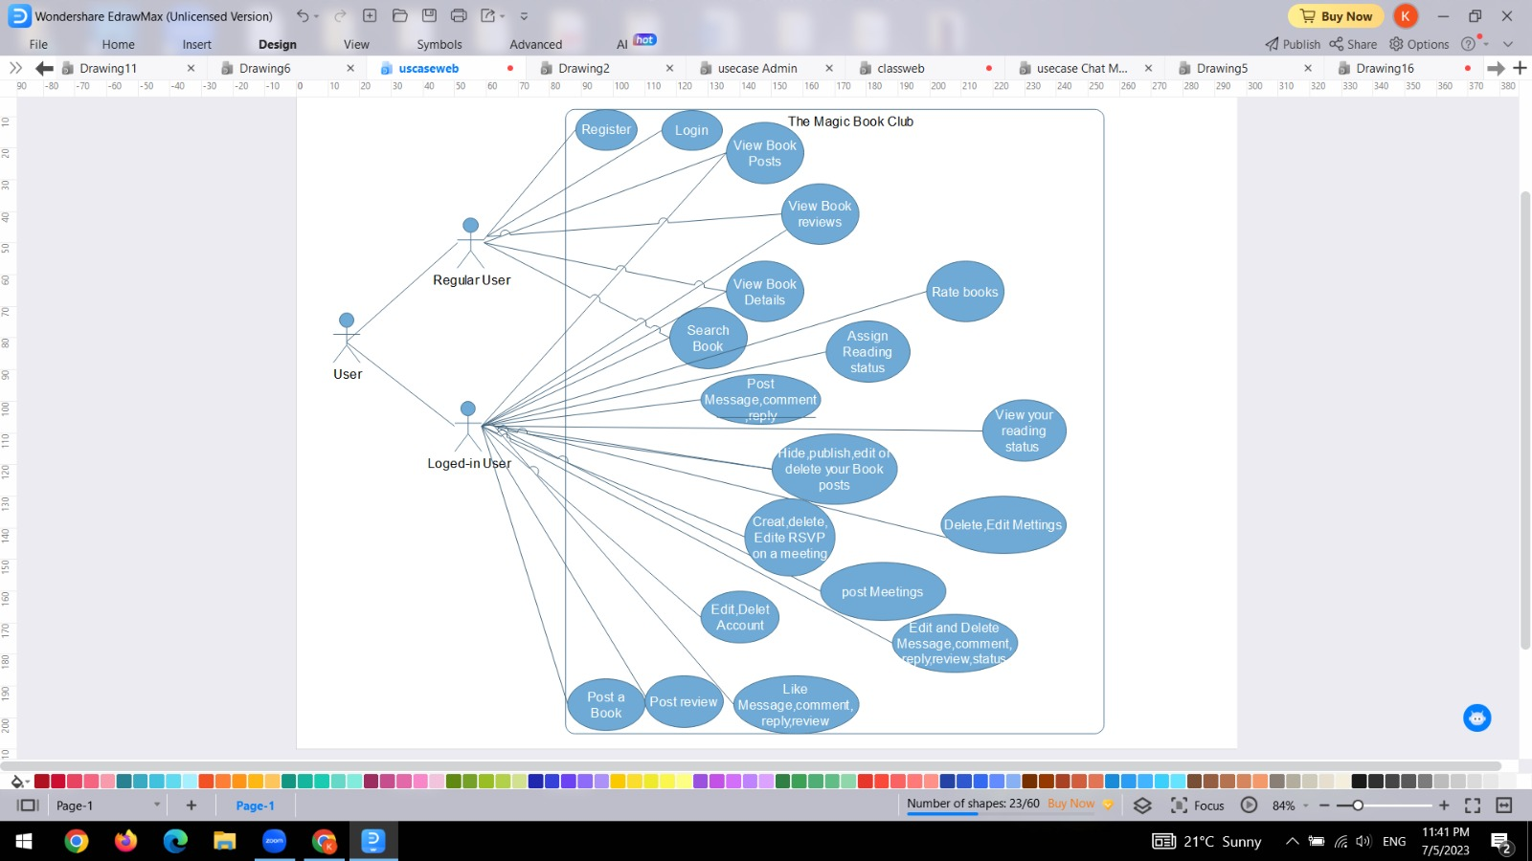

Figure 1: Website User Use Case Diagram

**3.3.1.2 Overview Administrator Use Case Diagram**

The Magic Book Club

C

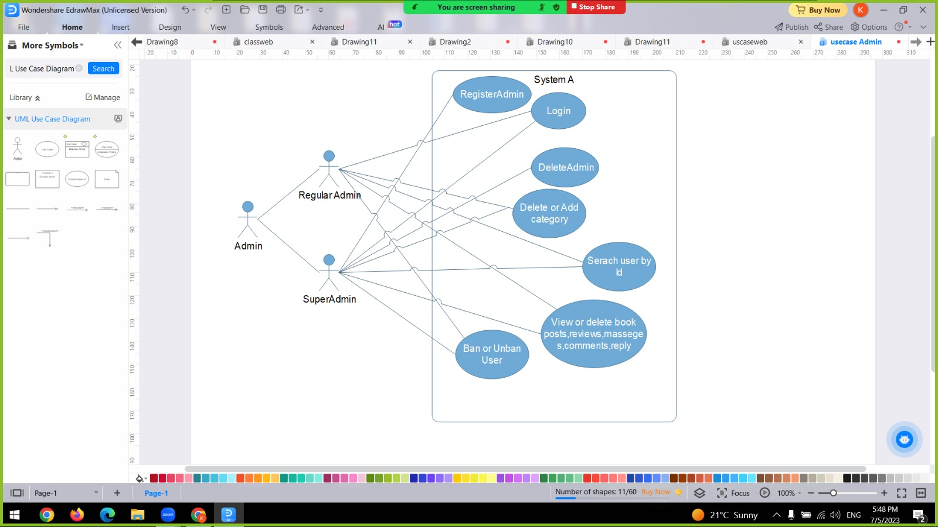

Figure 2: Website Admin Use Case Diagram

**3.3.2 Mobile App: Use Case Diagram**

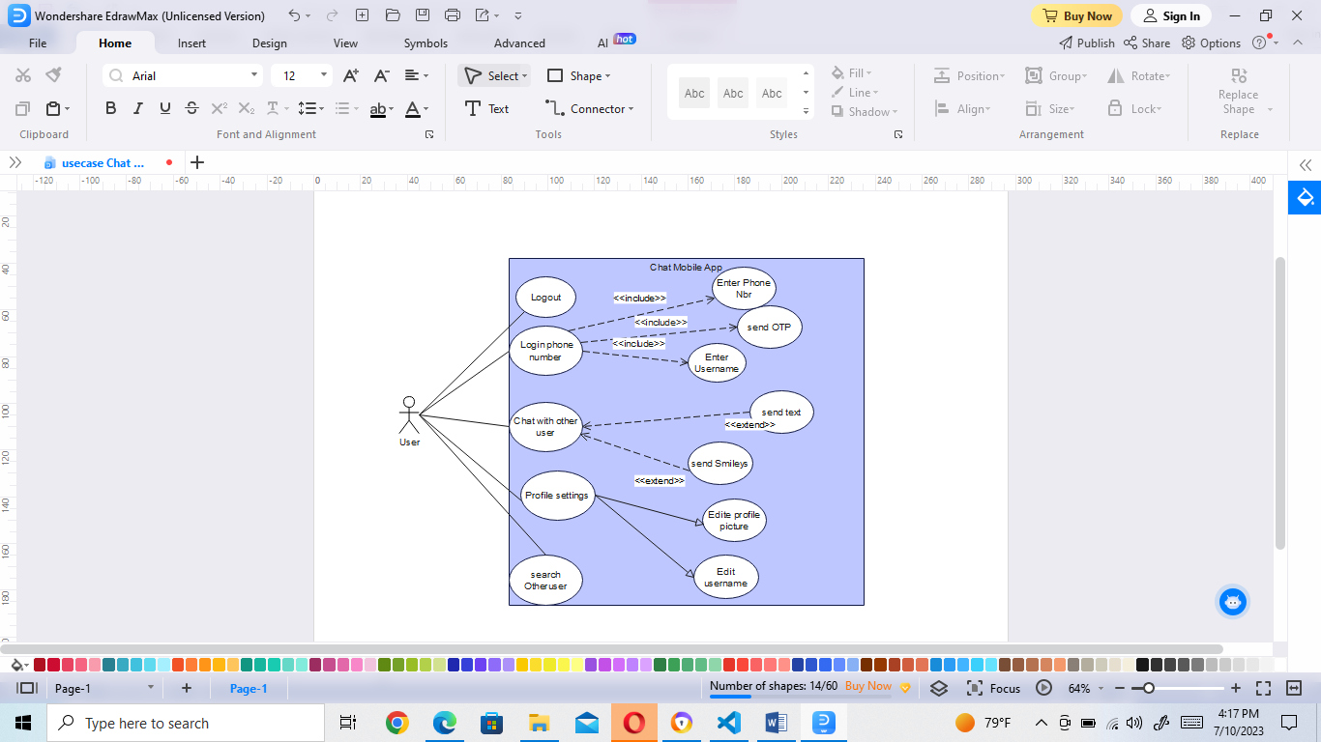

Figure 3: Mobile App Use Case Diagram

**3.4 Class Diagrams**

A class diagram is a visual representation of the classes, their attributes, and the relationships between them in a system. It provides an overview of the structure and organization of the classes in a software application. By using boxes to represent classes and lines to represent relationships, the class diagram helps in understanding how different classes interact and collaborate within the system. It serves as a blueprint for designing and implementing the software, allowing developers to visualize the class hierarchy, associations, and dependencies. The class diagram is an essential tool for software design and documentation, enabling effective communication and planning during the development process.

**3.4.1 Website: Class Diagrams**

**3.4.1.1 User Class Diagram**

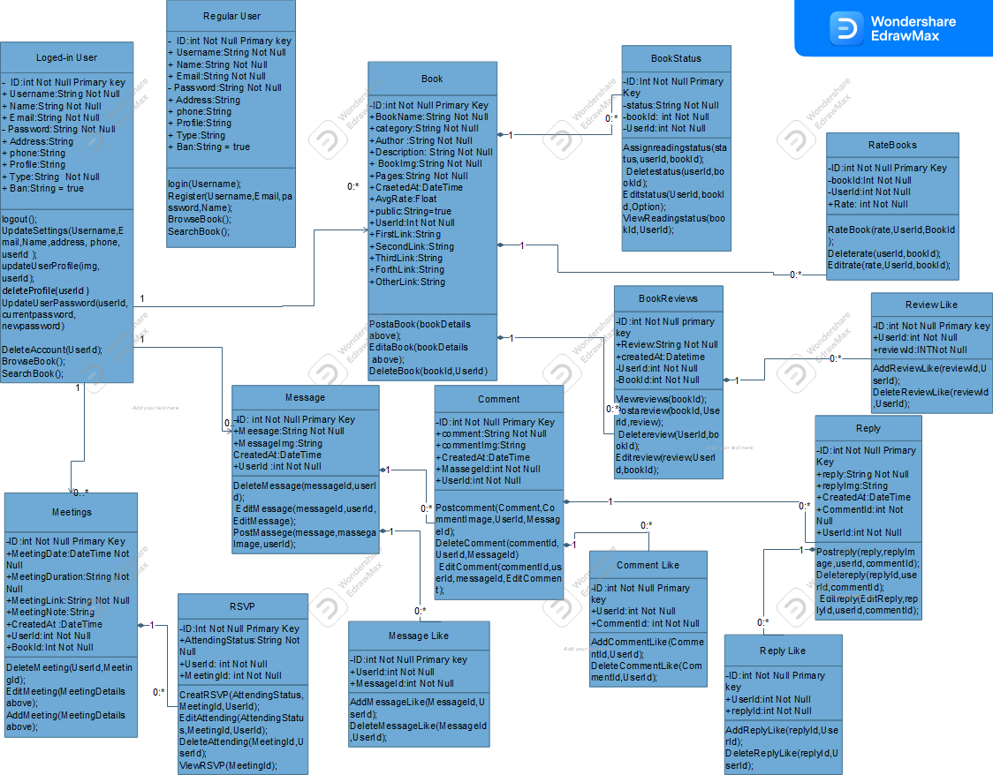

Figure 4: Website User Class Diagram

**3.4.1.2 Admin Class Diagram**

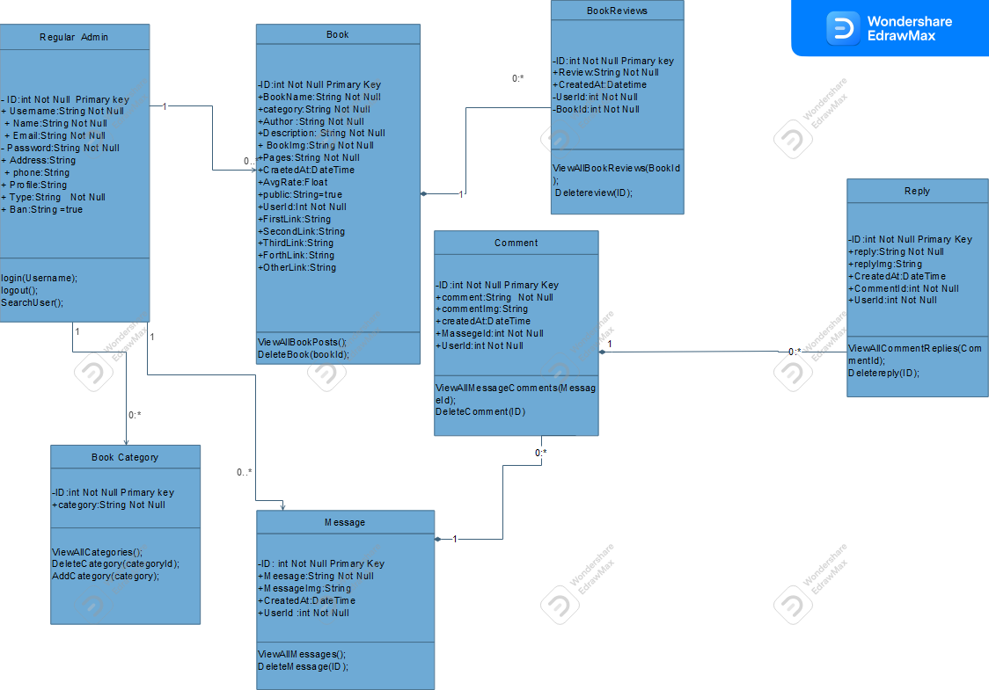

Figure 5: Website Regular Admin Class Diagram

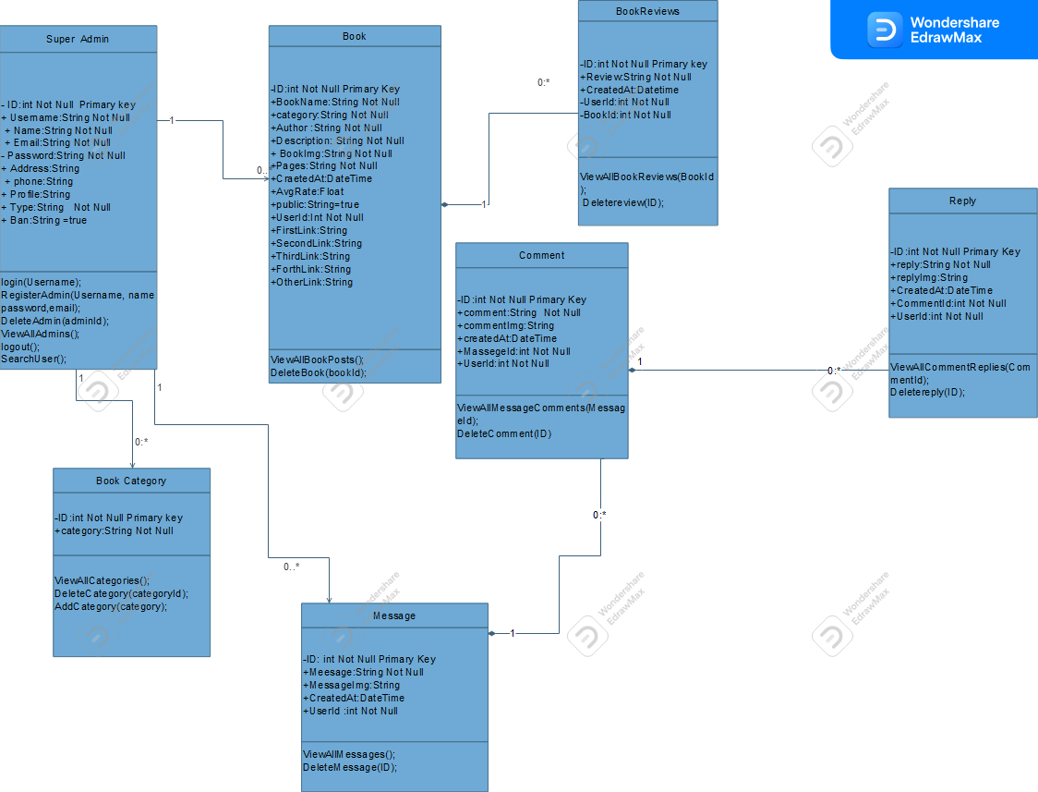

Figure 6: Website Super Admin Class Diagram

**3.4.2 Mobile App: Class Diagram**

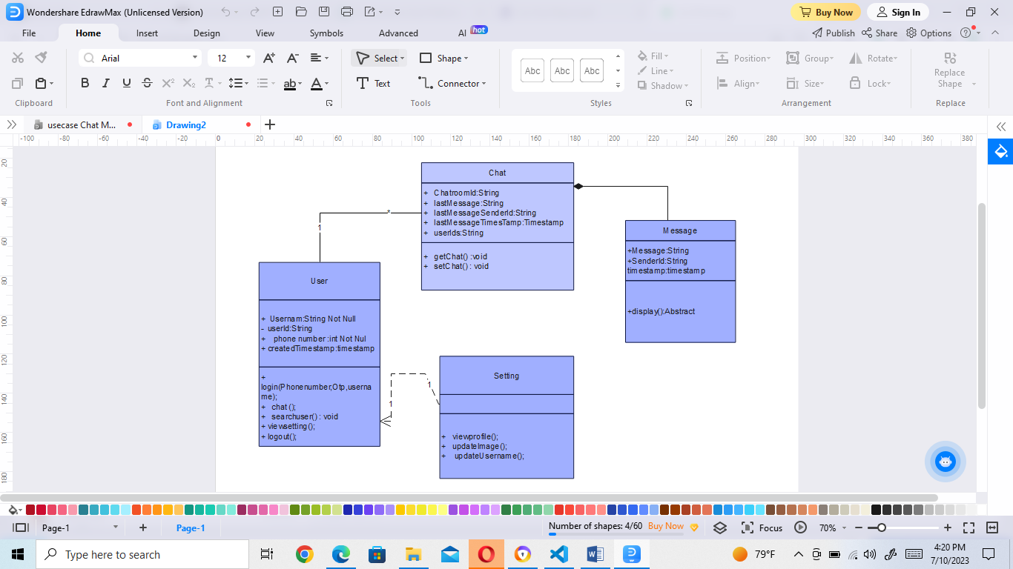

Figure 7: Mobile App Class Diagram

**3.5 Data Flow Diagrams (DFD)**

Data flow diagrams (DFDs) reveal relationships among and between the various components in a program or system. A data flow diagram (DFD) illustrates how data is processed by a system in terms of inputs and outputs. As its name indicates, its focus is on the flow of information, where data comes from, where it goes and how it gets stored.

**3.5.1 Context Diagram (DFD level-0)**

The Context Diagram shows the system under consideration as a single high-level process and then shows the relationship that the system has with external entities (systems, organizational groups, external data stores, etc.).

**3.5.1.1 Website: Context Diagram (DFD level-0)**

Create or delete other Admins

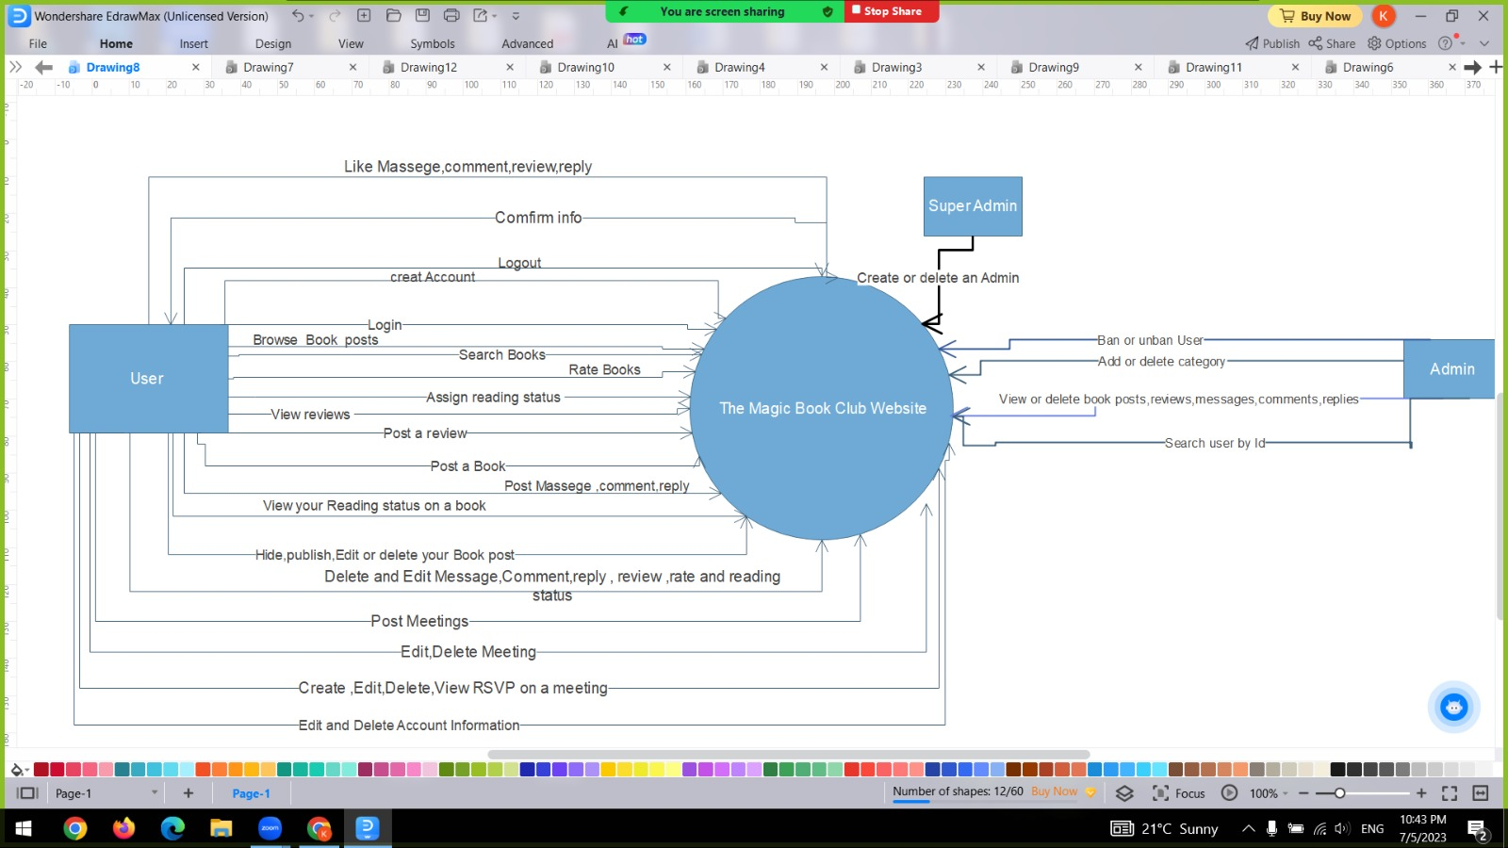

Figure 8: Website Context Diagram (DFD Level-0)

**3.5.1.2 Mobile App: Context Diagram (DFD level-0)**

**Logout**

**Update settings**

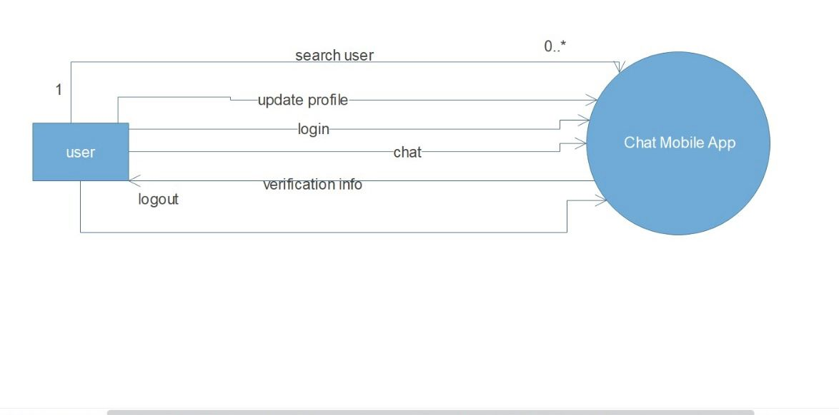

Figure 9 Mobile App Context Diagram (DFD Level-0)

**3.5.2 DFD Level 1 Diagram**

Level 1 DFD aims to give an overview of the full system. It looks at the system in more details.

**3.5.2.1 Website: DFD Level 1 Diagram**

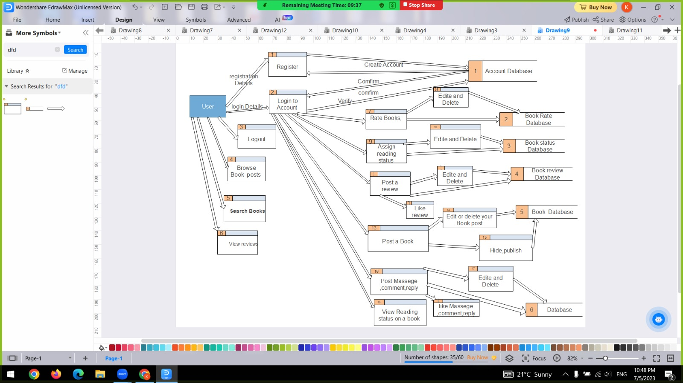

Figure 10: Website user DFD Level 1 Diagram (part 1)

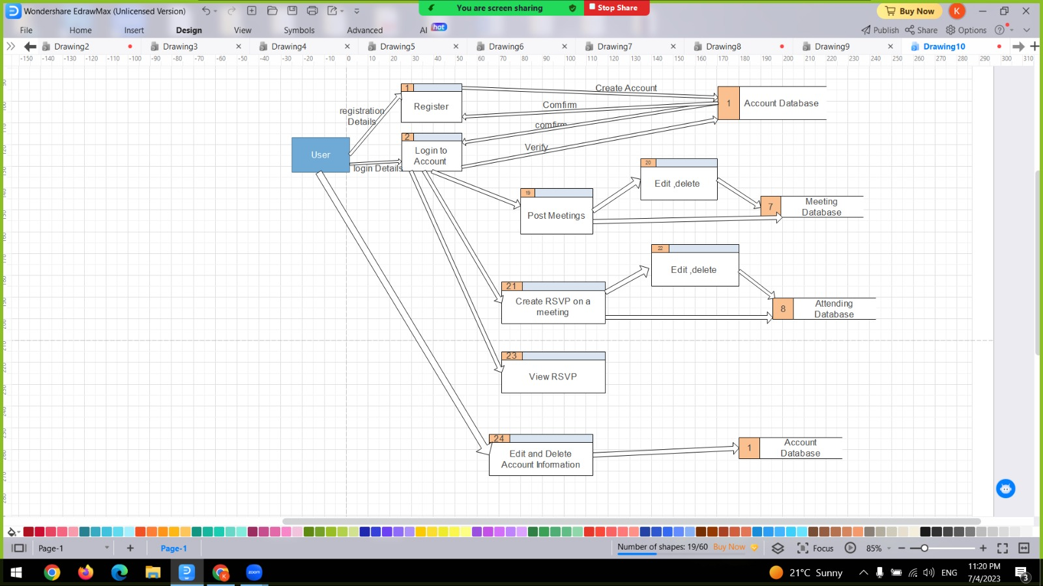

Figure 10.1: Website user DFD Level 1 Diagram (part 2)

Regular Admin

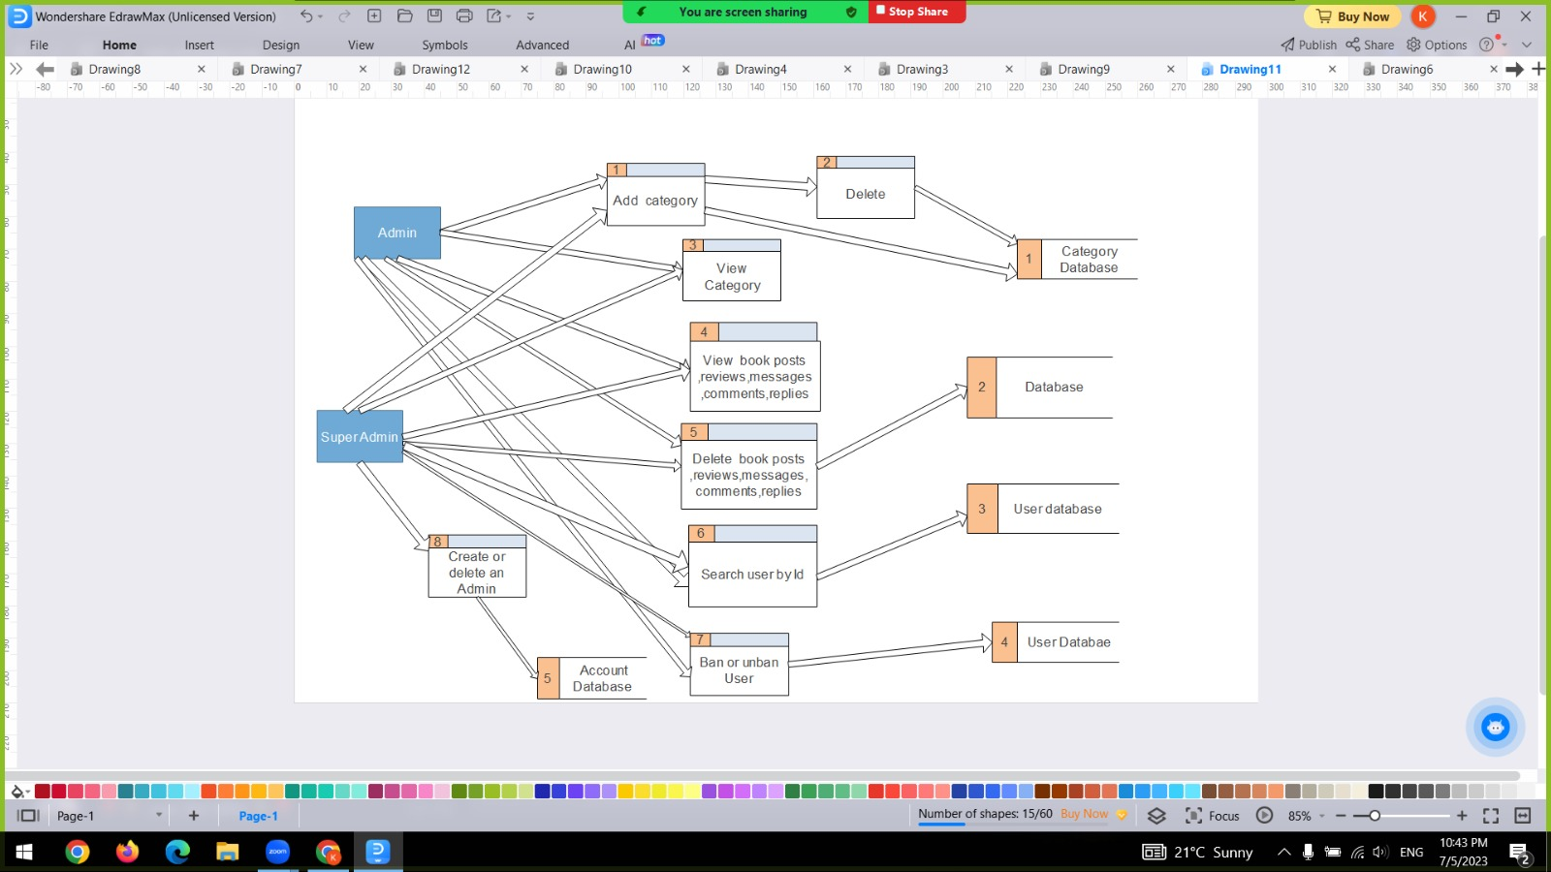

Figure 11: Website admin DFD Level 1 Diagram

**3.5.2.2 Mobile App: DFD Level 1 Diagram**

Edit settings

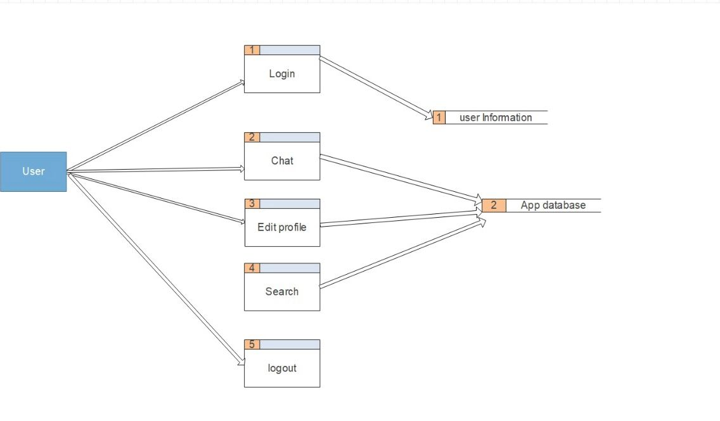

Figure 12: Mobile App DFD Level 1 Diagram

**3.6 Summary**

This chapter described the requirements of the project and presented its use case, class diagrams and DFD diagrams. Detailed requirements have to be gathered before a quality system can be produced. Hence, the process of requirements analysis is very important. The fact finding techniques that we have used is searching which helped us get more understanding of our project requirements and workflow. Once the client's requirements have been identified and facts collected, we are then in a position to design a solution.

**Chapter 4: System Design**

**4.1 Introduction**

This chapter will briefly discuss the system design. System design is the process of defining the architecture, components, modules, interfaces, and data for a system to satisfy the specified requirements. More specifically, this chapter presents the data dictionary, the database relational schema, and screen design.

**4.2 Data Dictionary**

This section describes data dictionary. Data dictionary shows the details of the database of this project, as field name, data type, data description, key and reference.

**4.2.1 Website: Data Dictionary**

Table name: users

|  |  |  |  |  |
| --- | --- | --- | --- | --- |
| **Field name** | **Data type** | **Data description** | **Key** | **Reference** |
| id | Int | User ID | PK |  |
| username | Varchar(45) | User Name |  |  |
| email | Varchar(45) | User Email |  |  |
| password | Varchar(200) | User Password |  |  |
| name | Varchar(45) | User name that will be used and viewed in the website |  |  |
| address | Varchar(45) | User Address |  |  |
| Phone | Varchar(45) | User Phone |  |  |
| profile | Varchar(200) | User Image |  |  |
| type | Varchar(200) | Role of the user |  |  |
| ban | Varchar(50) | Ban to indicate either user is banned or not through true or false ,true means unbanned ,false means banned |  |  |

**Description:** This table stores all information about a user, user can be a normal user or an admin , depending on the type (role),if it is equal User then the user is a normal user and if it is equal Admin then the user is an Admin .

Table name: book

|  |  |  |  |  |
| --- | --- | --- | --- | --- |
| **Field name** | **Data type** | **Data description** | **Key** | **Reference** |
| id | Int | Book Id | PK |  |
| bookname | Varchar(50) | Book Name |  |  |
| category | Varchar(50) | Book Category |  |  |
| author | Varchar(50) | Book Author |  |  |
| description | Varchar(500) | Book Summery |  |  |
| bookImg | Varchar(200) | Book Image |  |  |
| pages | Varchar(50) | number of pages in a book |  |  |
| createdAt | Datetime | date and time of book posting |  |  |
| averagerate | Float | Book Average Rate |  |  |
| firstlink | Varchar(50) | Purchase on BookShop: [link to the book on the BookShop website] |  |  |
| secondlink | Varchar(50) | Purchase on Libro.fm: [link to the book on the Libro.fm website] |  |  |
| thirdlink | Varchar(50) | Purchase on Amazon : [link to the book on the Amazon website] |  |  |
| fourthlink | Varchar(50) | Purchase on Apple Books: [link to the book on the Apple Books website] |  |  |
| otherlink | Varchar(50) | Purchase on other websites : [link to the book on the other websites] |  |  |
| public | Varchar(50) | This indicates whether the book is published to the club members or hidden. 'true' means published, while 'false' means hidden |  |  |
| userId | Int | User Id | FK | users |

**Description:** book table stores all information about a book post

Table name: bookrate

|  |  |  |  |  |
| --- | --- | --- | --- | --- |
| **Field name** | **Data type** | **Data description** | **Key** | **Reference** |
| id | int | Book Rate ID | PK |  |
| rate | int | Book Rate |  |  |
| userId | int | User ID | FK | users |
| bookId | int | Book ID | FK | book |

**Description:** bookrate table stores all information about book rate

Table name: bookstatus

|  |  |  |  |  |
| --- | --- | --- | --- | --- |
| **Field name** | **Data type** | **Data description** | **Key** | **Reference** |
| id | int | Book Status ID | PK |  |
| status | Varchar(50) | Book Status |  |  |
| userId | int | User ID | FK | users |
| bookId | int | Book ID | FK | book |

**Description:** bookstatus table stores all information about book status

Table name: bookreview

|  |  |  |  |  |
| --- | --- | --- | --- | --- |
| **Field name** | **Data type** | **Data description** | **Key** | **Reference** |
| id | int | Book Review ID | PK |  |
| review | Varchar(200) | Book Review |  |  |
| createdAt | datetime | date and time of book review posting |  |  |
| userId | int | User ID | FK | users |
| bookId | int | Book ID | FK | book |

**Description:** bookreview table stores all information about book review

Table name: reviewlikes

|  |  |  |  |  |
| --- | --- | --- | --- | --- |
| **Field name** | **Data type** | **Data description** | **Key** | **Reference** |
| id | int | Review Like ID | PK |  |
| userId | int | User ID | FK | users |
| reviewId | int | Review ID | FK | bookreview |

**Description:** reviewlikes table stores all information about likes on reviews

Table name: messages

|  |  |  |  |  |
| --- | --- | --- | --- | --- |
| **Field name** | **Data type** | **Data description** | **Key** | **Reference** |
| id | int | Club Message ID | PK |  |
| message | Varchar(100) | Club Message |  |  |
| messageImg | Varchar(200) | Message Image |  |  |
| createdAt | datetime | date and time of message posting |  |  |
| userId | int | User ID | FK | users |

**Description:** messages table stores all information about the club message post

Table name: messagelikes

|  |  |  |  |  |
| --- | --- | --- | --- | --- |
| **Field name** | **Data type** | **Data description** | **Key** | **Reference** |
| id | int | message Like ID | PK |  |
| userId | int | User ID | FK | users |
| messageId | int | Message ID | FK | messages |

**Description:** messagelikes table stores all information about likes on messages

Table name: comments

|  |  |  |  |  |
| --- | --- | --- | --- | --- |
| **Field name** | **Data type** | **Data description** | **Key** | **Reference** |
| id | int | Comment ID | PK |  |
| comment | Varchar(100) | Comment |  |  |
| commentImg | Varchar(200) | Comment Image |  |  |
| createdAt | datetime | date and time of comment posting |  |  |
| userId | int | User ID | FK | users |
| messageId | int | Message ID | FK | messages |

**Description:** comments table stores all information about a comment post

Table name: commentlikes

|  |  |  |  |  |
| --- | --- | --- | --- | --- |
| **Field name** | **Data type** | **Data description** | **Key** | **Reference** |
| id | int | comment Like ID | PK |  |
| userId | int | User ID | FK | users |
| commentId | int | Comment ID | FK | comments |

**Description:** commentlikes table stores all information about likes on comments

Table name: reply

|  |  |  |  |  |
| --- | --- | --- | --- | --- |
| **Field name** | **Data type** | **Data description** | **Key** | **Reference** |
| id | int | Reply ID | PK |  |
| reply | Varchar(100) | Reply |  |  |
| replyImg | Varchar(200) | Reply Image |  |  |
| createdAt | datetime | date and time of reply posting |  |  |
| userId | int | User ID | FK | users |
| commentId | int | Comment ID | FK | comments |

**Description:** reply table stores all information about a reply post

Table name: replylikes

|  |  |  |  |  |
| --- | --- | --- | --- | --- |
| **Field name** | **Data type** | **Data description** | **Key** | **Reference** |
| id | int | reply Like ID | PK |  |
| userId | int | User ID | FK | users |
| replyId | int | Reply ID | FK | reply |

**Description:** replylikes table stores all information about likes on replies

Table name: meeting

|  |  |  |  |  |
| --- | --- | --- | --- | --- |
| **Field name** | **Data type** | **Data description** | **Key** | **Reference** |
| id | int | Meeting ID | PK |  |
| meetingDate | datetime | Date and Time of the meeting(when it will be made) |  |  |
| meetingduration | Varchar(100) | Meeting Duration |  |  |
| meetingLink | Varchar(100) | Meeting Link |  |  |
| meetingnote | Varchar(200) | Meeting Note |  |  |
| createdAt | datetime | Date and time of the meeting posting(when it posted) |  |  |
| userId | int | User ID | FK | users |
| bookId | int | Book ID | FK | book |

**Description:** meeting table stores all information about meeting posts

Table name: attending

|  |  |  |  |  |
| --- | --- | --- | --- | --- |
| **Field name** | **Data type** | **Data description** | **Key** | **Reference** |
| id | int | Attending ID | PK |  |
| attendingStatus | Varchar(50) | Attending Status |  |  |
| userId | int | User ID | FK | users |
| meetingId | int | Meeting ID | FK | meeting |

**Description:** attending table stores all information about attending a meeting

Table name: category

|  |  |  |  |  |
| --- | --- | --- | --- | --- |
| **Field name** | **Data type** | **Data description** | **Key** | **Reference** |
| id | int | Category ID | PK |  |
| category | Varchar(50) | Category |  |  |

**Description:** Category table stores all information about Category

Table name: password

|  |  |  |  |  |
| --- | --- | --- | --- | --- |
| **Field name** | **Data type** | **Data description** | **Key** | **Reference** |
| id | int | password ID | PK |  |
| password | Varchar(50) | password |  |  |

**Description:** password table stores the password of the Super Admin where he use it to enter the page where Admins account are controlled in the admin panel.

**4.2.2 Mobile App: Data Dictionary**

Table name: chatrooms

|  |  |  |  |  |
| --- | --- | --- | --- | --- |
| **Field name** | **Data type** | **Data description** | **Key** | **Reference** |
| chotroomId | varchar | Chat Room ID |  |  |
| lastMessage | varchar | Last Message | FK | Users |
| lastMessageSenderId | varchar | Last Sender ID |  |  |
| lastMessageTimestamp | timestamp | Capturing the creation time of the chat. |  |  |
| userIds | varchar | User ID | PK |  |

**Description**: chatrooms table stores all information about a chatroom

Table name: Users

|  |  |  |  |  |  |  |  |  |
| --- | --- | --- | --- | --- | --- | --- | --- | --- |
| **Field name** | | **Data type** | | **Data description** | | **Key** | | **Reference** |
| userId | | varchar | | User ID | | PK | |  |
| Phone | | varchar | | Phone Number | |  | |  |
| createdTimestamp | | timestamp | | Reflecting the time of user creation. | |  | |  |
| username | | varchar | | User name | |  | |  |
| profile | varchar | | User Profile | |  | |  | |

**Description**: Users table stores all information about a user

Table name: chats

|  |  |  |  |  |
| --- | --- | --- | --- | --- |
| **Field name** | **Data type** | **Data description** | **Key** | **Reference** |
| message | varchar | Message | PK |  |
| senderId | varcharr | Sender Message ID |  |  |
| timestamp | timestamp | Capturing the creation time of the chat. |  |  |

**Description:** chat table stores all information about chat

**4.3 ER Diagram**

The ER Diagrams will show the flow of data in our project and it also will represent the data table and the relation between them. Our project consists of:

**16 tables for the website :**

1. users.

2. book.

3. bookrate.

4. bookstatus.

5. bookreview.

6. reviewlikes.

7. messages.

8. messagelikes.

9. comments.

10. commentlikes.

11. reply.

12. replylikes.

13. meeting.

14-attending

15. category.

16. password.

**4 tables for the Mobile App :**

1. chatrooms
2. Users
3. Chats
4. profile

In Our ER diagrams ,that is one for the website and one for the mobile app, we can see the relation between every table, such as one to one and one too many and in some cases we can see the relation many to many that depend on the case.

The figures below shows the ER diagrams of our project:

**4.3.1 Website: ER Diagram**

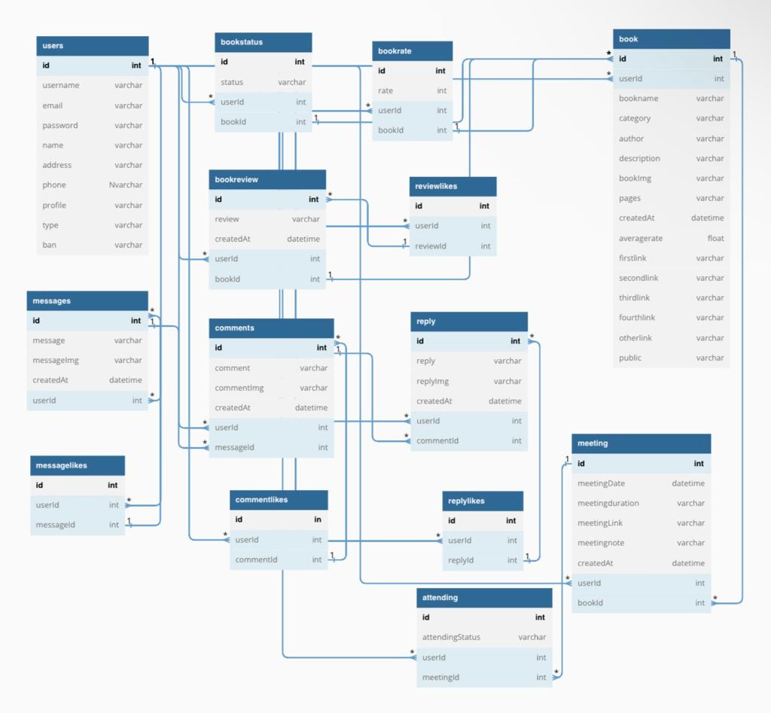

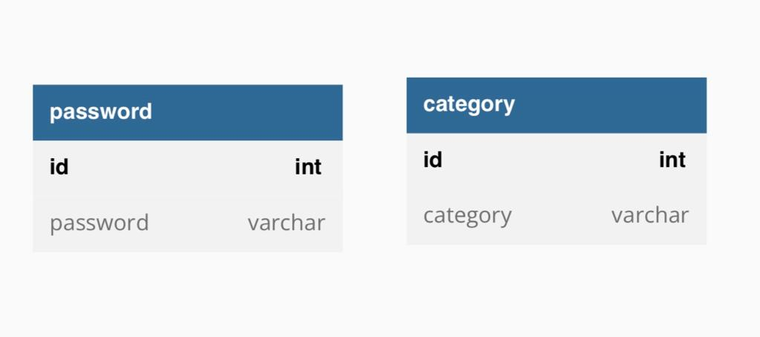

Figure 13: Website ER Diagram

**4.3.2 Mobile App: ER Diagram**

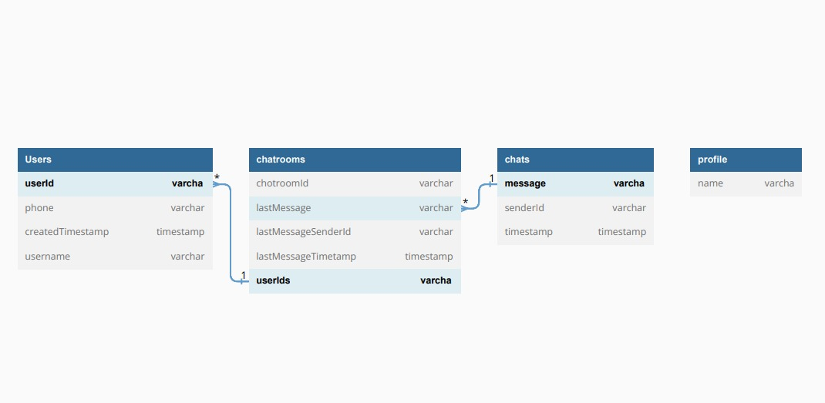

Figure 14: Mobile App ER Diagram

**Chapter 5: Implementation**

**5.1 Tools and Techniques**

In this chapter, we will discuss the tools and techniques used in the development of the online virtual book club project. We utilize a combination of tools and technologies to build both the website and the mobile app, ensuring a comprehensive and seamless user experience across different platforms.

**5.1.1 Website Tools and Techniques:**

For the website, we employ the following tools and techniques:

React.js: A powerful JavaScript library for building user interfaces. React.js allows us to create interactive and dynamic web pages, ensuring a smooth and responsive user experience.

HTML and CSS: Used for structuring and styling the website's interface, providing a visually appealing and user-friendly design.

Node.js: A runtime environment that enables us to run JavaScript code on the server-side. We utilize Node.js to handle server logic, API integration, and database interactions.

SQL (Structured Query Language): A standard language for managing relational databases. We utilize SQL queries and joins to retrieve and manipulate data stored in the database, ensuring efficient data management.

Hashed Passwords: To enhance security, we implement password hashing. Passwords are securely stored in the database by applying a hashing algorithm, such as bcrypt or SHA-256. This ensures that even if the database is compromised, the actual passwords cannot be easily obtained.

Authentication and Authorization: We implement user authentication and authorization mechanisms to control access to different parts of the website. This ensures that only authorized users can perform certain actions and access restricted resources.

**5.1.2 Mobile App Tools and Techniques:**

For the mobile app, we employ the following tools and techniques:

XML: We use XML (extensible Markup Language) for structuring and storing data in a hierarchical format. XML is widely used for mobile app development due to its simplicity and compatibility with different platforms.

Java: A popular programming language used for Android app development. We utilize Java to build the backend logic, handle database interactions, and implement business logic in the mobile app.

Firebase Database: We utilize Firebase Database, a NoSQL cloud database, for data storage in the mobile app. Firebase Database provides real-time data synchronization, offline support, and seamless integration with mobile platforms.

Authentication and Authorization: Similar to the website, we implement user authentication and authorization mechanisms in the mobile app to ensure secure access and protect user data.

**5.2 Discussion about Languages**

The online virtual book club project employs a variety of languages to develop both the website and the mobile app, ensuring a comprehensive and engaging user experience.

For the website, the frontend is built using HTML, CSS, and JavaScript, with the assistance of the React.js library. HTML provides the structure of the web pages, while CSS is used for styling and layout. JavaScript enables interactivity and dynamic functionality on the client-side. React.js, a powerful JavaScript library, allows us to build reusable UI components and efficiently manage the application state.

On the backend of the website, Node.js is utilized as the runtime environment for executing JavaScript code. Node.js enables us to handle server-side logic, API integration, and database interactions seamlessly.

In the context of the mobile app, the programming language Java is used for Android app development. Java is a versatile and widely adopted language that provides the necessary tools and libraries to build robust mobile applications. It allows us to implement the backend logic, handle database interactions, and implement business logic in the mobile app.

Additionally, XML (extensible Markup Language) is used for structuring and storing data in a hierarchical format within the mobile app. XML is a popular choice for mobile app development due to its simplicity and compatibility across different platforms.

By utilizing these languages, we ensure that both the website and the mobile app offer a seamless and intuitive user experience, with consistent functionality and design across different platforms.

**5.3 Database Procedures**

-To showcase some of the database procedures utilized in the online virtual book club project, we will discuss an example procedure used for user registration in the Website. This procedure involves checking for existing users and securely storing user information in the database.

**Here the code snippet demonstrating the user registration procedure:**

export const register = (req, res) => {

// CHECK EXISTING USER

const type = "User";

const q = "SELECT * FROM users WHERE email = ? OR username = ?";

db.query(q, [req.body.email, req.body.username], (err, data) => {

if (err) return res.status(500).json(err);

if (data.length > 0) return res.status(409).json("User already exists!");

// Hash the password and create a user

const salt = bcrypt.genSaltSync(10);

const hash = bcrypt.hashSync(req.body.password, salt);

const insertQuery =

"INSERT INTO users(`username`, `email`, `password`, `name`, `type`) VALUES (?)";

const values = [

req.body.username,

req.body.email,

hash,

req.body.name,

type,

];

db.query(insertQuery, [values], (err, data) => {

if (err) return res.status(500).json(err);

return res.status(200).json("User has been created.");

});

});

};

Explanation:

The code starts by defining the register function, which is responsible for handling user registration requests.

The first step in the registration process is to check if the user already exists in the database. This is done by executing a SQL query to select users with matching email or username. The query is parameterized to avoid SQL injection vulnerabilities.

If the query returns any data (i.e., there is already a user with the provided email or username), a response with status 409 (Conflict) is sent back to the client, indicating that the user already exists.

If no matching user is found, the code proceeds to hash the password provided by the user. This is done using a hashing algorithm (in this case, bcrypt) to securely store the password in the database. The generated hash is then stored in the hash variable.

Next, an SQL INSERT query is prepared to insert the user's information into the database. The query includes placeholders for the values to be inserted, which are passed as an array (values).

The query is executed using the database connection (db.query) along with the values array. If any error occurs during the execution, an error response with status 500 (Internal Server Error) is sent back to the client.

If the insertion is successful, a response with status 200 (OK) and a success message is sent back to the client, indicating that the user has been created.

By including this code snippet and explanation, we provide insights into the procedures used to interact with the database during user registration, ensuring secure storage of user information and preventing duplicate registrations.

-Another database procedure used in the online virtual book club project. Specifically, we will focus on retrieving books from the database and returning them as a response to client requests in the Website. This procedure enables users to view a list of books available in the book club.

**Here is the code snippet that demonstrates the retrieval of books from the database:**

export const getBooks = (req, res) => {

const q = `SELECT b.*, u.id AS userId, name, profile FROM book AS b JOIN users AS u ON u.id = b.userId

ORDER BY b.createdAt DESC`;

db.query(q, (err, data) => {

if (err) return res.status(500).json(err);

return res.status(200).json(data);

});

};

Explanation:

The code defines the getBooks function, responsible for handling requests to retrieve books from the database.

The SQL query (q) is used to select book information from the book table and retrieve additional details from the users table. The JOIN operation is used to link the book and user information based on the userId column, allowing us to retrieve the name and profile of the user who created each book.

The query is structured to retrieve all columns from the book table (b.*) and additional columns u.id, name, and profile from the users table. The books are ordered by their creation timestamp in descending order (ORDER BY b.createdAt DESC), ensuring that the most recent books appear first in the result.

The db.query function executes the SQL query using the database connection (db). It takes two arguments: the query itself (q) and a callback function that handles the result of the query.

If an error occurs during the execution of the query, an error response with status 500 (Internal Server Error) is sent back to the client, along with the error details.

If the query is successful, the result (data) is returned as a response with status 200 (OK). The response contains the retrieved book information, which can be used by the client to display the book list or perform further actions.

By including this code snippet and explanation , we provide an overview of the procedure used to retrieve books from the database. This allows users of the online virtual book club to access and explore the available books, enhancing their overall experience within the application.

- Another database procedure used in the online virtual book club Website. It is responsible for retrieving both upcoming and past meetings from the database.

**Here is the code snippet that demonstrates the retrieval of both upcoming and past meetings from the database**

export const getMeetings = (req, res) => {

const currentDate = new Date().toISOString().slice(0, 19).replace('T', ' ');

const upcomingMeetingsQuery = `

SELECT m.*, u.id AS userId, u.name AS userName, u.profile AS userProfile, b.id AS IdBook, b.bookname AS bookName, b.author AS bookAuthor, b.bookImg AS bookImage

FROM meeting AS m

JOIN users AS u ON u.id = m.userId

JOIN book AS b ON b.id = m.bookId

WHERE m.meetingDate >= '${currentDate}'

ORDER BY m.meetingDate ASC `;

const pastMeetingsQuery = `

SELECT m.*, u.id AS userId, u.name AS userName, u.profile AS userProfile, b.id AS IdBook, b.bookname AS bookName, b.author AS bookAuthor, b.bookImg AS bookImage

FROM meeting AS m

JOIN users AS u ON u.id = m.userId

JOIN book AS b ON b.id = m.bookId

WHERE m.meetingDate < '${currentDate}'

ORDER BY m.meetingDate DESC

`;

const upcomingMeetingsPromise = new Promise((resolve, reject) => {

db.query(upcomingMeetingsQuery, (err, data) => {

if (err) reject(err);

else resolve(data);

});

});

const pastMeetingsPromise = new Promise((resolve, reject) => {

db.query(pastMeetingsQuery, (err, data) => {

if (err) reject(err);

else resolve(data);

});

});

Promise.all([upcomingMeetingsPromise, pastMeetingsPromise])

.then(([upcomingMeetings, pastMeetings]) => {

// Filter the meetings based on both date and time

const filteredUpcomingMeetings = upcomingMeetings.filter((meeting) => {

const meetingDate = new Date(meeting.meetingDate);

const currentDate = new Date();

return meetingDate > currentDate;

});

const filteredPastMeetings = pastMeetings.filter((meeting) => {

const meetingDate = new Date(meeting.meetingDate);

const currentDate = new Date();

return meetingDate < currentDate;

});

const meetings = {

upcomingMeetings: filteredUpcomingMeetings,

pastMeetings: filteredPastMeetings,

};

res.status(200).json(meetings);

})

.catch((err) => {

res.status(500).json(err);

});

};

Explanation:

1. The code begins by obtaining the current date and time using the `toISOString()` function and formatting it appropriately.

2. Two SQL queries are defined: `upcomingMeetingsQuery` and `pastMeetingsQuery`. These queries retrieve the relevant meeting data along with associated user and book information. The `WHERE` clause filters the meetings based on whether they are upcoming or in the past, using the current date as a reference.

3. Two promises, `upcomingMeetingsPromise` and `pastMeetingsPromise`, are created to handle the asynchronous database queries. These promises wrap the `db.query` function and handle the resolution or rejection of the queries.

4. The `Promise.all()` function is used to wait for both promises to resolve. Once resolved, the retrieved data is available in the `upcomingMeetings` and `pastMeetings` arrays.

5. The code then proceeds to filter the meetings based on the current date and time. The `filter()` function is used on both arrays, comparing the `meetingDate` of each meeting with the current date and returning the appropriate results.

6. The filtered meetings are stored in the `filteredUpcomingMeetings` and `filteredPastMeetings` arrays.

7. Finally, an object named `meetings` is created, containing the filtered meetings as properties: `upcomingMeetings` and `pastMeetings`. This object represents the upcoming and past meetings retrieved from the database.

8. The response is sent with a status of 200 (success) and the `meetings` object is returned as JSON data.

If any errors occur during the database queries or promise handling, the catch block will catch the error, and a response with a status of 500 (internal server error) will be sent, along with the error details.

In summary, this code retrieves upcoming and past meetings from the database, filters them based on the current date, and returns the filtered meetings as a JSON response. It ensures that only relevant meetings are displayed to the users of the online virtual book club.

- Another essential database procedure utilized in the online virtual book club mobile app is the implementation of real-time chat functionality. This feature enables users to engage in seamless and interactive conversations with other members of the book club. By leveraging Firebase Authentication and Firestore, the app provides a secure and efficient messaging system that facilitates communication and enhances the overall user experience. The database procedure manages the storage, retrieval, and synchronization of chat messages, as well as the creation and management of chat rooms between users. Through this functionality, members can share thoughts, discuss books, and foster a vibrant community within the online virtual book club app

**Here the code snippet that demonstrates the implementation of real-time chat functionality in the online virtual book club mobile app.**

public class chat extends AppCompatActivity {

UserModel otherUser;

String chatroomId;

ChatrowModel chatrowModel;

ChatRecycleAdapter adapter;

EditText messageInput;

ImageButton sendMessageBtn;

ImageButton bachBtn;

TextView otherUserName;

RecyclerView recyclerView;

ImageView imageView;

@Override

protected void onCreate(Bundle savedInstanceState) {

super.onCreate(savedInstanceState);

setContentView(R.layout.activity_chat);

//get user model

otherUser= AndroidUtil.getUserModelFromIntent(getIntent());

chatroomId= FirebaseUtil.getChatRoomId(FirebaseUtil.currentUserId(),otherUser.getUserId());

messageInput=findViewById(R.id.chat_message_input);

sendMessageBtn=findViewById(R.id.message_send_btn);

bachBtn=findViewById(R.id.backbtn);

otherUserName=findViewById(R.id.other_username);

recyclerView=findViewById(R.id.chat_recycle);

imageView=findViewById(R.id.profile_pic_image_view);

FirebaseUtil.getOtherProfilePicStorageRef(otherUser.getUserId()).getDownloadUrl()

.addOnCompleteListener(t -> {

if (t.isSuccessful()){}

Uri uri=t.getResult();

AndroidUtil.setProfilePic(this,uri,imageView);

});

//Log.d(TAG, "onCreate: Setting up recycle");

setupChatRecyclerView();

bachBtn.setOnClickListener(v -> {

onBackPressed();

});

sendMessageBtn.setOnClickListener(v -> {

String message=messageInput.getText().toString().trim();

if (message.isEmpty())

return;

sendMessageToUser(message);

});

otherUserName.setText(otherUser.getUsername());

getOrCreateChatroomModel();

setupChatRecyclerView();

}

void setupChatRecyclerView(){

Query query= FirebaseUtil.getChatroomMessageReference(chatroomId)

.orderBy("timestamp", Query.Direction.DESCENDING);

FirestoreRecyclerOptions<ChatMessageModel> options= new FirestoreRecyclerOptions.Builder<ChatMessageModel>()

.setQuery(

query,

ChatMessageModel.class)

.build();

adapter=new ChatRecycleAdapter(options,getApplicationContext());

LinearLayoutManager manager=new LinearLayoutManager(this);

manager.setReverseLayout(true);

recyclerView.setLayoutManager(manager);

recyclerView.setAdapter(adapter);

adapter.startListening();

adapter.registerAdapterDataObserver(new RecyclerView.AdapterDataObserver() {

@Override

public void onItemRangeInserted(int positionStart, int itemCount) {

super.onItemRangeInserted(positionStart, itemCount);

recyclerView.smoothScrollToPosition(0);

}

});

}

void sendMessageToUser(String message){

chatrowModel.setLastMessageTimetamp(Timestamp.now());

chatrowModel.setLastMessageSenderId(FirebaseUtil.currentUserId());

chatrowModel.setLastMessage(message);

FirebaseUtil.getChatroomReference(chatroomId).set(chatrowModel);

ChatMessageModel chatMessageModel=new ChatMessageModel(message,FirebaseUtil.currentUserId(),Timestamp.now());

FirebaseUtil.getChatroomMessageReference(chatroomId).add(chatMessageModel)

.addOnCompleteListener(new OnCompleteListener<DocumentReference>() {

@Override

public void onComplete(@NonNull Task<DocumentReference> task) {

if(task.isSuccessful()){

messageInput.setText("");

}

}

});

}

void getOrCreateChatroomModel(){

FirebaseUtil.getChatroomReference(chatroomId).get().addOnCompleteListener(task -> {

if(task.isSuccessful()){

chatrowModel=task.getResult().toObject(ChatrowModel.class);

if(chatrowModel==null){

//first time chate

chatrowModel=new ChatrowModel(

chatroomId,

Arrays.asList(FirebaseUtil.currentUserId(),otherUser.getUserId()),

Timestamp.now(),

""

);

FirebaseUtil.getChatroomReference(chatroomId).set(chatrowModel);

}

} }); }}

Explanation:

1. The first code snippet is from the `loginotp` class, which represents the login OTP (One-Time Password) activity in the mobile app.

- The code initializes various UI elements such as `otpInput` (EditText for OTP input), `nextBtn` (Button for moving to the next step), `progressBar` (ProgressBar for indicating the progress), and `resendOtpTextView` (TextView for resending OTP).

- It retrieves the phone number from the previous activity and sets up the Firebase authentication instance.

- The `onCreate` method sets the layout for the activity and assigns the UI elements.

2. The second code snippet is from the `chat` class, representing the chat activity in the mobile app.

- It initializes various UI elements such as `otherUser` (represents the UserModel of the other user in the chat), `chatroomId` (the ID of the chat room), `messageInput` (EditText for entering messages), `sendMessageBtn` (ImageButton for sending messages), and `recyclerView` (RecyclerView for displaying chat messages).

- The `onCreate` method sets the layout for the activity, retrieves the other user's profile picture, and sets up the chat RecyclerView.

- The `setupChatRecyclerView` method configures the RecyclerView to display chat messages from the Firestore database. It creates a query to retrieve messages for the specific chat room and sets up the adapter to populate the RecyclerView.

- The `sendMessageToUser` method handles sending a message to the other user. It updates the chatroom model with the last message details and adds the new message to the Firestore database.

- The `getOrCreateChatroomModel` method retrieves or creates the chatroom model associated with the chatroom ID. It retrieves the chatroom model from Firestore and creates a new model if it doesn't exist.

In summary, the provided code represents two database procedures in the mobile app. The first code snippet handles the login OTP functionality, while the second code snippet manages the chat functionality, including sending messages, retrieving chatroom details, and displaying messages in a RecyclerView. These procedures utilize Firebase Authentication and Firestore to handle user authentication, message storage, and retrieval in the online virtual book club mobile app.

**Chapter 6: Testing and Results**

As we mentioned before this project contains a Website and a complementary chat Mobile App. The website is divided into admin side and user side, the users on the website are divided into two types: guests and registered users. On the other hand, the chat mobile app only contains a user side. Users can install the app and directly join it using an opt-in process. Unlike the website, the mobile app does not have guest users. To use the mobile app, a user needs to join using an opt-in mechanism.

**6.1 User’s Test**

**6.1.1 Website: User’s Test**

In our website, a navbar and a footer are present on almost all pages, and both the navbar and footer remain consistent across all pages.

-For guest users the navbar appear like this:

OUR CHAT APP



Figure 15: The navbar layout for guest users

In this figure, we can see the navbar as it appears to guest users. On the right side of the navbar, there are SIGNIN and SIGN UP links. The navbar remains the same for both guest users and logged-in users, with the distinction being that, for guest users, the right side displays the options to sign in and sign up. In contrast, for logged-in users, their username is shown on the right side, and the links to sign in and sign up disappear. So for the logged-in users the navbar appears like this:

OUR CHAT APP



Figure 16: The navbar layout for logged-in users

So as I mentioned above that for logged-in user ,the right side of the navbar display the user name , while the signin and signup links disappeared.

-Footer:

Figure 17: The footer layout

OUR CHAT APP

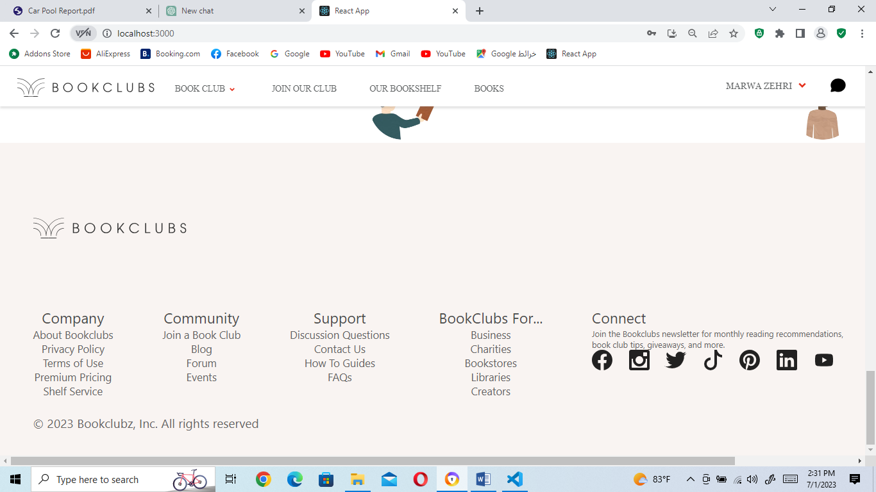

The footer remains consistent for both guest users and logged-in users, providing a set of links that allow users to explore and learn more about our online virtual book club. Additionally, the footer also includes contact links, such as Facebook, Instagram, Twitter, and other platforms, enabling users to connect with our club through various social media channels

- The “SIGN UP” link in the navbar directs users to the user registration page:

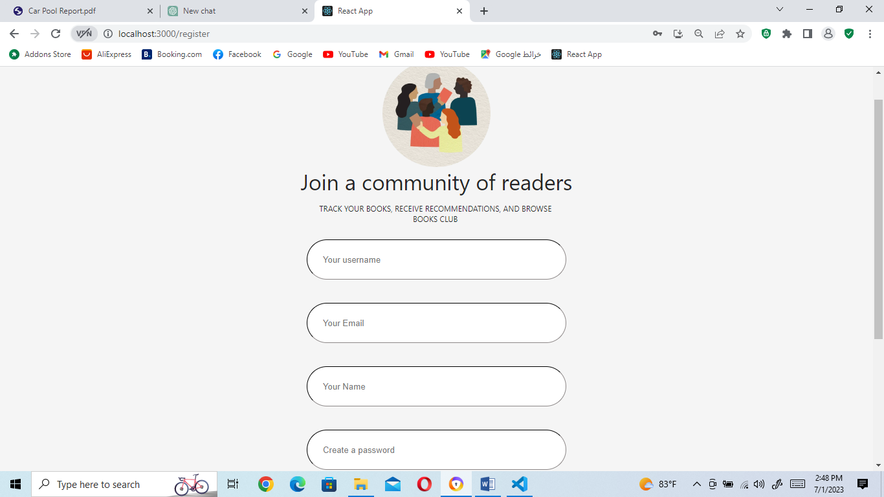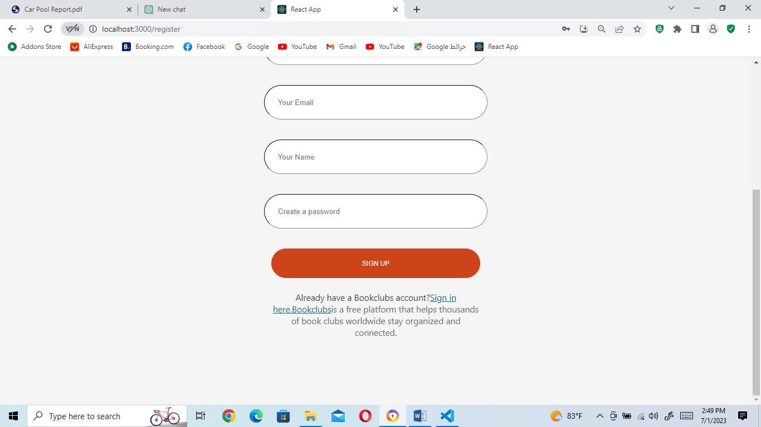

Figure 18: User registration page

In the above figure, the user registration page allows new users to create an account and join our online virtual book club by providing the necessary registration information. If the username entered by the user already exists, they will receive a message indicating that a member with the same username already exists. Similarly, if the email entered is already associated with another member, the user will be notified that a member with the same email already exists. Additionally, if the email entered is not valid, the user will receive a message stating that the email is invalid. Furthermore, if the name entered by the user contains numbers or other non-alphabet characters, they will be prompted with a message specifying that the name should only include alphabetic characters, and if everything is true then the user is created successfully and redirected to the login page.

- The “SIGN IN” link in the navbar directs users to the login page:

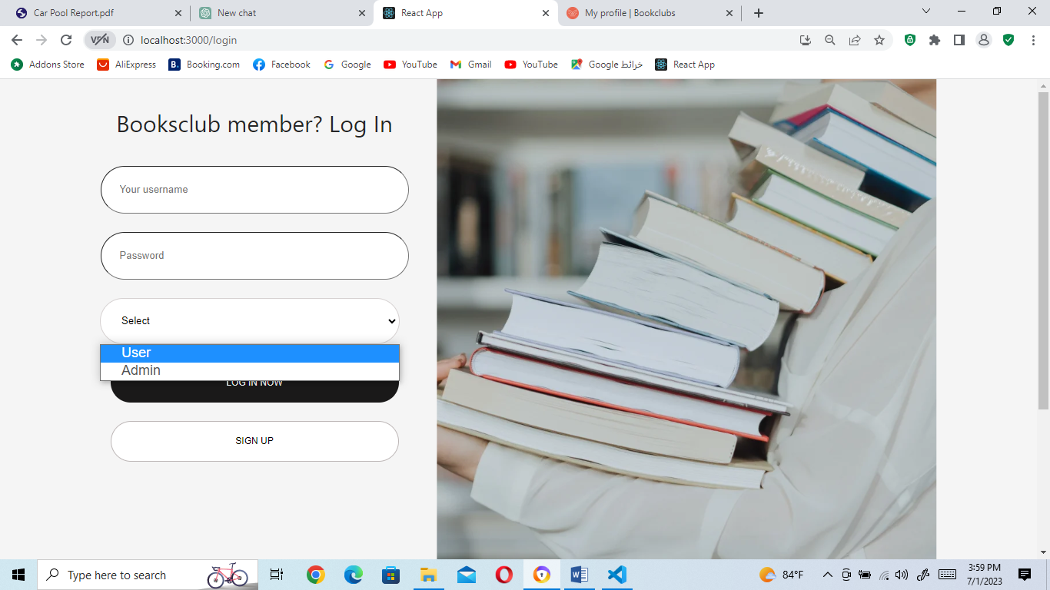

Figure 19: Login page

In the figure above, when a regular user attempts to log in, they need to enter their username, password, and select their role from the role dropdown list as 'User.' This is because during registration, their role is set as 'User' in the system. The login process verifies the entered username and performs the following checks:

If the entered username does not exist, the user will receive an error message stating that the username is invalid.

If the username exists but the entered password is incorrect, the user will receive an error message indicating that the password is incorrect.

If both the username and password are correct but the user selects 'Admin' as their role from the dropdown list, they will receive a message stating that they cannot log in as an admin.

On the other hand, when an admin tries to log in, they must enter their username, password, and select their role as 'Admin' from the role dropdown list. This is because, during admin registration, their role is set as 'Admin' in the system. The login process for admins follows the same checks as regular users, including username and password verification.

If all the entered credentials are correct for either a regular user or an admin, they will be successfully redirected to their respective pages: regular users to the Home page (default page), and admins to the admin panel.

- The 'BOOK CLUB' link on the navbar serves as a navigation element that allows users to access the home page, which is the default page when opening the website ,Home page can be accessed by both guest users and logged-in users. When users click on the 'BOOK CLUB' link, they are directed to the home page where they can explore various sections and content related to our online virtual book club.

In addition to directing users to the home page, the 'BOOK CLUB' link also displays a dropdown list. This dropdown list provides users with further navigation options to navigate between different parts of the home page. The dropdown list typically contains four links, allowing users to easily access specific sections or areas of interest within the home page.

OUR CHAT APP

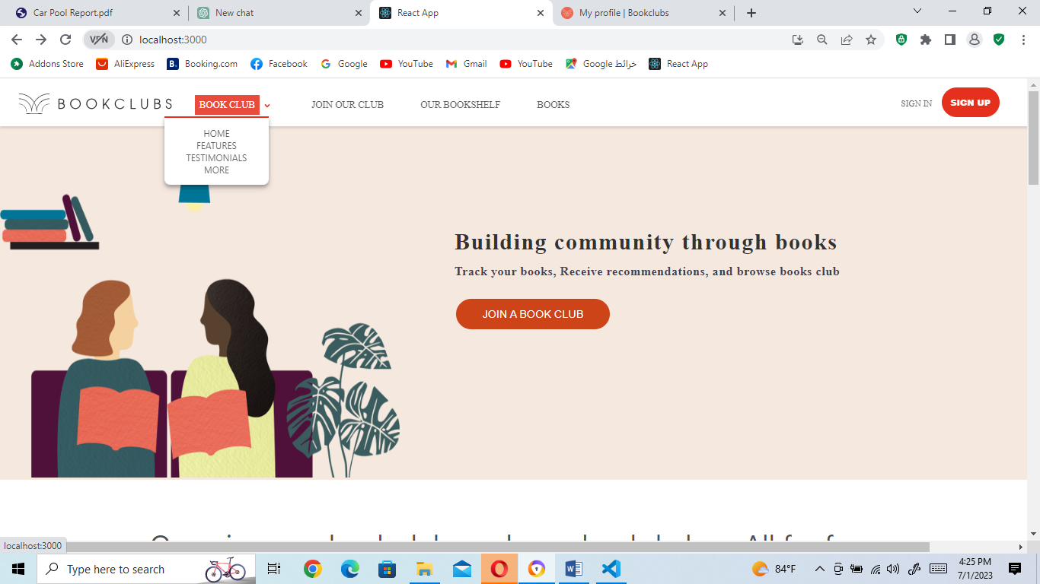

OUR CHAT APP

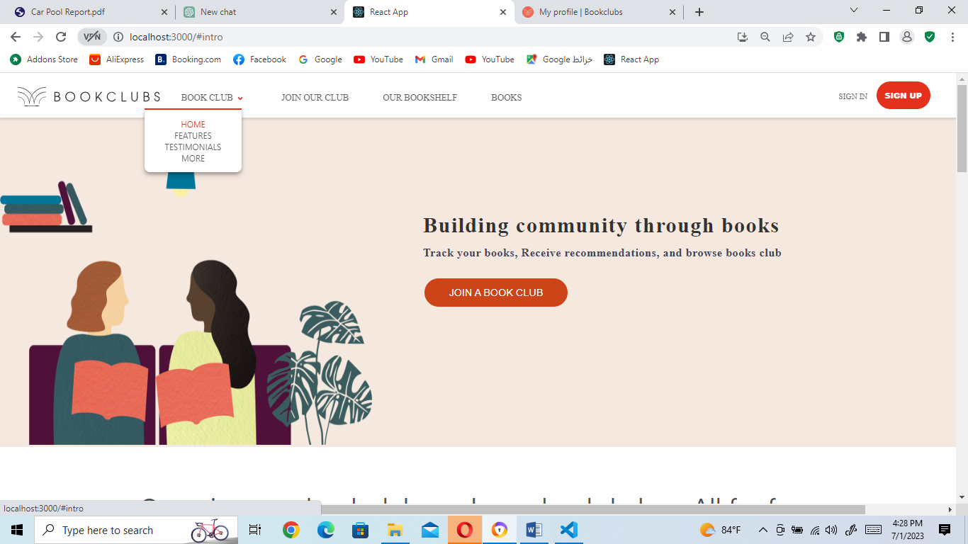

Figure 20: First part of the Home page

As you can see the "HOME" link in the dropdown list shows the first part of the home page

OUR CHAT APP

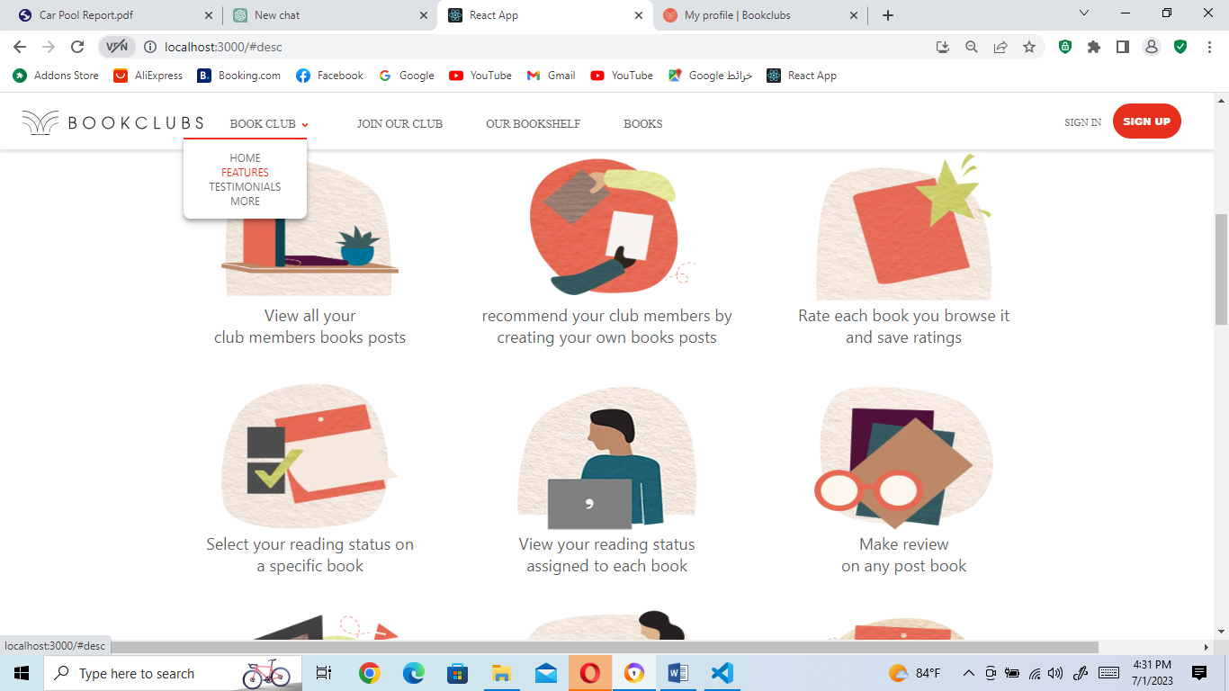

Figure 21: Second part of the Home page

The "FEATURE" link directs users to the second section of the home page, which provides an overview of the features of the website. This section highlights the key functionalities, capabilities, or special offerings of the website. It serves as a way to showcase the unique selling points and benefits of using the website to attract and inform users. By clicking on the "FEATURE" link, users can explore and learn more about the specific features and functionalities that the website offers

OUR CHAT APP

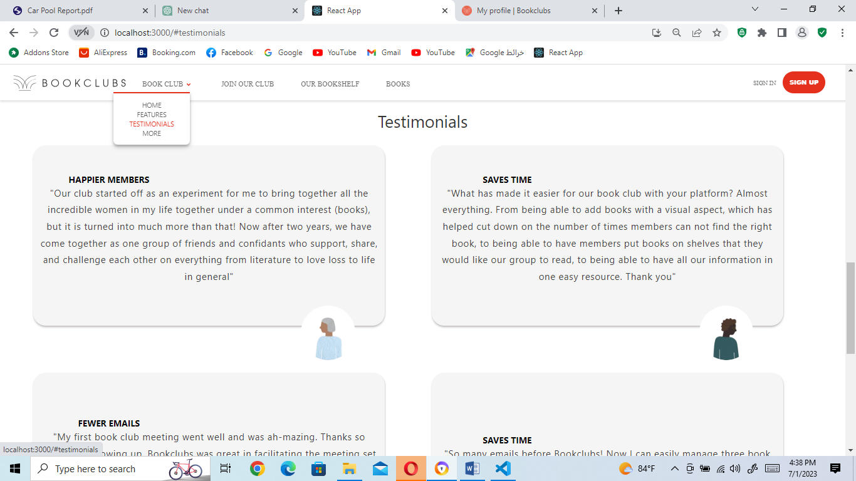

Figure 22: Third part of the Home page

The "TESTIMONIALS" link directs users to the third section of the home page, which is dedicated to displaying testimonials. This section provides users with the opportunity to read testimonials or reviews from other users who have had experiences with the website or its services. The purpose of including testimonials is to offer social proof and build trust among visitors by showcasing positive feedback and experiences shared by previous users.

Finally, the "MORE" link that is under the "TESTIMONIALS" link directs users to the footer, which has been previously explained as containing additional links and contact information.

The "JOIN OUR CLUB" link in the navbar directs users to a page that consists of two distinct parts. The first part is designed to allow users to join and explore the club, while the second part enables them to view a list of book posts created by club members.

- The first part layout of the join club page for the guest users:

OUR CHAT APP

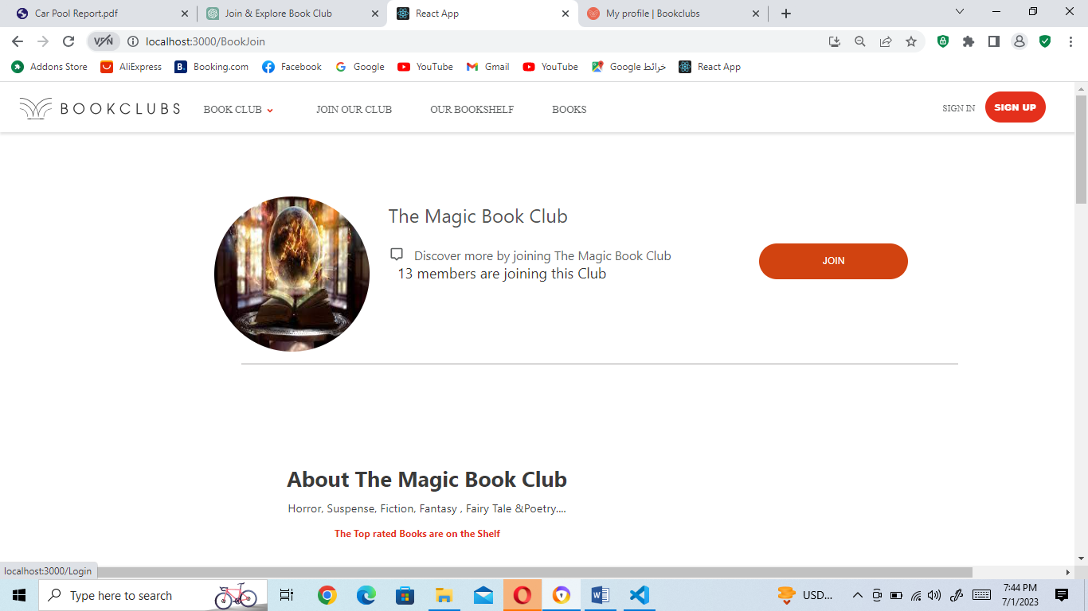

Figure 23: The first part layout of the join club page for the guest users

The first part layout of the join club page for the logged-in users

OUR CHAT APP

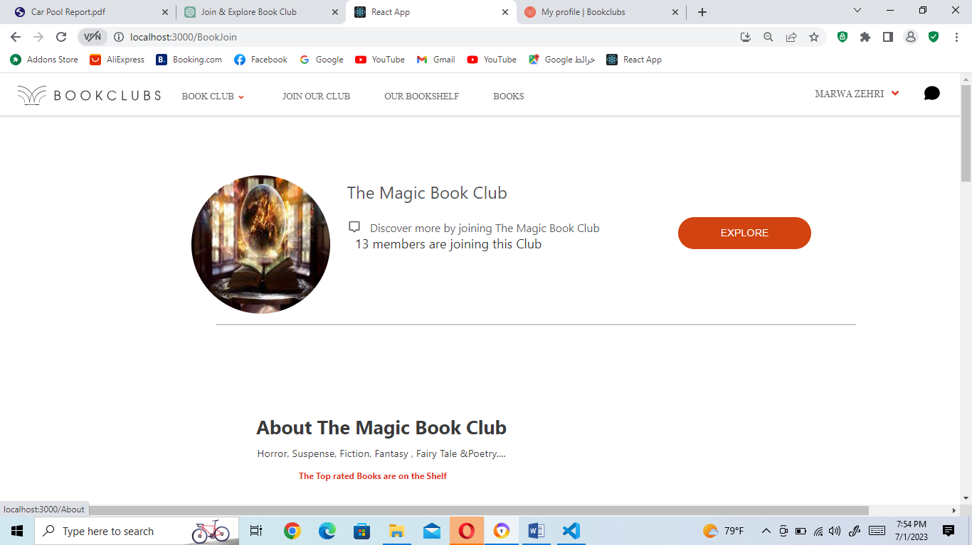

Figure 24: The first part layout of the join club page for the logged-in users

In the above 2 figures, If the user is a guest (not logged in), the button displayed in the first part of the page will be labeled as "JOIN." When the guest user clicks on this button, they will be redirected to the login page. This is because access to the club's features and content is restricted to logged-in members only. By redirecting the guest user to the login page, they can provide their credentials and gain access to the club.

On the other hand, if the user is already logged in, the button displayed in the first part of the page will be labeled as "EXPLORE." When the logged-in user clicks on this button, they will be redirected to the club area where they can access various features and view additional information specific to club members. This could include member-exclusive events, discussions, resources, or any other benefits associated with being part of the club.

-The second part of the join club page is the list of the books posted by the club members:

OUR CHAT APP

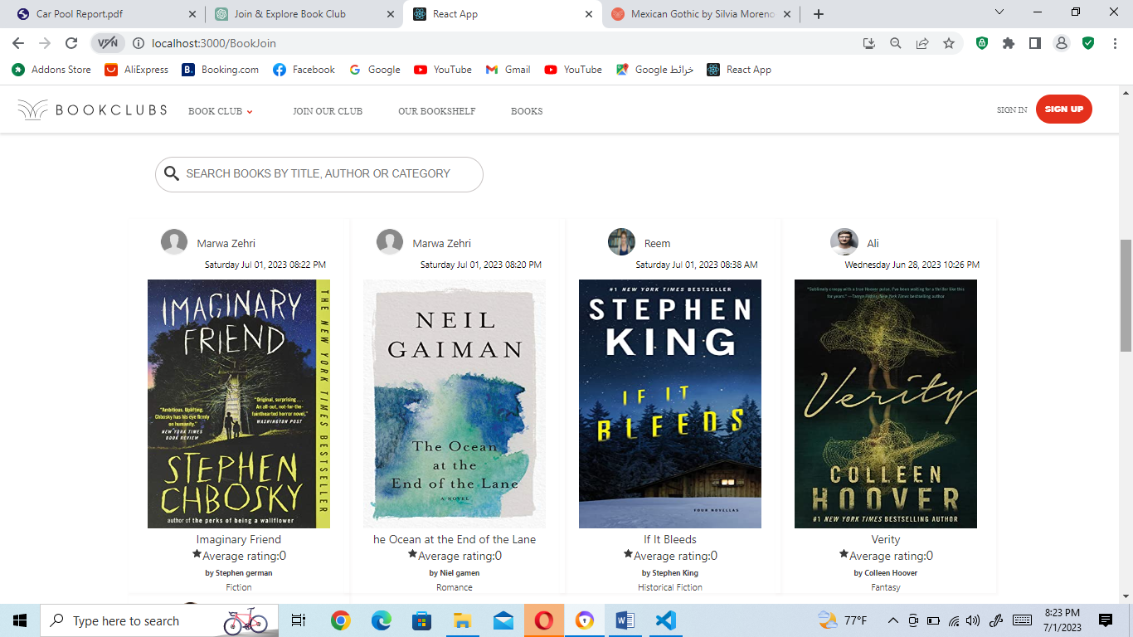

Figure 25: List of book posts

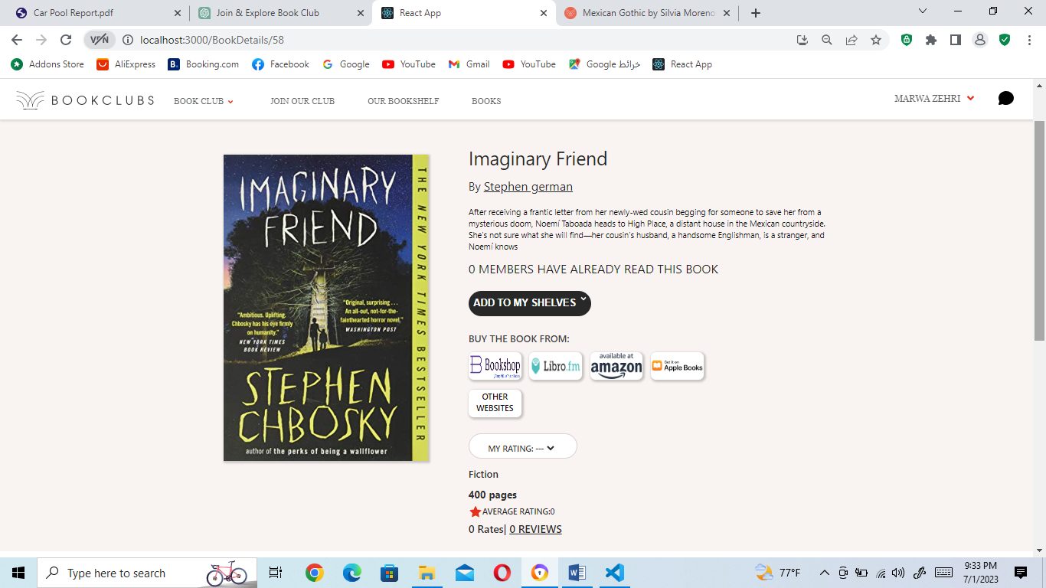

OUR CHAT APP

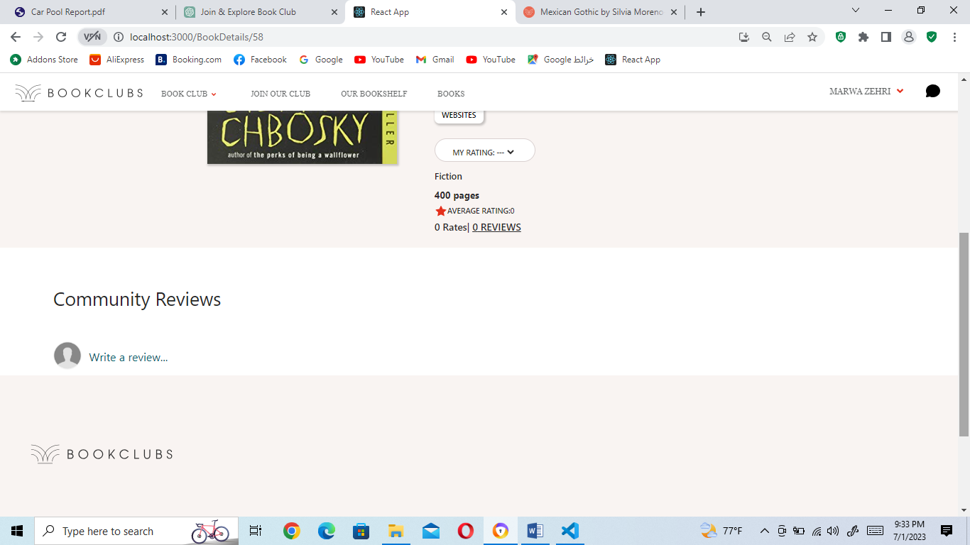

Figure 26: Book details page

In the above 2 figures, List of book posts figure and Book details page figure:

* **For Guest Users:**

Guest users can access the list of book posts on the page.

When a guest user clicks on a book to view its details, they can read the information about the book and any reviews posted by club members.

However, certain interactive features are limited for guest users. When a guest user tries to place a reading status, rate a book, leave a review, or make a like they will be directed to the login page. This is because these actions require the user to be logged in.

Guest users can still see the number of ratings and the average rating for a book, providing them with an overall sense of its reception within the club.

* **For Logged-In Users:**

Logged-in users can access the list of book posts on the page, just like guest users.

When a logged-in user clicks on a book to view its details, they can read the book information, reviews, and any other content related to the book.

Logged-in users have additional privileges. They can place a reading status on the book by selecting an option from a dropdown list. They can also rate the book using the available rating system, and their rating will contribute to the overall average rating displayed.

Logged-in users can read reviews posted by other club members and interact with them. They can like reviews, post a review, edit their own review, or even delete it if necessary.

The full range of interactive features is available to logged-in users, allowing them to actively engage with the book posts and contribute to the club's discussions and community.

Additionally, both guest users and logged-in users have the ability to search for books within the list of book posts. They can search by title, author, or category to find specific books of interest.

By differentiating the functionality based on the user's login status, the book details page provides a personalized experience tailored to each user's level of access and involvement within the club.

- When a logged-in user explores the club by clicking on the "EXPLORE" button, they are directed to the club's main page, which begins with the default display of the "About Our Club" page. This page provides detailed information about the club's features, activities, and what users can do as members.

Once on the main page, the user can then utilize the left navigation bar to navigate between the different pages and access various features and controls within the club. The left navbar serves as a menu that allows users to explore and interact with different sections of the club.

OUR CHAT APP

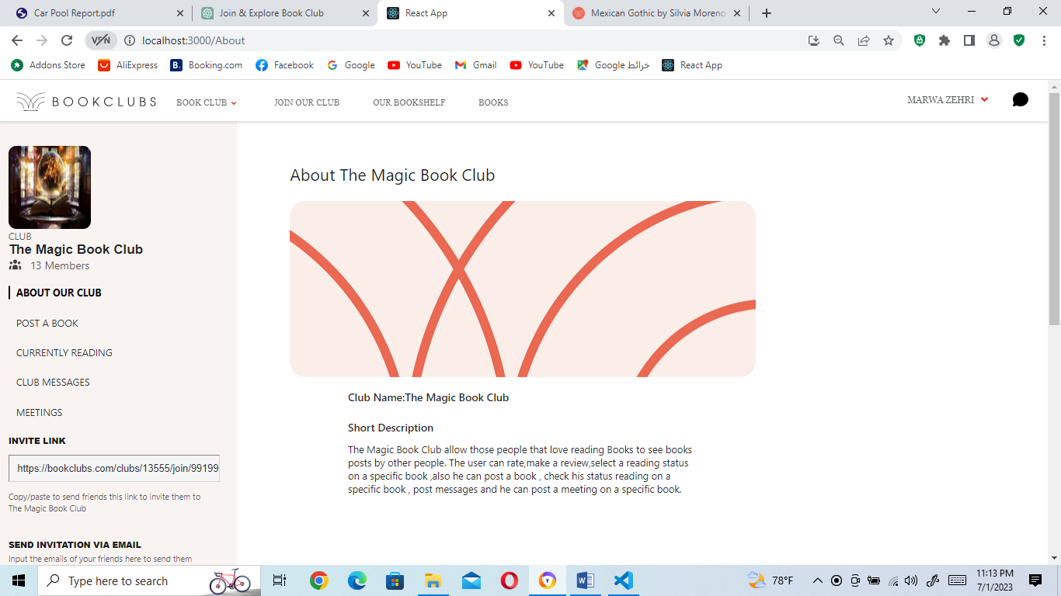

Figure 27: ABOUT OUR CLUB PAGE

OUR CHAT APP

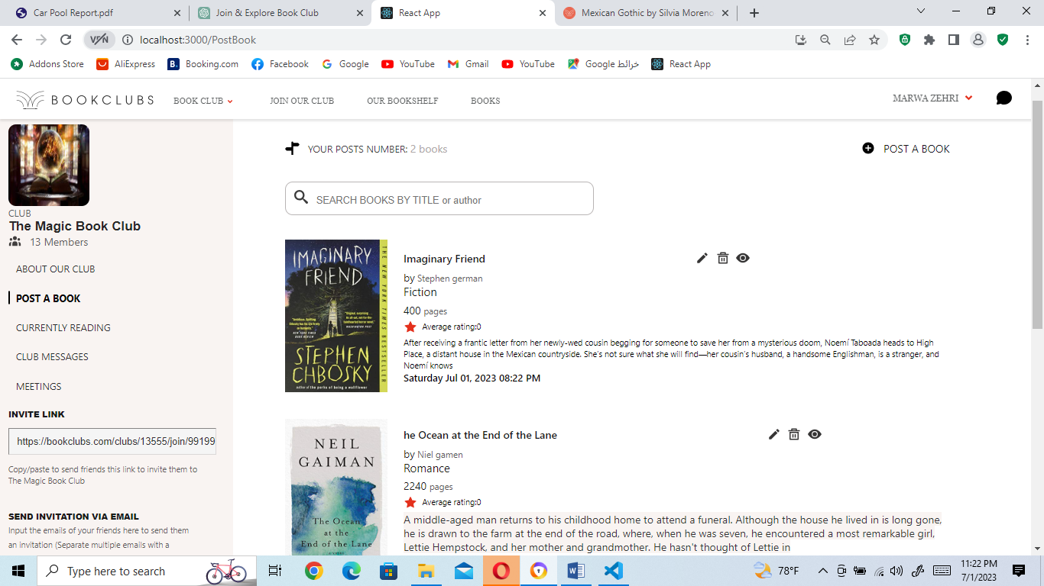

Figure 28: POST A BOOK PAGE

In the figure above, in the "Post A Book" page, logged-in users have the ability to view all of their book posts and perform various actions such as deleting, editing, or hiding their posts.

1. Viewing Book Posts: When a user accesses the "Post a Book" page, they will be presented with a convenient list view of all the book posts they have previously created. This list will display essential information such as the book's title, brief description, and cover image etc.…, making it easy for the user to identify their posts at a glance. The list view can be designed in a user-friendly format, allowing for easy navigation and readability.
2. A search functionality that enables the user to search for their own book posts by author, title, or category. This search feature allows users to quickly locate specific books within their collection. By entering relevant keywords or selecting filters, users can refine their search and retrieve the desired book posts efficiently.

The search functionality provides convenience and efficiency by allowing users to access specific book posts without having to scroll through an extensive list manually. By incorporating search options based on author, title, and category, users can easily locate their desired book posts within their collection on the "Post A Book" page.

3. Deleting a Book Post: If the user decides they no longer want a specific book post to be visible, they can choose to delete it. This action permanently removes the post from the club's platform. The user have a delete button associated with each book post, which, when clicked, prompts a confirmation message before the post is permanently deleted.

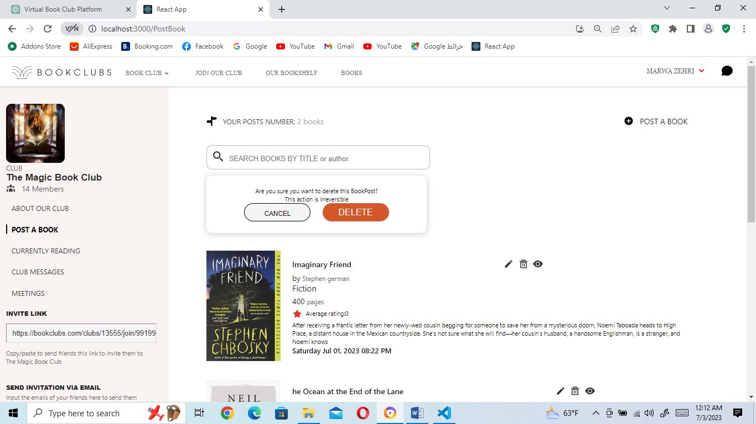

4. Editing a Book Post: In case the user wants to update or modify the information within a book post, they can choose the "Edit" option associated with the relevant post. Clicking on this option would redirect the user to an edit page, where they can make changes to the book title, description, cover image, or any other relevant details. After making the desired modifications, the user can save the changes, and the updated version of the book post will be displayed.

5. Hiding a Book Post: Instead of completely deleting a book post, the user may prefer to hide it temporarily. By selecting the "Hide" option associated with a specific post, the post will no

longer be visible to other club members or guests. However, the post will remain accessible to the user for future reference or potential reactivation.

These features provide users with control over their own book posts, enabling them to manage and curate their content within the club. Users can delete posts they no longer wish to have visible, edit posts to keep information up to date, and hide posts if they prefer to temporarily remove them from public view. These functionalities contribute to a personalized and customizable experience for each user within the club's platform.

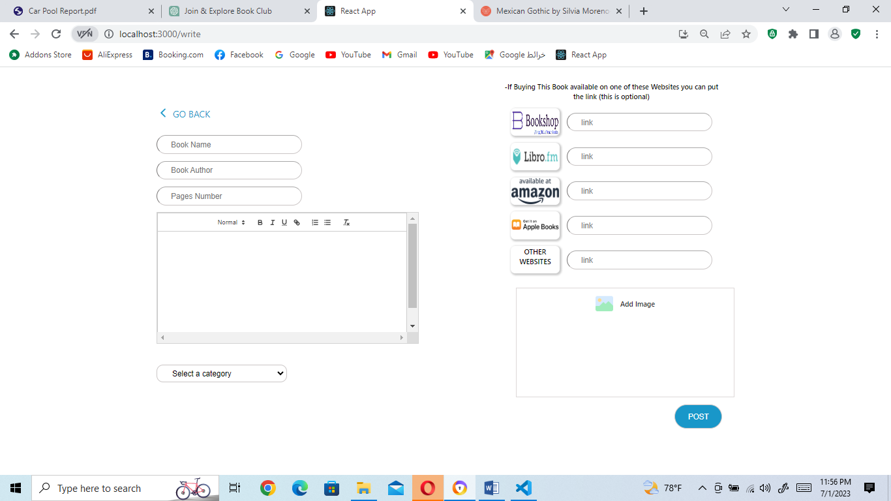

Figure 29: Create Book Post page

When you click on the "Post a Book" option in the "POST A BOOK" page, it will direct you to a page where you can fill in the necessary information about the book to create a new book post, this page is viewed in the figure above.

So in the figure above:

1. Book Title: The user is required to enter the title of the book they want to post.

2. Book Author: The user is required to enter the name of the book's author.

3. Description: The user is required to provide a brief description or summary of the book.

4. Book Image: The user is required to upload an image or cover art representing the book. This helps visually identify the book in the book posts.

5. Pages Number: The user is required to specify the number of pages in the book.

6. Purchase Links: The user has the option to provide links to purchase the book from specific websites. These links include the BookShop website, Amazon website, Libro.fm website, Apple Books website, and other relevant website from the user's selection.

By requiring essential information such as the book title, author, description, book image, and page count, the "Post A Book" page ensures that each book post is complete and informative. The inclusion of optional purchase links allows users to share convenient avenues for purchasing the book, making it easier for other members to access the book if interested. Additionally, the option to include other websites provides flexibility in case the book is available for purchase elsewhere.

Once all the required and optional information is filled in, the user can submit the form to create a new book post with the provided details.

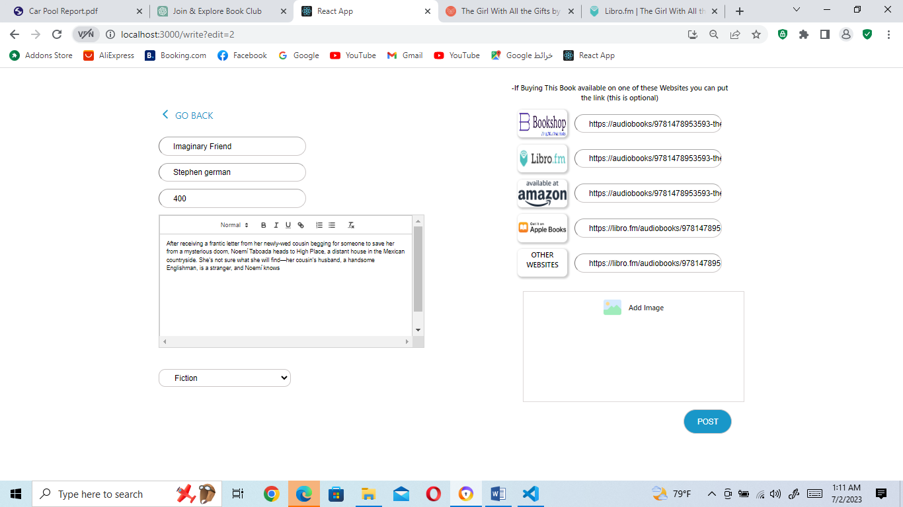

Figure 30: Edit Book Post page

When you press the "Edit" button on a book post, you will be directed to a similar page (the figure above) as the one used for adding a book post. However, in this case, the book details will be pre-filled in the respective input boxes, allowing you to update any information you wish to change. Here's an explanation of the process:

1. Edit Book Details: After clicking on the "Edit" button, you will be redirected to the book post creation page, which will display the existing book details in their respective input boxes.

2. Pre-filled Information: The book title, author, description, book image, and page count will already be filled in based on the original information provided when the book post was created. This allows you to conveniently review the existing details.

3. Update Book Information: You can make changes to any of the pre-filled information. For example, you can edit the book title to reflect any corrections or updates, modify the author's name, revise the book description, upload a new book image, or update the page count if necessary.

4. Retaining Original Information: If you do not wish to change certain details, you can leave them as they are, and they will remain the same as the original post.

5. Submitting Changes: Once you have made the desired updates, you can submit the edited book post. This action will overwrite the previous information with the updated details you have provided.

By following this process, the "Edit" button allows you to conveniently modify the book details without starting from scratch. The pre-filled information saves you time by presenting the existing details, while also enabling you to make any necessary changes or updates to the book post.

OUR CHAT APP

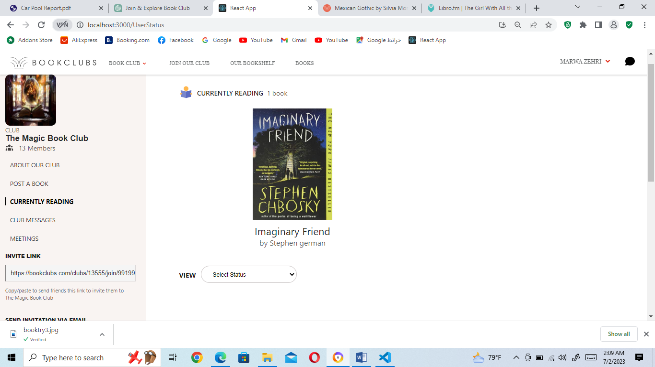

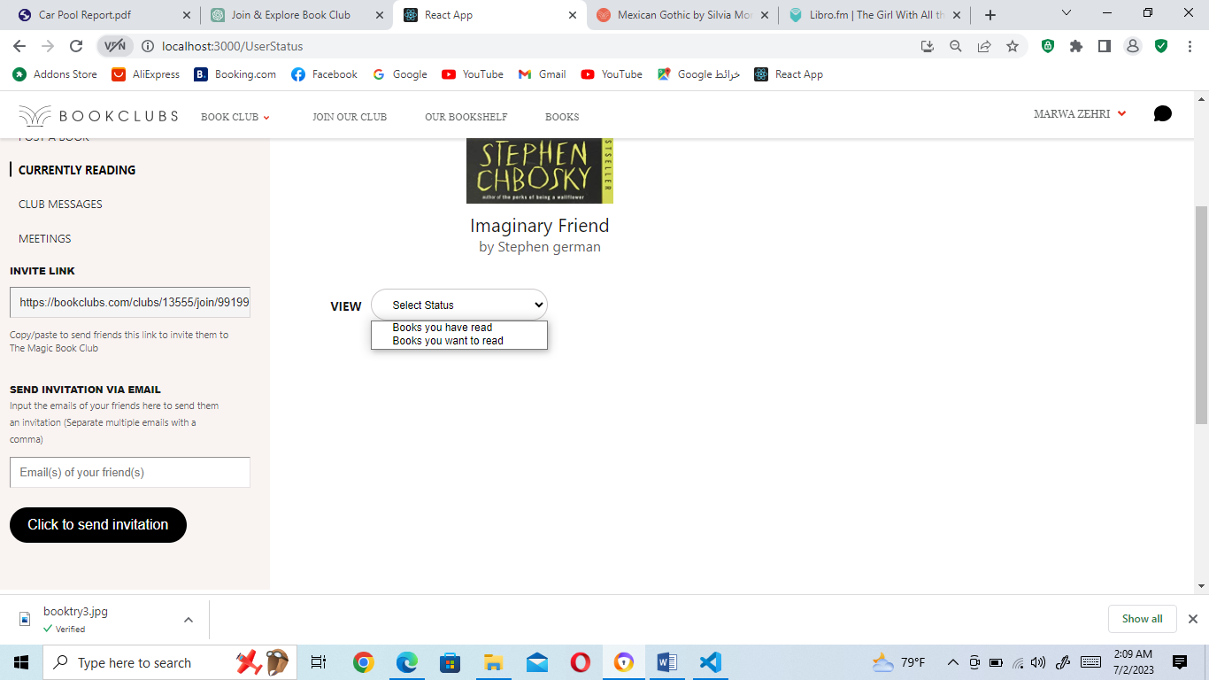

OUR CHAT APP

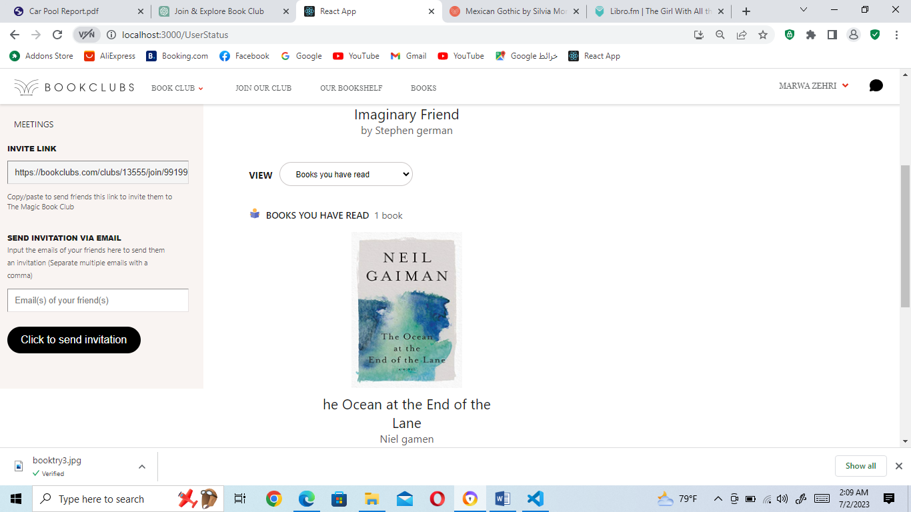

OUR CHAT APP

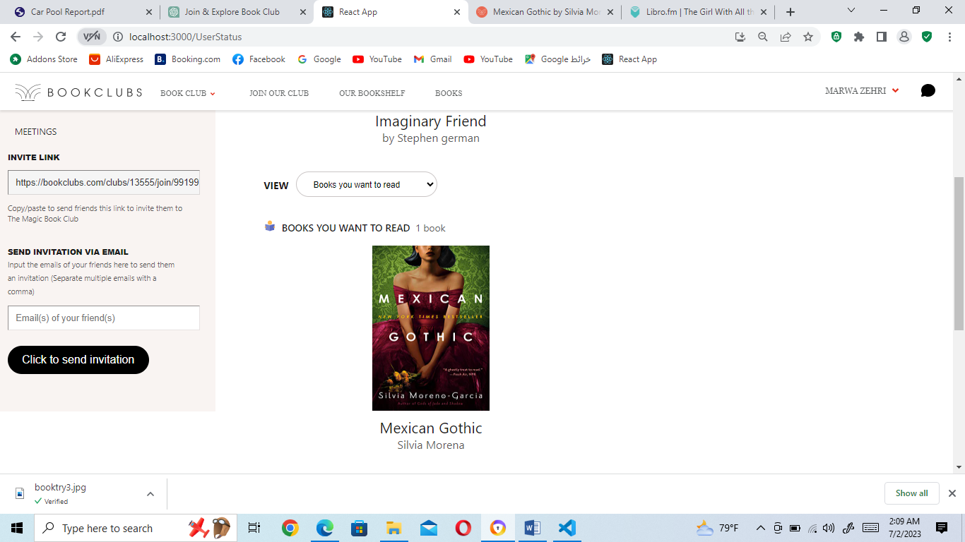

OUR CHAT APP

Figure 31: Track Reading Status

In the "CURRENTLY READING" page (figure above), users can view all the books to which they have assigned a reading status. The page provides a convenient overview of the user's reading progress and allows them to categorize their books into different statuses. Here's an explanation of how this page works:

1. Book Display: The " CURRENTLY READING" page displays a list of books that the user has assigned a reading status to. Each book is represented with its title, author, and book image, providing a visual reference for easy identification.

2. At the top of the “CURRENTLY READING" page, all the books that have been assigned the status of "Currently Reading" will be displayed

3. After the section that displays all the books that have been assigned the status of "Currently Reading," there is a dropdown list that allows the user to select different reading statuses. The dropdown typically includes 2 options "Books you have read" and "Books you want to read." These options enable the user to filter and view their books based on their reading history and future reading plans.

By selecting the "Books you have read" option from the dropdown, the user can view a list of books that they have already read. This list will include the titles, authors, and book images of the books they have completed.

By selecting the "Books you want to read" option from the dropdown, the user can view a list of books that they are planning to read in the future. This list will include the titles, authors, and book images of the books they intend to read.

This dropdown functionality provides users with the ability to organize and view their books based on different reading statuses, allowing for a more personalized and tailored reading experience.

OUR CHAT APP

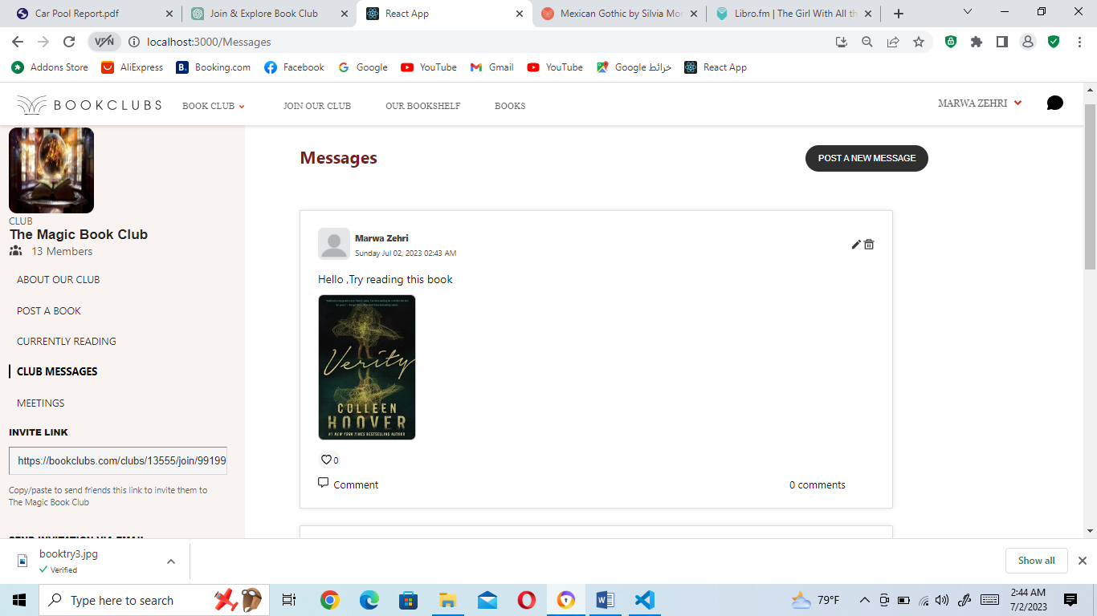

OUR CHAT APP

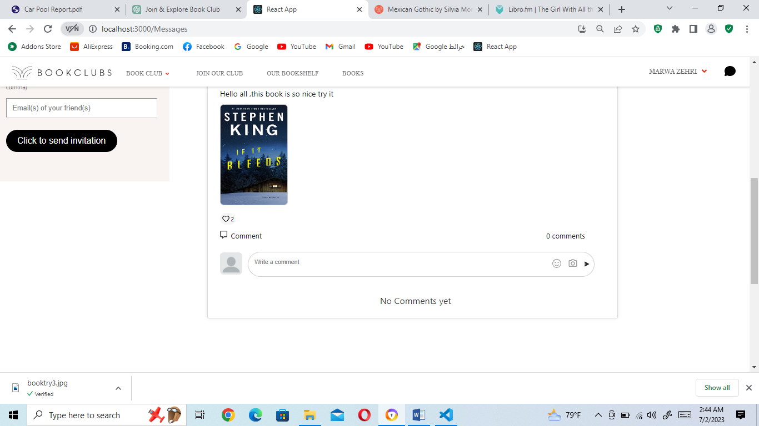

OUR CHAT APP

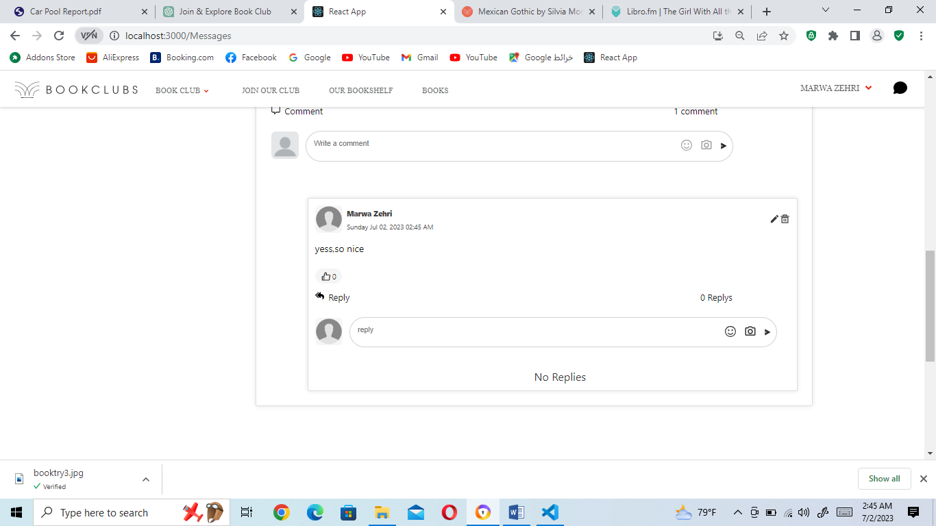

Figure 32: Club messages

In the club messages section (the figure above), users can engage in discussions and interactions by posting messages, comments, and replies. Here's an explanation of the functionality:

1. Posting a Message: Users can click on the "POST A NEW MESSAGE" button to create a new message. A text box will appear where they can enter their message content. Additionally, users have the option to include an image along with their message.

2. Editing or Deleting a Message: After posting a message, users have the ability to edit or delete their own messages. This allows them to make corrections or remove messages if needed.

3. Posting a Comment: Users can post comments on existing messages. They can enter their comment in a text box provided and also have the option to include an image with their comment.

4. Editing or Deleting a Comment: Similar to messages, users can edit or delete their own comments. This gives them the flexibility to modify or remove their comments as required.

5. Posting a Reply: Users can reply to comments by entering their reply in a text box. They can also attach an image if necessary.

6. Editing or Deleting a Reply: Users can edit or delete their own replies to further refine or remove them from the conversation.

7. Viewing Messages, Comments, and Replies: Users can view messages, comments, and replies posted by other club members. This allows them to read and engage in discussions within the club.

8. Liking Messages, Comments, and Replies: Users can show appreciation or agreement by placing likes on messages, comments, and replies. This feature allows for positive engagement and acknowledgment of valuable contributions.

By providing these features, the club messages section promotes active communication and interaction among club members. It allows users to share their thoughts, engage in discussions, and express their opinions through messages, comments, and replies. The ability to edit or delete their own content provides users with control over their contributions, while the option to like messages, comments, and replies encourages positive engagement and feedback within the club community.

OUR CHAT APP

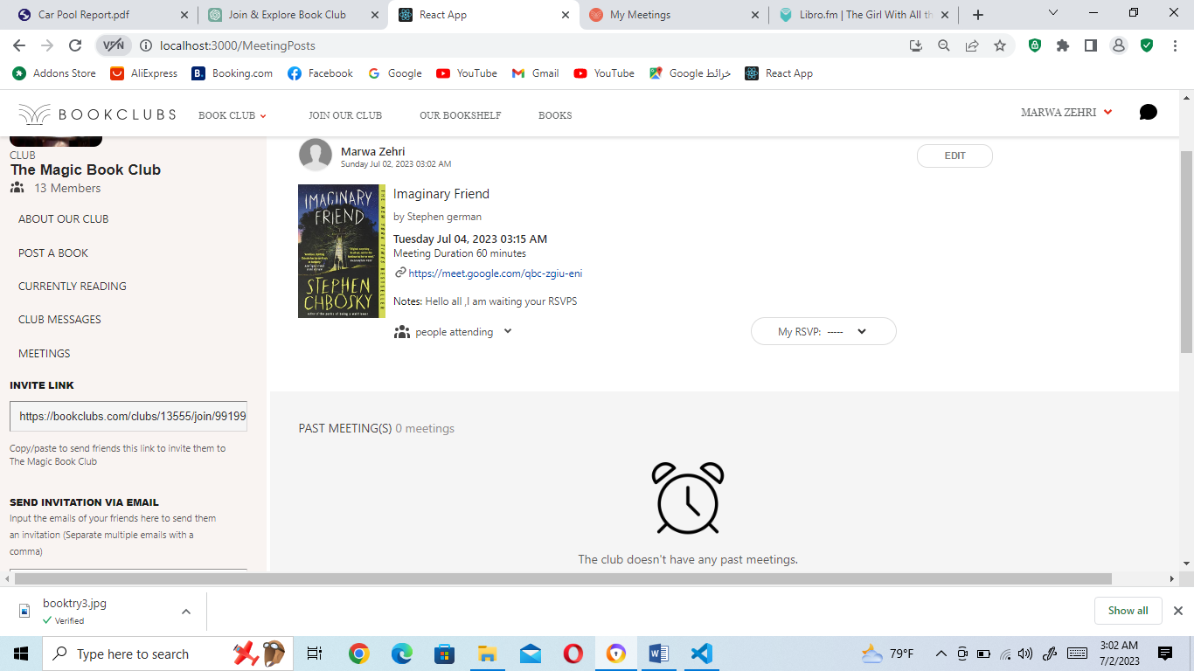

OUR CHAT APP

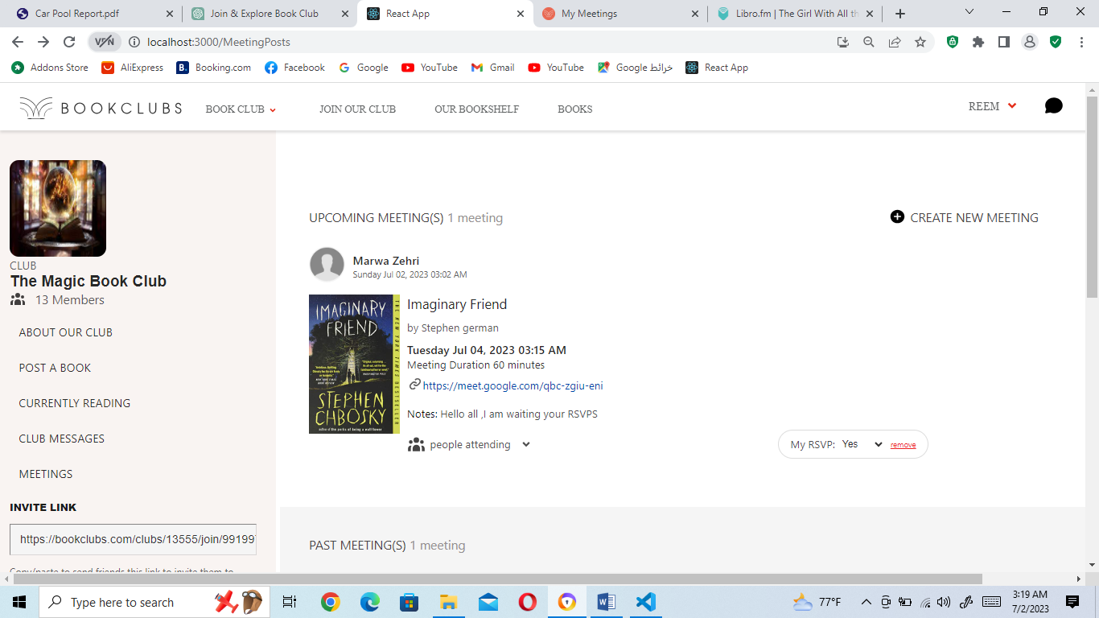

OUR CHAT APP

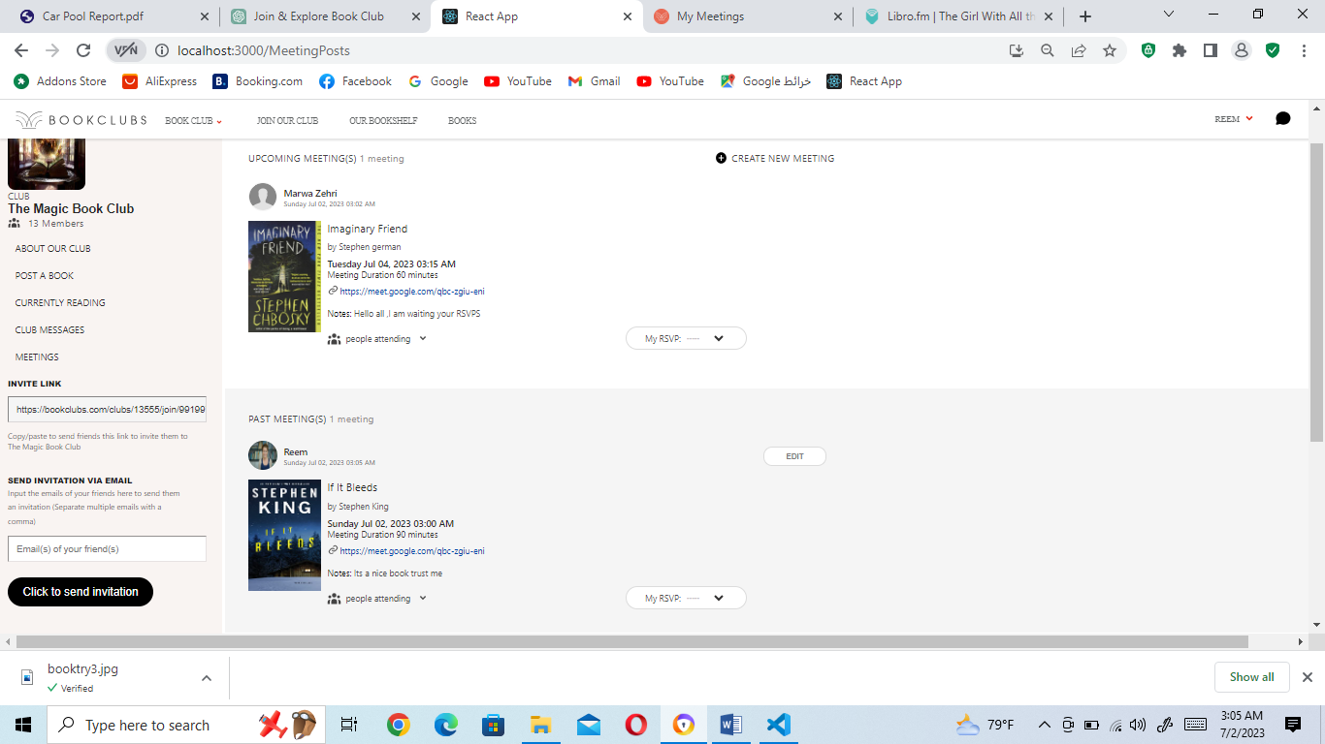

OUR CHAT APP

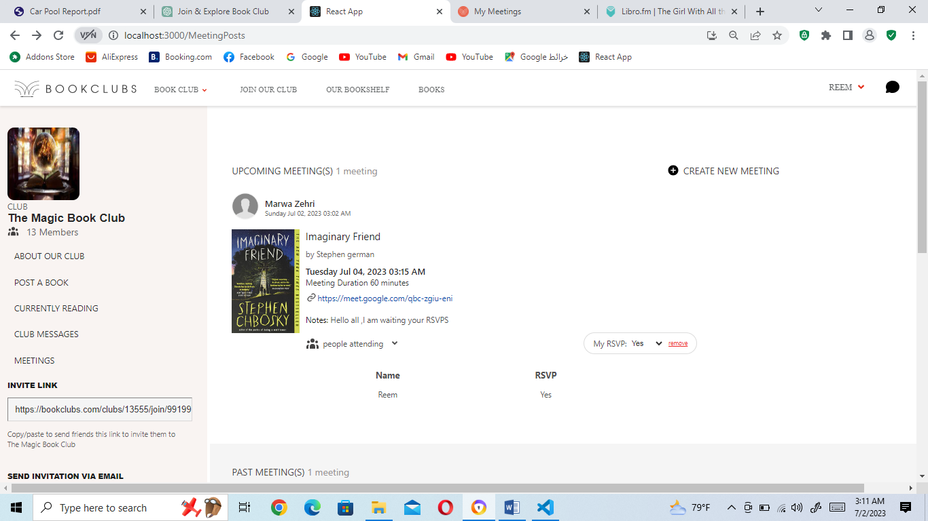

Figure 33: Club meetings

In the club meetings section (the figure above), users can access and view all the meetings posted by club members for a specific book. Here's an explanation of the functionality:

1. Upcoming and Past Meetings: The meetings are categorized into two sections: "Upcoming Meetings" and "Past Meetings." This allows users to easily differentiate between upcoming meetings they can still attend and past meetings that have already taken place.

2. Meeting Details: Each meeting is displayed with its relevant details, including the meeting date, time, duration, and meeting link. If necessary, there may also be a meeting note that provides additional information or instructions to club members regarding the meeting.

3. RSVP Functionality: Users have the option to RSVP (confirm their attendance) for a specific meeting. They can indicate whether they will be attending by selecting their RSVP status from a dropdown list associated with the meeting. The dropdown list provides three options: "Yes," "No," and "Maybe."

4. Updating RSVP: If a user has already RSVP'd for a meeting and their availability changes, they can update their RSVP status. This allows them to modify their attendance confirmation based on their schedule or availability.

5. Removing RSVP: Users also have the option to remove their RSVP for a meeting if they are no longer able to attend. This ensures that the attendance list remains up to date and accurate.

6. Viewing RSVP List: Users can view the list of RSVPs for a specific meeting. This enables them to see who else is attending and facilitates better coordination and planning for the meeting.

By providing these features, the club meetings section allows users to stay informed about upcoming and past meetings related to a specific book. The ability to RSVP, update RSVP status, and view the RSVP list enhances engagement and enables effective planning for the meetings.

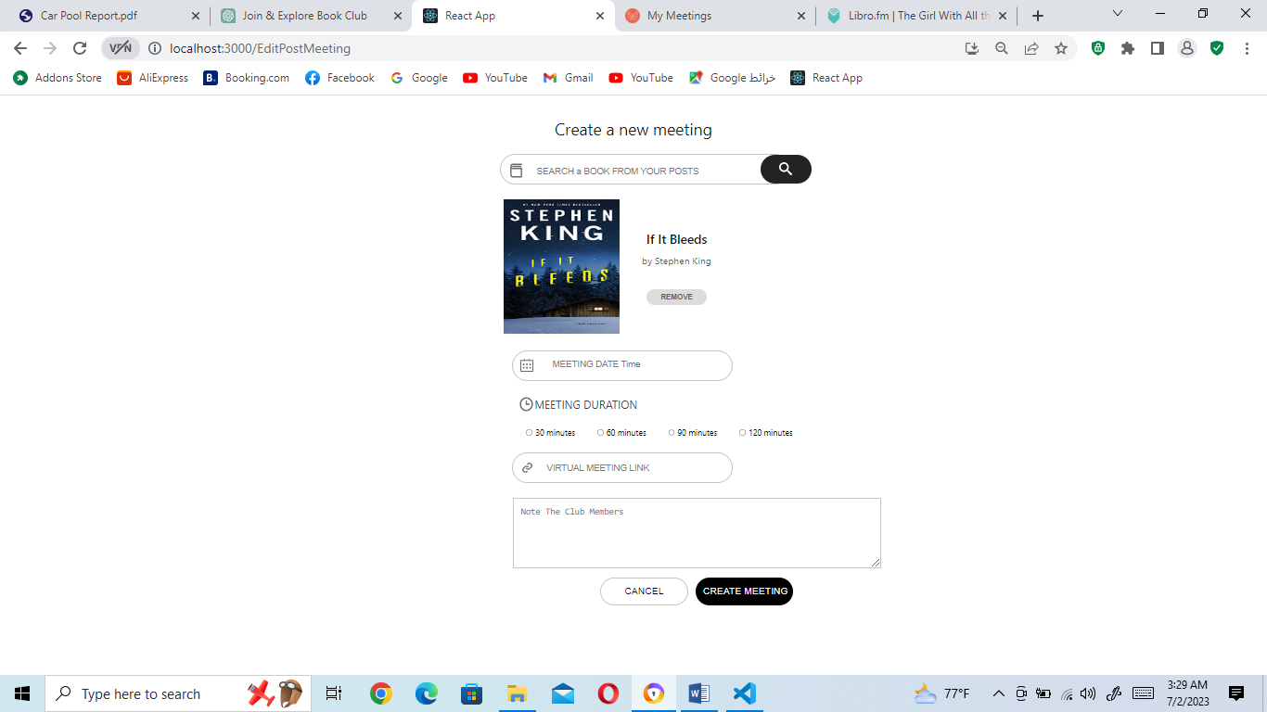

Figure 34: Post meetings

By pressing on the "CREATE NEW MEETING" option, user is directed to a page (figure above) where he can post a meeting for a specific book. Here's an explanation of the process:

1. Clicking on “CREATE NEW MEETING ": Users can click on the “CREATE NEW MEETING “option to initiate the process of posting a meeting.

2. Searching and Selecting a Book: Users can search for a specific book by entering relevant details such as the book title or author. Once they find the desired book from their posts, they can select it to associate the meeting with that particular book.

3. Meeting Information: Users need to fill in the meeting details, which typically include:

- Meeting Date and Time: The user specifies the date and time for the meeting to take place.

- Meeting Duration: Users indicate the estimated duration of the meeting.

- Meeting Link: Users provide the link where the meeting will be held, such as a video conferencing platform.

- Meeting Note (Optional): Users have the option to include a meeting note, which can contain additional information or instructions for the club members attending the meeting.

4. Required Information: All fields, except for the meeting note, are required. Users must provide the necessary information to create the meeting successfully.

5. Posting the Meeting: Once all the required information is filled in, the user can post the meeting. This makes it visible to other club members and allows them to view the meeting details.

By following this process, users can post a meeting on a specific book. This ensures that club members are informed about upcoming meetings, including the date, time, duration, meeting link, and any additional notes or instructions.

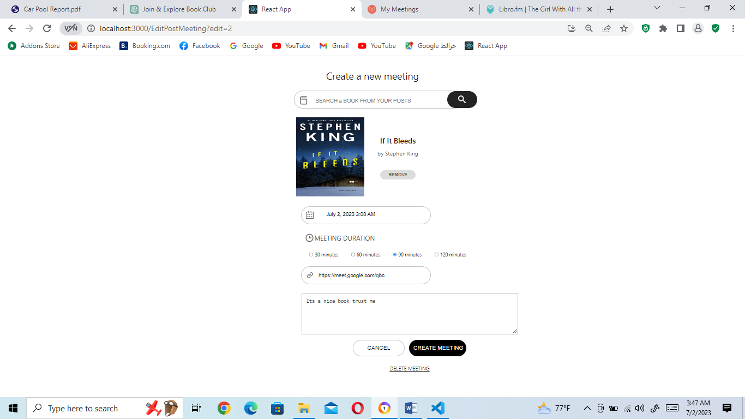

Figure 35: Edit meetings

When a user wants to edit a meeting, they can click on the "Edit" button associated with the meeting. Here's how the editing process typically works:

1. Clicking on the "Edit" Button: By clicking on the "Edit" button, the user is directed to the same page where they originally posted the meeting.

2. Filled Meeting Information: All the input boxes on the edit page are filled with the existing meeting information. This allows the user to have a reference and make changes to any of the fields.

3. Modifying Meeting Information: The user can modify any aspect of the meeting information, including the meeting date and time, duration, meeting link, and meeting note. They can change any of these details as necessary.

4. Saving Changes: After making the desired changes, the user can save the updated meeting. This ensures that the changes are applied to the meeting.

5. Deleting the Meeting: In addition to editing, the edit page typically includes a "Delete" option. If the user decides to delete the meeting altogether, they can click on the "Delete" button to remove it from the club's meeting list.

By providing the ability to edit and delete meetings, users have the flexibility to update the meeting details if there are any changes or delete a meeting if it is no longer needed. This allows for better management and organization of the club's meetings.

OUR CHAT APP

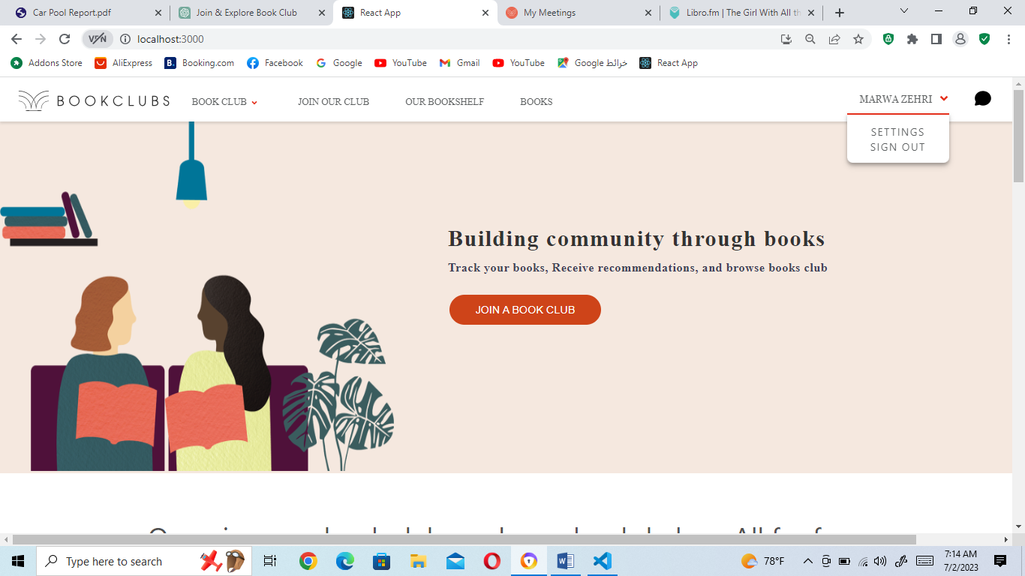

Figure 36: User settings and sign out

As we explain before, and as we are seeing in the figure above, when a user is logged in, the right side of the navbar displays their name and an arrow. Here's an explanation of the functionality:

1. User Name: The logged-in user's name is displayed on the right side of the navbar. This provides a personalized touch and helps users easily identify their account.

2. Dropdown Menu: When the user clicks on the arrow next to their name, a dropdown menu appears. This menu offers additional options for the user.

3. User Settings Link: Within the dropdown menu, there is a "User Settings" link. Clicking on this link directs the user to their account settings page. Here, they can modify their profile information, change their password, and delete their account.

4. Sign Out: Also within the dropdown menu, there is a "Sign Out" link. Clicking on this link allows the user to log out of their account. This ensures that their session is terminated, and they are securely signed out.

By including the user's name, a dropdown menu, and options like User Settings and Sign Out, the system provides a convenient way for users to access their account settings and log out when needed. This enhances the user experience and ensures their account information remains easily accessible and secure.

OUR CHAT APP

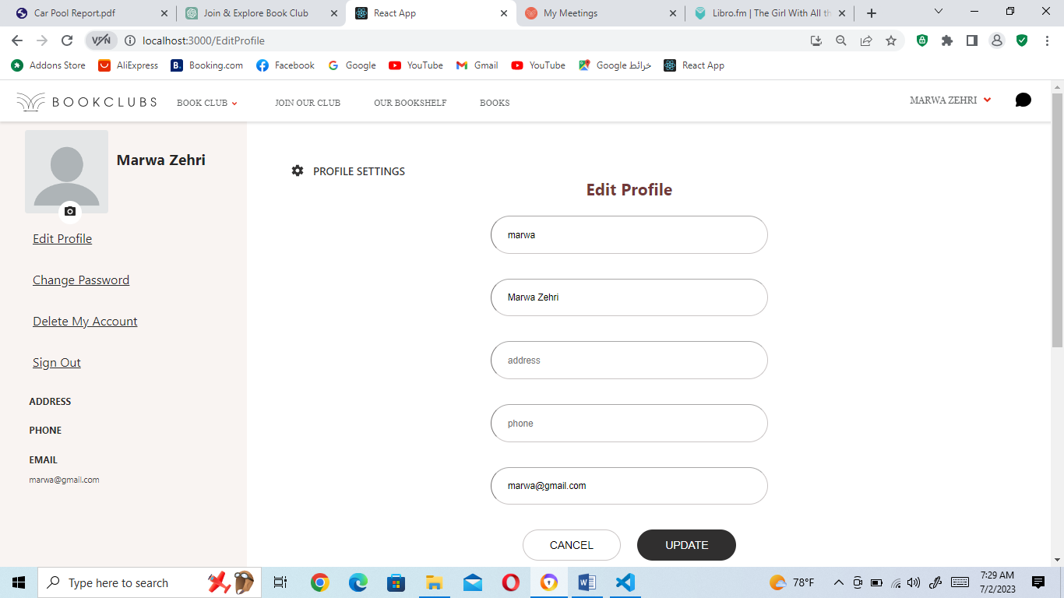

Figure 37: User settings page

The settings page contains a left navbar with three links: "Edit Profile," "Change Password," and "Delete My Account." Additionally, there is an option to sign out using the left navbar. This allows users to conveniently access these important account management features and provides an intuitive navigation experience within the settings page.

OUR CHAT APP

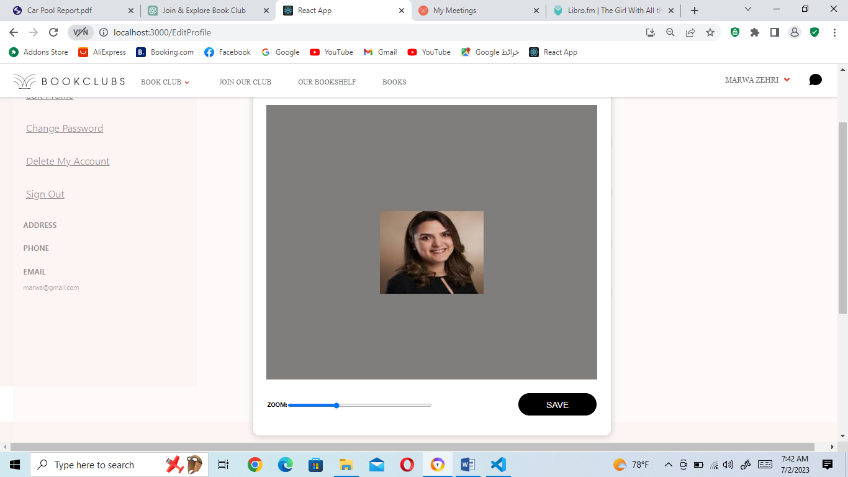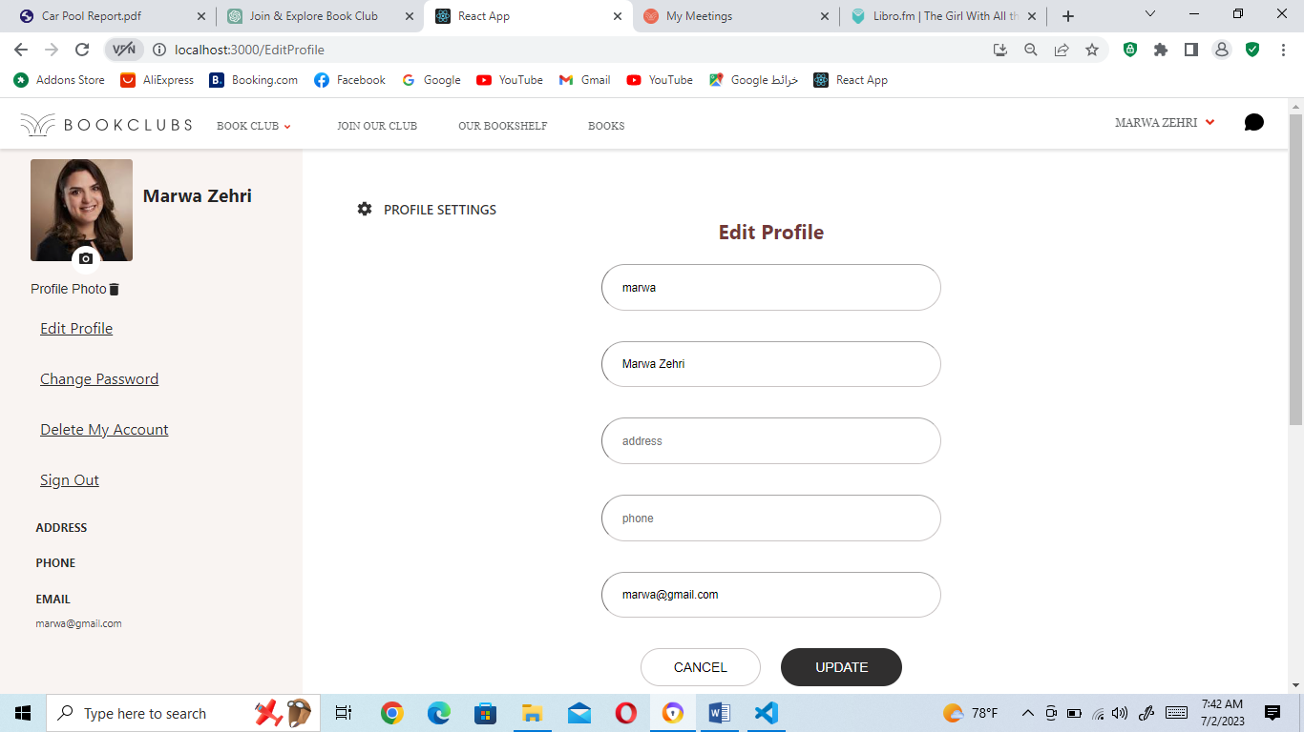

Figure 38: Placing a profile image

In the figure above, when a user clicks on the camera icon to add a profile image, they can choose an image file from their device. Here's how the process typically continues:

1. Choosing a Profile Image: After clicking on the camera icon, a file picker or image selection interface appears, allowing the user to choose an image from their device. The selected image is then displayed in a designated box.

2. Adjusting Image Size: To control the size of the profile image, a zoom line feature is provided. The user can use this feature to zoom in or out on the image, there by adjusting its size within the designated box. This allows the user to achieve the desired cropping or scaling of their profile picture.

3. Saving the Profile Image: Once the user is satisfied with the image size and composition, they can click on the "SAVE" button to save the profile image. After saving, the profile picture is displayed in the designated box.

4. Removing the Profile Image: With the profile image in place, an option to remove the image is typically provided. This is a link labeled "Profile Photo" and beside it a delete icon. If the user decides to remove their profile image at any point, they can click on this option to do so.

By allowing users to choose a profile image, adjust its size using a zoom line feature, and providing the option to save or remove the image, the platform offers a flexible and customizable profile picture feature. This enables users to personalize their profile and manage their profile image according to their preferences.

OUR CHAT APP

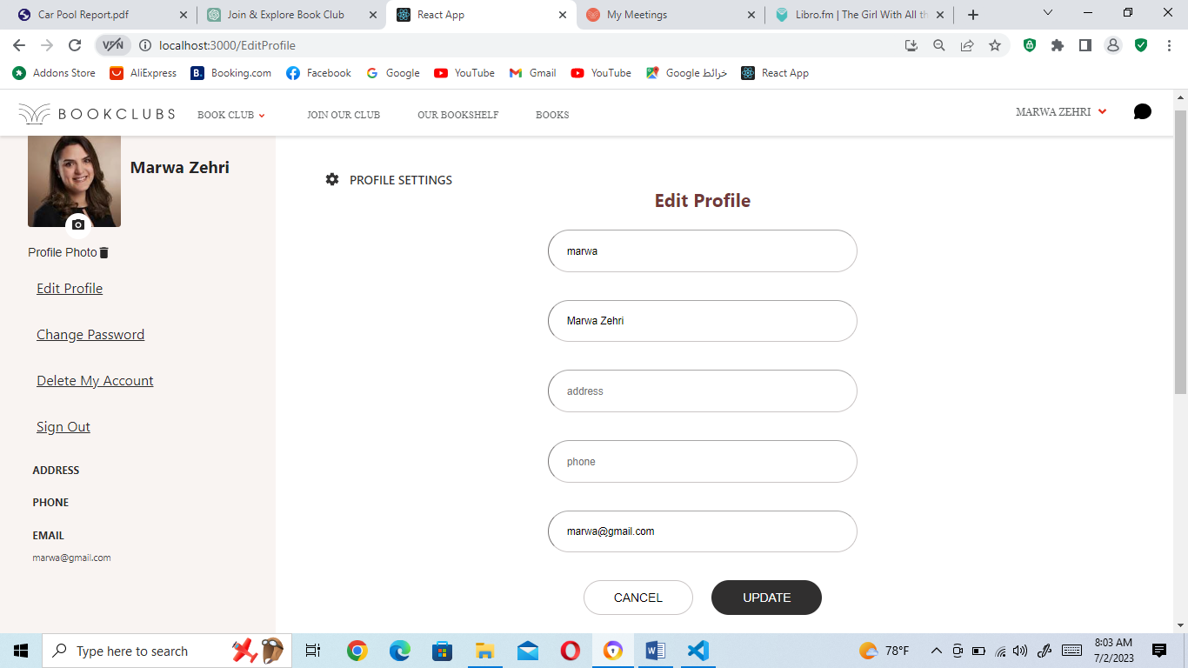

Figure 39: Edit Profile page

The Edit Profile page provides users with a comprehensive view of their current account details, allowing them to review and make changes to specific fields. This ensures that users have control over their profile information and can keep it up to date. So Users have the option to modify their account information and update it as needed, here's how the process typically works, including validation checks and error messages:

1. Required Fields: The user is required to fill in certain fields, including the username, name, and email address. These fields cannot be left empty.

2. Optional Fields: The address and phone number fields are optional, and the user can choose to leave them empty if they prefer.

3. Username Validation: If the user enters a username that already exists in the system, they receive an error message indicating that a member with the same username already exists. The user is then prompted to choose a different username.

4. Email Validation: If the user enters an email address that already exists in the system, they receive an error message stating that a member with the same email address already exists. The user is required to provide a unique email address.

5. Email Format Validation: If the user enters an invalid email address format (e.g., missing "@" symbol or domain name), they receive an error message indicating that the email is invalid. The user must enter a valid email address.

6. Name Validation: If the user's name contains numbers or special characters, they receive an error message stating that the name should only contain characters (letters). The user is prompted to enter a name without numbers or special characters.

7. Successful Update: If all the entered information is valid and meets the required criteria, the system updates the account information and displays a success message confirming that the account details have been updated successfully.

By incorporating these validation checks and providing appropriate error messages, the platform ensures that users provide accurate and valid information during the profile editing process. It helps maintain data integrity and improves the overall user experience.

OUR CHAT APP

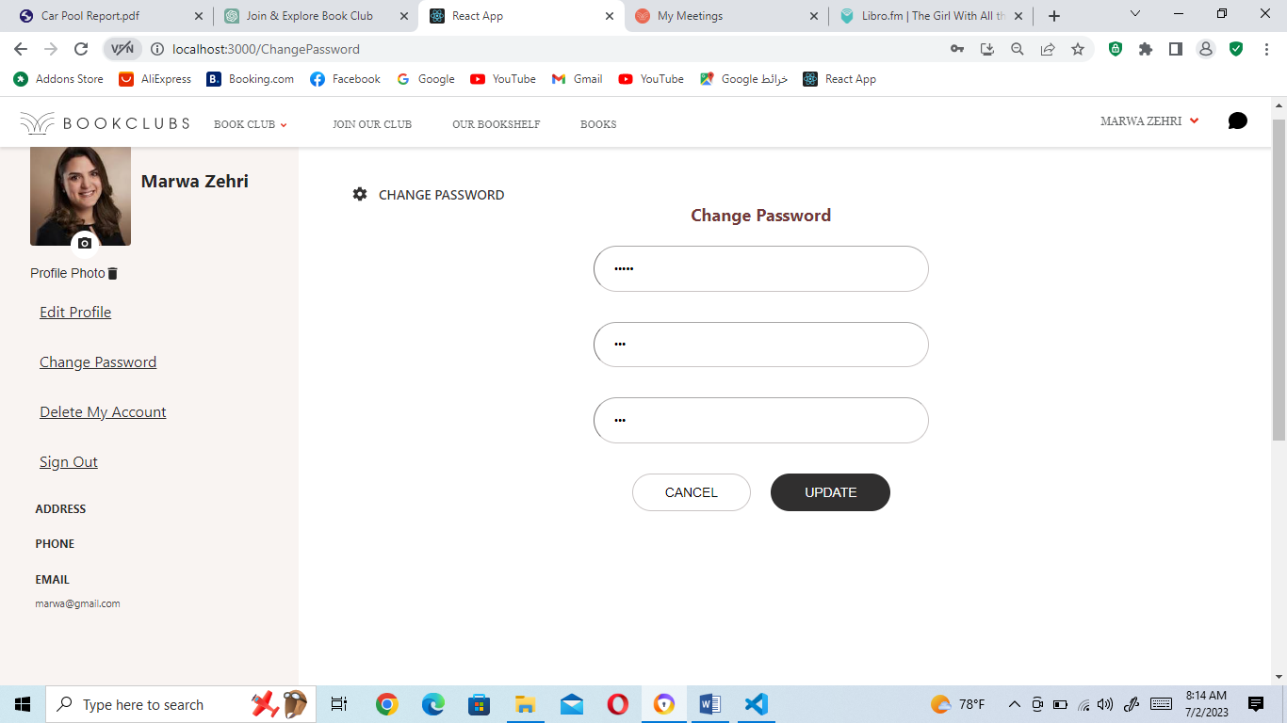

Figure 40: Change Password page

In the Change Password page (figure above), users can update their password by following these steps:

1. Current Password: The user is required to enter their current password. This is done to ensure that only the account owner can make changes to the password.

2. New Password and Confirm Password: The user must enter their new password in the "New Password" field and re-enter it in the "Confirm Password" field for verification.

3. Password Match Validation: If the new password and confirm password do not match, the user receives an error message indicating that the two fields don't match. The user is prompted to re-enter the password correctly.

4. Current Password Validation: After the user enters the correct new password and confirms it, the system checks if the entered current password matches the one associated with the user's account. If the current password is incorrect, the user receives an error message stating that the current password is invalid.

5. Successful Password Update: If the entered current password is correct and the new password and confirm password match, the system updates the password and displays a success message confirming that the password has been changed successfully.

By incorporating these password validation checks, the platform ensures that users provide accurate information and follow the required password update process. This helps maintain account security and prevents unauthorized access.

OUR CHAT APP

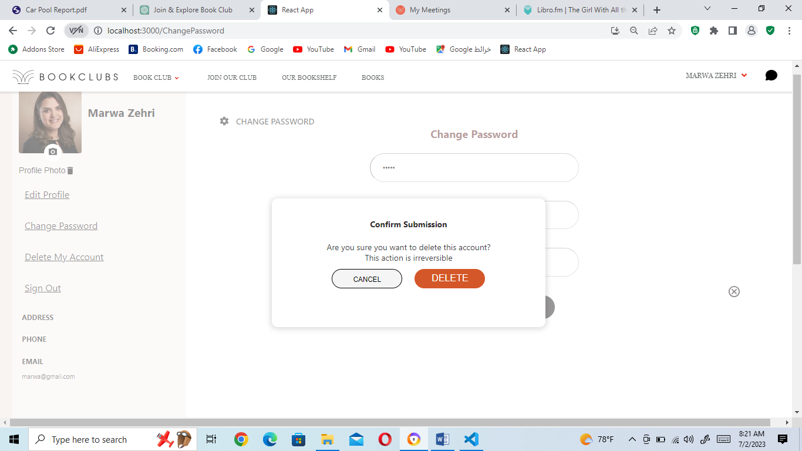

Figure 41: Delete Account

When a user clicks on the link to delete their account, a confirmation box or dialog appears, asking the user to confirm their decision (figure above). Here's how the process typically works:

1. Clicking on the Delete Account Link: The user clicks on the link provided to delete their account, indicating their intent to proceed with account deletion.

2. Confirmation Box: A confirmation box or dialog box appears on the screen, seeking final confirmation from the user. The box typically includes a message that asks the user if they are sure they want to delete their account, because this action is irreversible.

3. User Confirmation: The user is required to confirm their decision by clicking on a "DELETE" button. This ensures that the user understands the consequences of their action and intends to proceed with deleting their account.

4. Account Deletion Process: If the user confirms their decision to delete their account, the system initiates the account deletion process. This process involves permanently removing the user's account and all associated data from the system.

5. Cancel Option: In the confirmation box or dialog, along with the "DELETE" button, there is a "CANCEL" button. If the user changes their mind or decides not to proceed with the account deletion, they can click on the "CANCEL" button.

By incorporating this confirmation step, the platform ensures that users have an additional opportunity to reconsider their decision to delete their account. It helps prevent accidental deletions and ensures that users fully understand the consequences of their action before proceeding.Top of Form

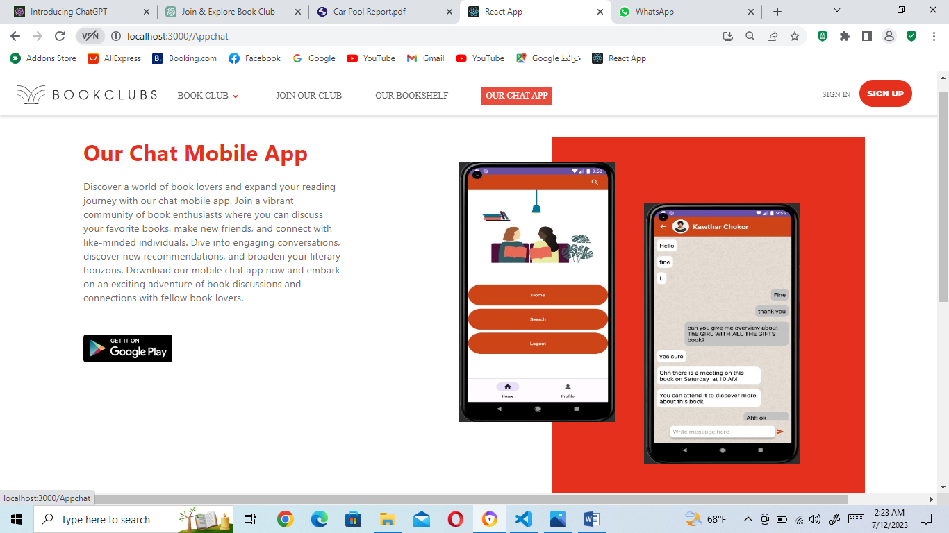

Figure 42: Our Chat App page

The "Our Chat App" link on the navbar directs users to a dedicated page promoting our chat mobile app. On this page (figure above), users can learn more about the features and benefits of our app, including the opportunity to connect with fellow book lovers, engage in book discussions, and make new friends. Additionally, the page includes a direct link to the Play Store where users can easily install the app on their mobile devices and start exploring the exciting world of book conversations. The "Our Chat App" page can be viewed by both guest users and logged-in users. Whether you're new to the online virtual book club or an existing member, you can access this page to learn more about our chat mobile app. Discover the benefits of joining the app, connect with like-minded individuals, and engage in lively discussions about your favorite books. Whether you're seeking book recommendations, looking to share your thoughts, or simply want to connect with fellow book enthusiasts, our chat app offers a vibrant community to fulfill your literary passions.

**6.1.2 Mobile App: User’s Test**



Figure 43: Splash Screen

When users enter our chat mobile app, the first screen they encounter is the splash screen, which typically displays the app's logo or branding. After a short period, they are automatically redirected to the "Login Phone Number" activity.

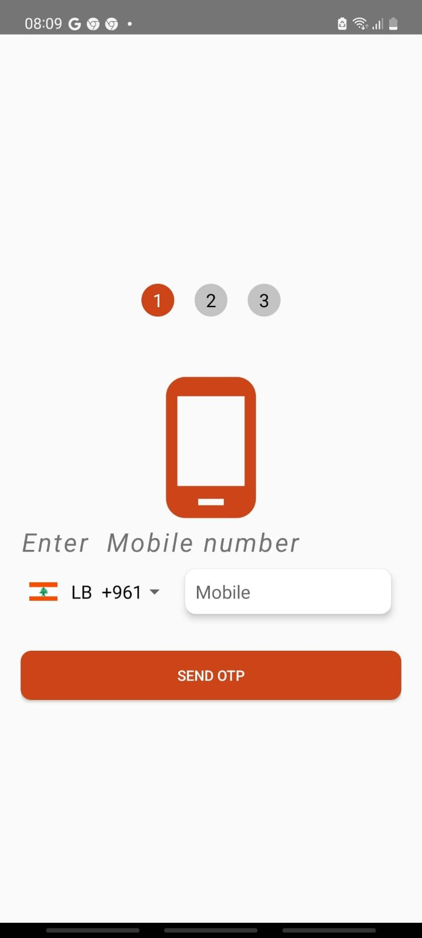

Figure 44: Login Phone Number Activity

In the "Login Phone Number" activity (the figure above), the user is prompted to enter their phone number along with the country code. It is essential for the user to enter a valid phone number to proceed with the login process. If the user enters an incorrect or invalid number, they will be prompted to re-enter a valid phone number.

Once the user enters a valid phone number, the number is securely stored in the app's database. Subsequently, a verification message is sent to the user's phone number via SMS. The message contains a unique code that the user will need to enter on the next page or screen to complete the verification process.

By utilizing phone number verification, the app enhances security and ensures that each user is associated with a valid and verified phone number. This process helps in preventing unauthorized access and maintaining the integrity of user accounts

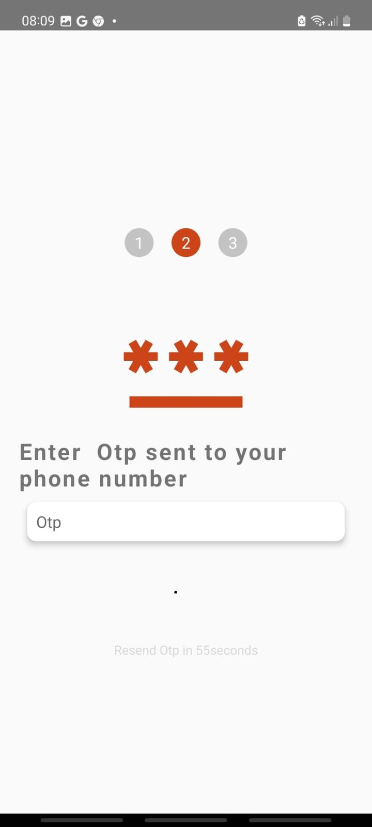

Figure 45: verification code page

On the verification code page, the user is presented with a text field where they can enter the code they received via SMS. This code is typically a unique combination of numbers or alphanumeric characters.

The user must enter the code accurately to proceed to the next page or screen. If the entered code matches the code sent to their phone number, the app verifies their identity and grants them access to the next stage of the login process.

By requiring users to enter the verification code sent to their phone, the app ensures an additional layer of security. It confirms that the user is in possession of the registered phone number and minimizes the risk of unauthorized access to user accounts.

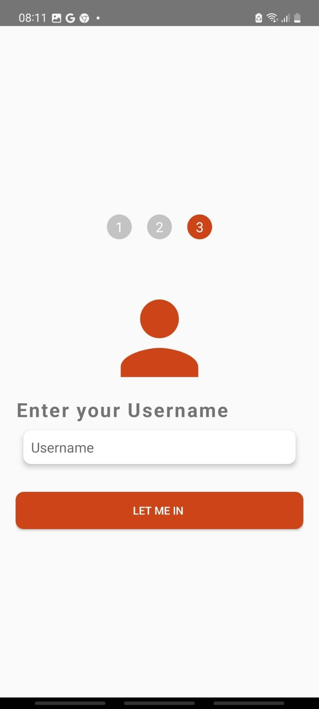

Figure 46: Username login Activity

After successfully entering the correct verification code on the verification code page, the user is directed to a page where they can enter their desired username. This username will be used and displayed within the chat app to represent the user. On the “Username login Activity” (figure above), there is typically a text field where the user can input their preferred username.

After entering their desired username on the username entry page, the user is redirected to the Search User activity. In this activity, the user can search for a specific person they want to communicate with within the chat app. The search results are usually presented in a list format, showing relevant profiles or user accounts that match the search query. Each result may include the user's profile picture, username and user number .The Search User activity is showed in the figure below.

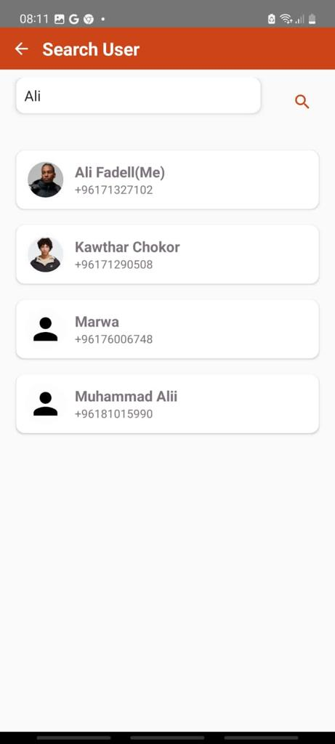

Figure 47: Search User activity

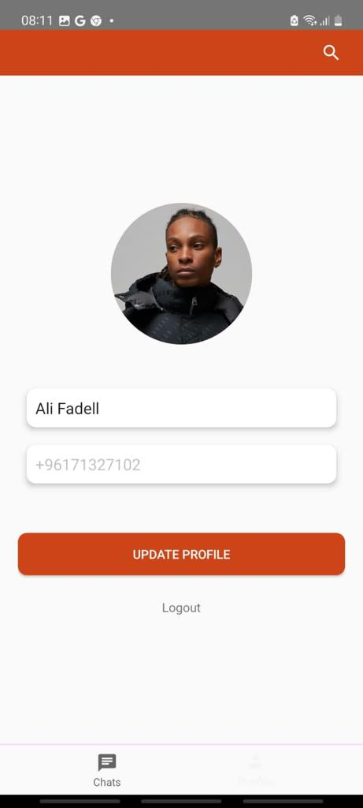

Figure 48: Profile Activity

In the Profile Activity, the user can view their profile information, including their name and phone number. The activity provides the user with the ability to control their profile picture by placing or changing it. Additionally, the user can update their name, but the phone number is only displayed for viewing purposes and cannot be modified.

The Profile Activity typically displays the user's profile picture, name, and phone number in designated sections of the screen. The profile picture may be shown as an image or an avatar, while the name and phone number are displayed as text.

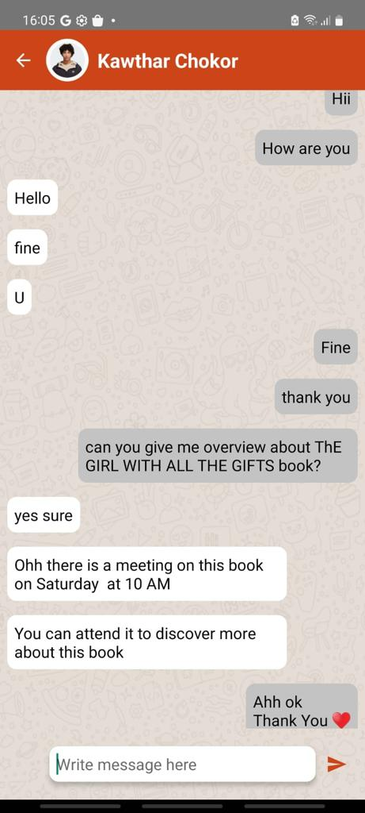

Figure 49: Chat Activity

In the Chat Activity, users can engage in real-time communication with other individuals within the chat app.

In this activity, chat sent by the user are usually displayed with a gray background, distinguishing them from the chat received from other individuals, which are displayed with a white background. This visual distinction helps users easily identify their own chat within the conversation.

**6.2 Website: Admin test**

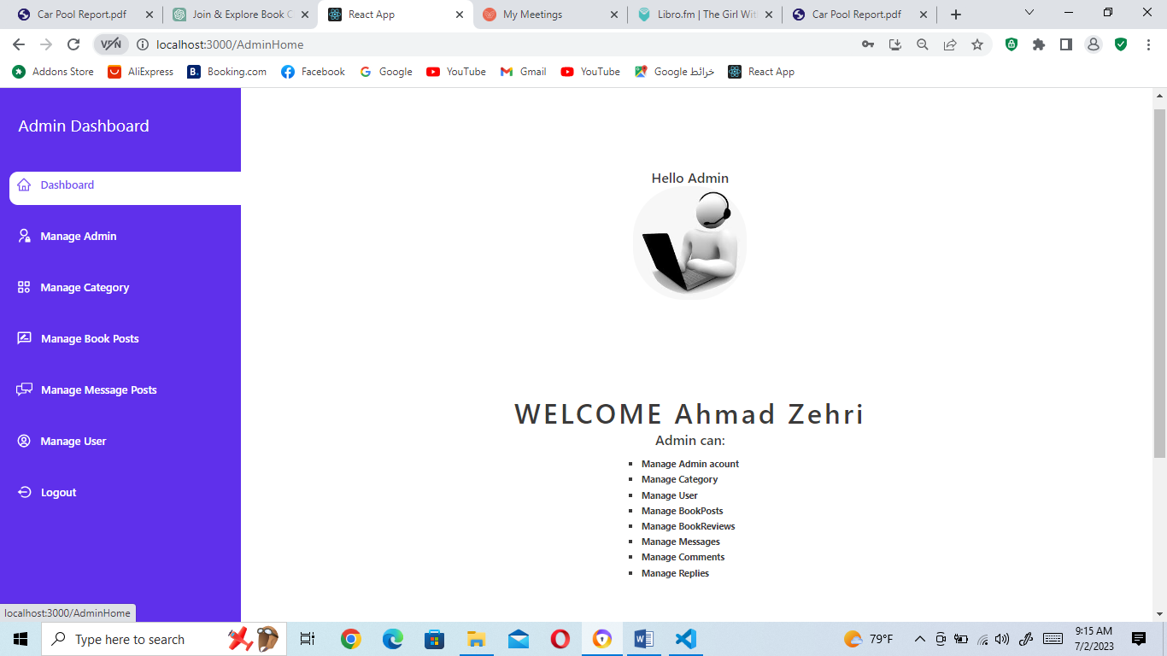

Figure 50: Admin Panel

In the admin panel (figure above), the administrator is provided with an admin dashboard, which serves as a centralized control center for managing various aspects of the system. The admin dashboard offers a range of features and functionalities that allow the administrator to oversee and manage different components of the platform. So admin can manages other admins, manages category, manages book posts, manages message posts and manages user.

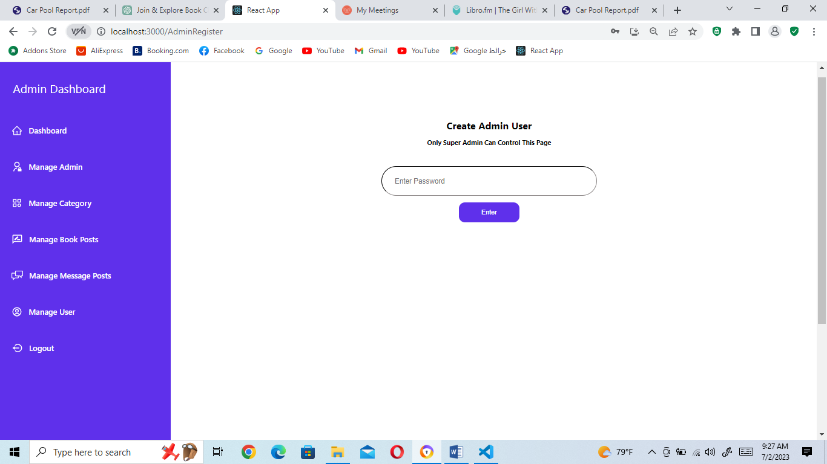

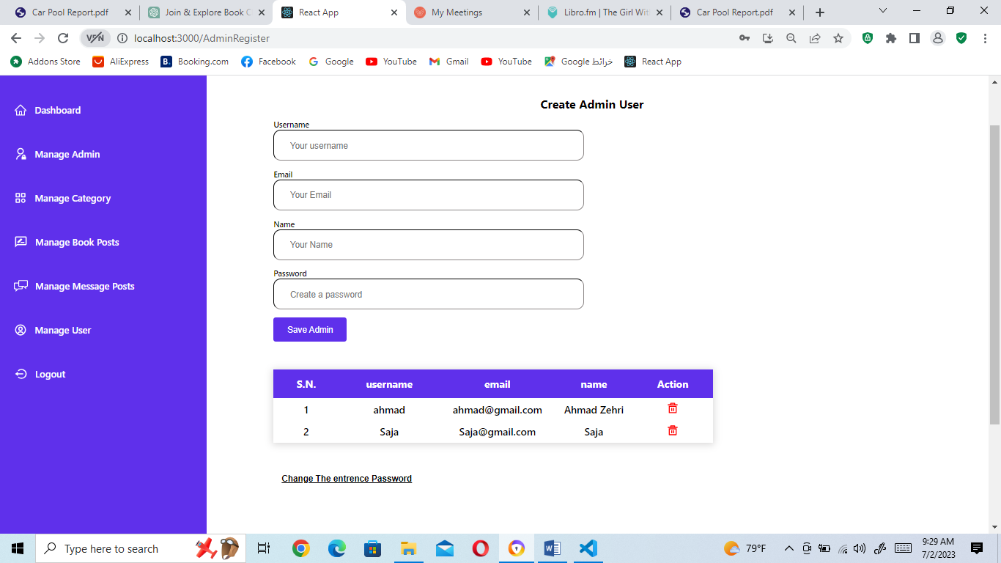

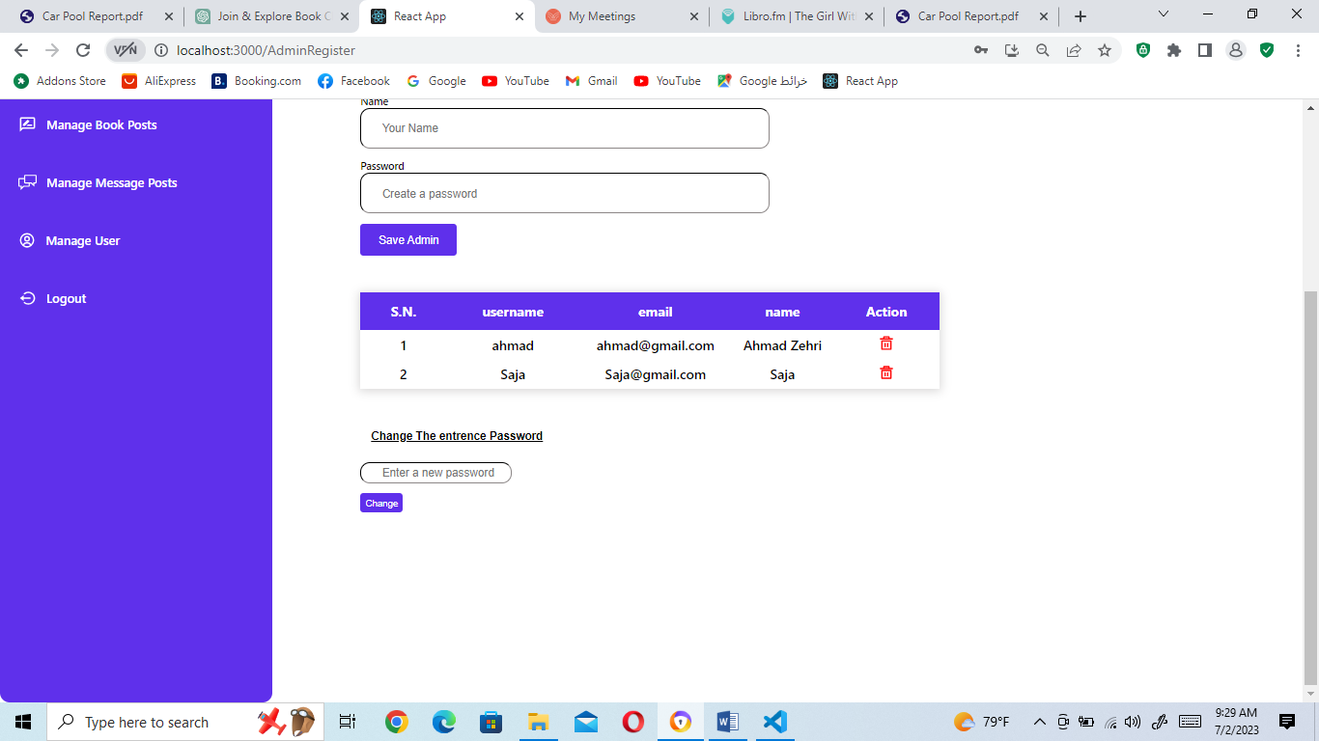

Figure 51: Manage Admin page

In the figure above, the "Manage Admin" page in the admin panel is a restricted section that can only be accessed by the super admin. To ensure security, the super admin is required to enter a password before entering this page. Once the super admin enters the correct password, they gain access to the "Manage Admin" page, which allows them to register new admins and perform other admin-related actions.

1. Registering a New Admin: The super admin can register a new admin by providing their username, name, email, and password. During the registration process, several validations are performed:

- Username Validation: If the entered username already exists, a message is sent to the super admin indicating that an admin with the same username already exists.

- Email Validation: If the entered email already exists, a message is sent to the super admin indicating that an admin with the same email exists. Additionally, if the entered email is invalid, a message appears stating that the email is invalid.

- Name Validation: If the entered name contains numbers, a message appears indicating that the name should contain only characters.

2. Admin Table: The super admin can view a table listing all the admins. This table typically includes columns for the admin's username, name, and email. The table provides an overview of all registered admins and facilitates easy management and identification of admins.

3. Admin Actions: The super admin has the authority to delete any admin account if necessary. By clicking on the delete action option in the admin table, the super admin can remove an admin from the system.

4. Changing the Entrance Password: The "Change the entrance Password" link allows the super admin to update the password required to access the "Manage Admin" page. When the super admin clicks on this link, an input box appears, enabling them to change the entrance password as needed.

By providing these functionalities, the "Manage Admin" page empowers the super admin to effectively manage admins, control access to the admin panel, and maintain the overall security and integrity of the system.

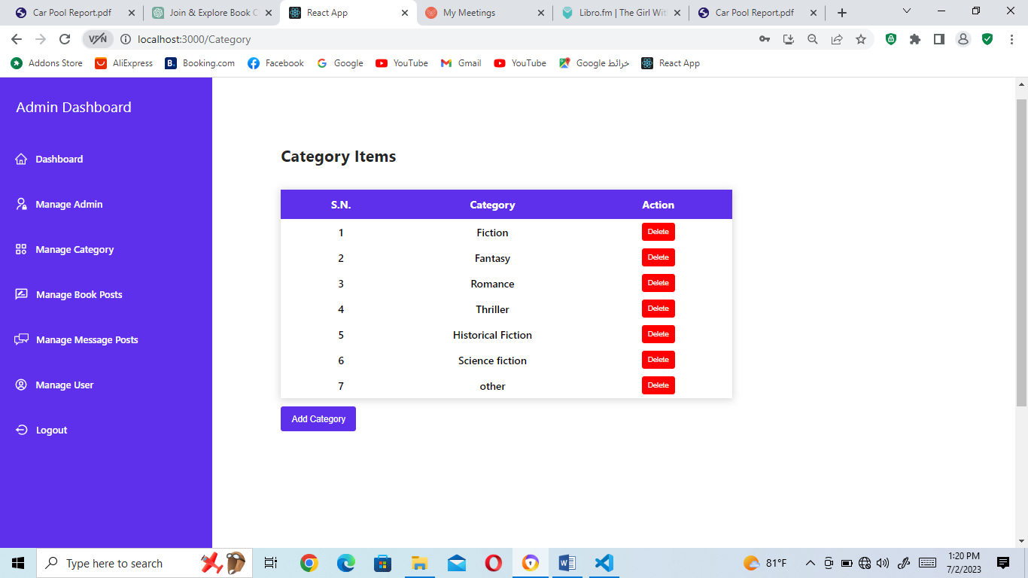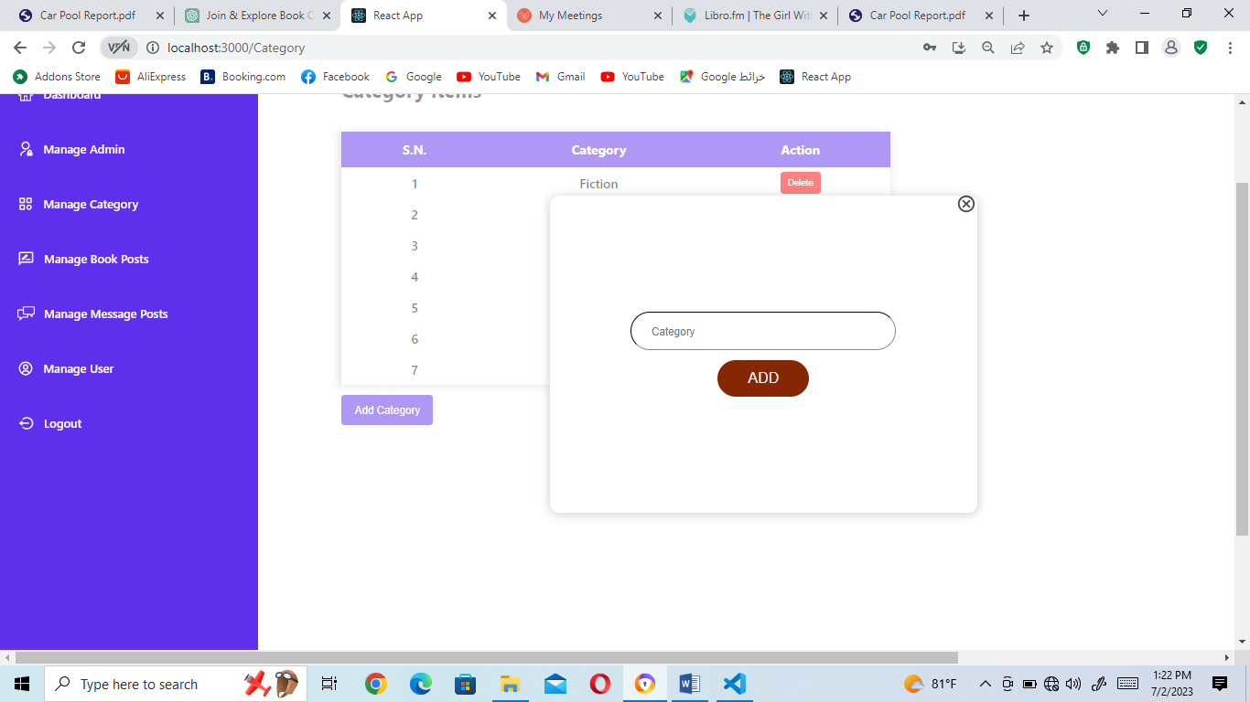

Figure 52: Manage Category

In the "Manage Category" page (figure above) within the admin panel, the admin has control over the categories that are available for users when they post a book. The page provides a table displaying the list of categories, allowing the admin to manage them effectively.

1. Category Table: The admin can view all the existing categories in a table format. The table includes two columns: the Category Name column and the Delete Action column.

2. Adding a Category: The admin has the ability to add new categories to the system. By clicking on the "Add Category" button, an input fields appear where the admin can enter the new category.

- Category Validation: During the addition of a new category, validations are performed to ensure data integrity. If the admin attempts to add a category with a name that already exists, a message is displayed indicating that the category already exists in the system. This helps prevent duplicate categories and maintains consistency.

3. Deleting a Category: The admin is also empowered to delete categories from the system. Each category listed in the table typically has a corresponding "Delete" button or action that allows the admin to remove a category. By selecting the appropriate action, the admin can delete a category that is no longer needed.

By providing these functionalities, the "Manage Category" page enables the admin to maintain control over the available categories, ensuring that the book posting process remains organized and categorized correctly.

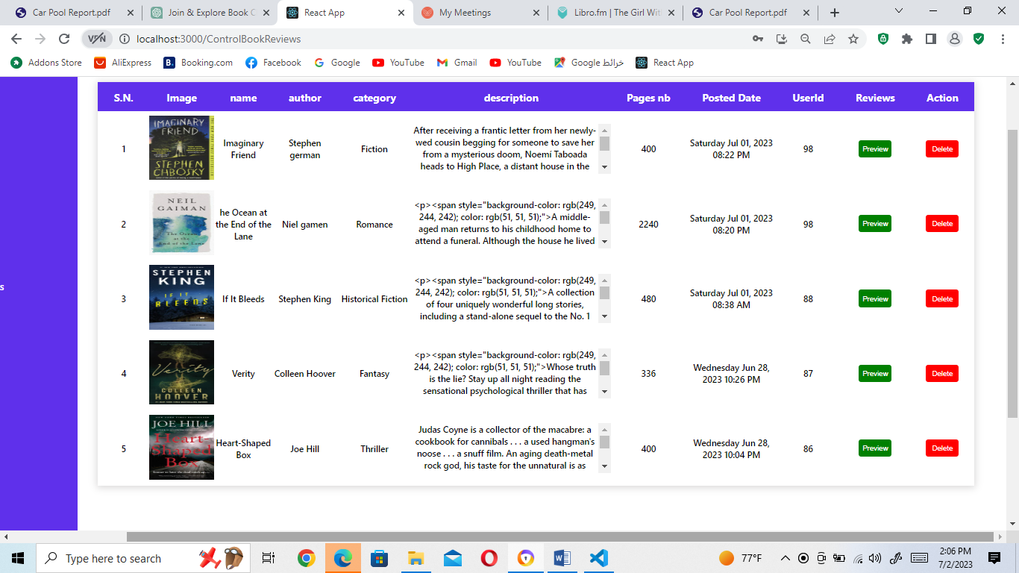

Figure 53: Manage Book Posts page

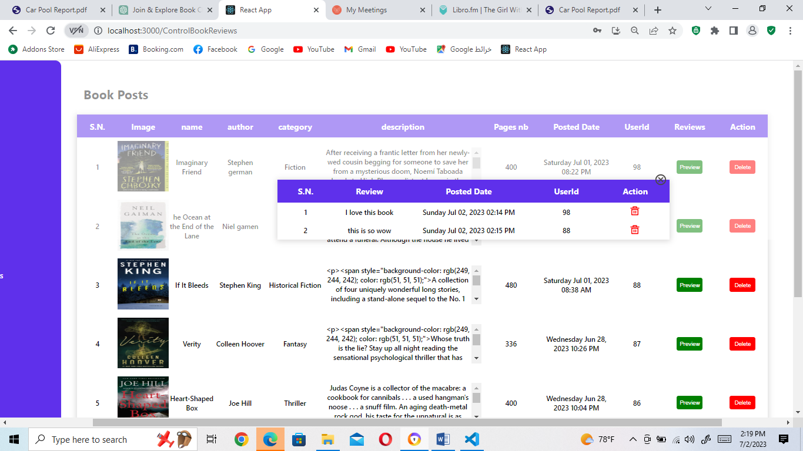

Figure 54: Display all review on a book post

In the "Manage Book Posts" page (the above 2 figures), the admin can view all the book posts created by the club members in a table format. The table consists of multiple columns that provide information about each book post, including the book title, author, category, date posted, and other relevant details.

Review Button: Within the "Review" column, there is a button labeled as "Preview" for each book post. When the admin clicks on the "Preview" button for a specific book post, it triggers an action that displays all the reviews associated with that book.

Action Column for Book Posts: The table also includes an "Action" column that allows the admin to take specific actions on each book post. This column includes a delete button for each book post. By clicking on the delete button associated with a particular book post, the admin can initiate the deletion process for that post. This feature enables the admin to remove any inappropriate or unwanted book posts from the platform.

Reviews Table: When the admin clicks on the "Preview" button for a book post, it opens a separate table that displays all the reviews related to that specific book post. This table also includes an "Action" column for each review, which includes a delete button. By clicking on the delete button associated with a review, the admin can delete that particular review if it is deemed inappropriate or violates the club's guidelines.

By incorporating the "Action" column with delete buttons for both book posts and reviews, the admin has the authority to maintain the quality and integrity of the content within the club. This allows the admin to ensure that the book posts and reviews align with the platform's standards and provide a safe and engaging environment for all club members.

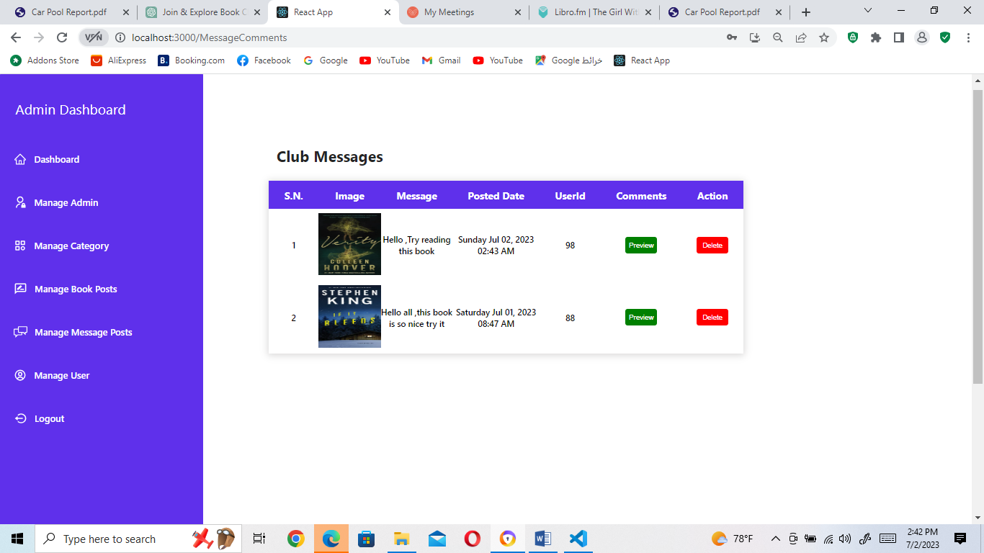

Figure 55: Manage Message Posts page

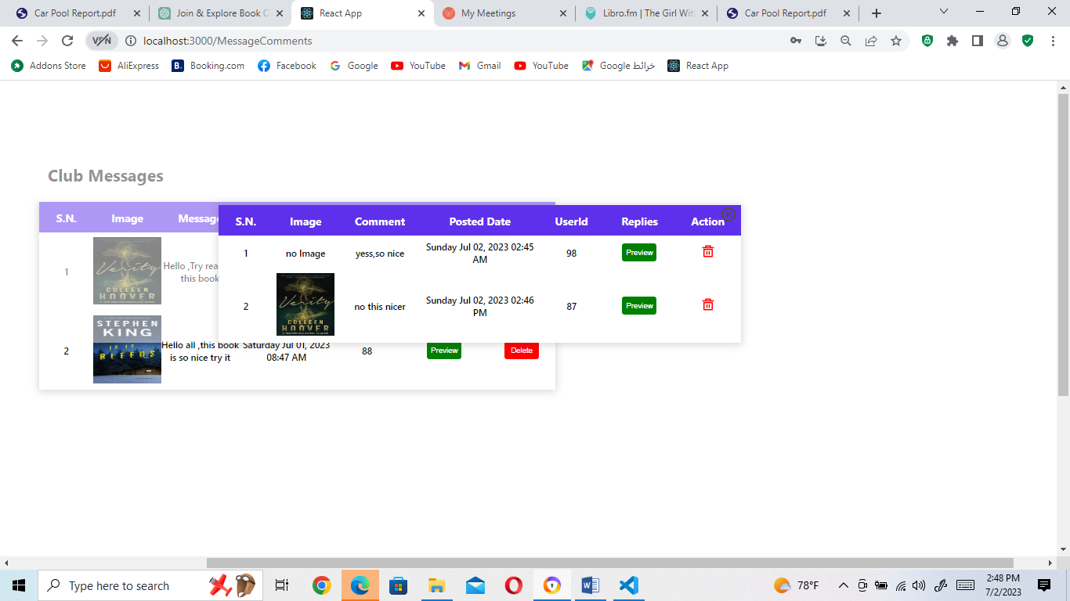

Figure 56: Preview all Comments on a message

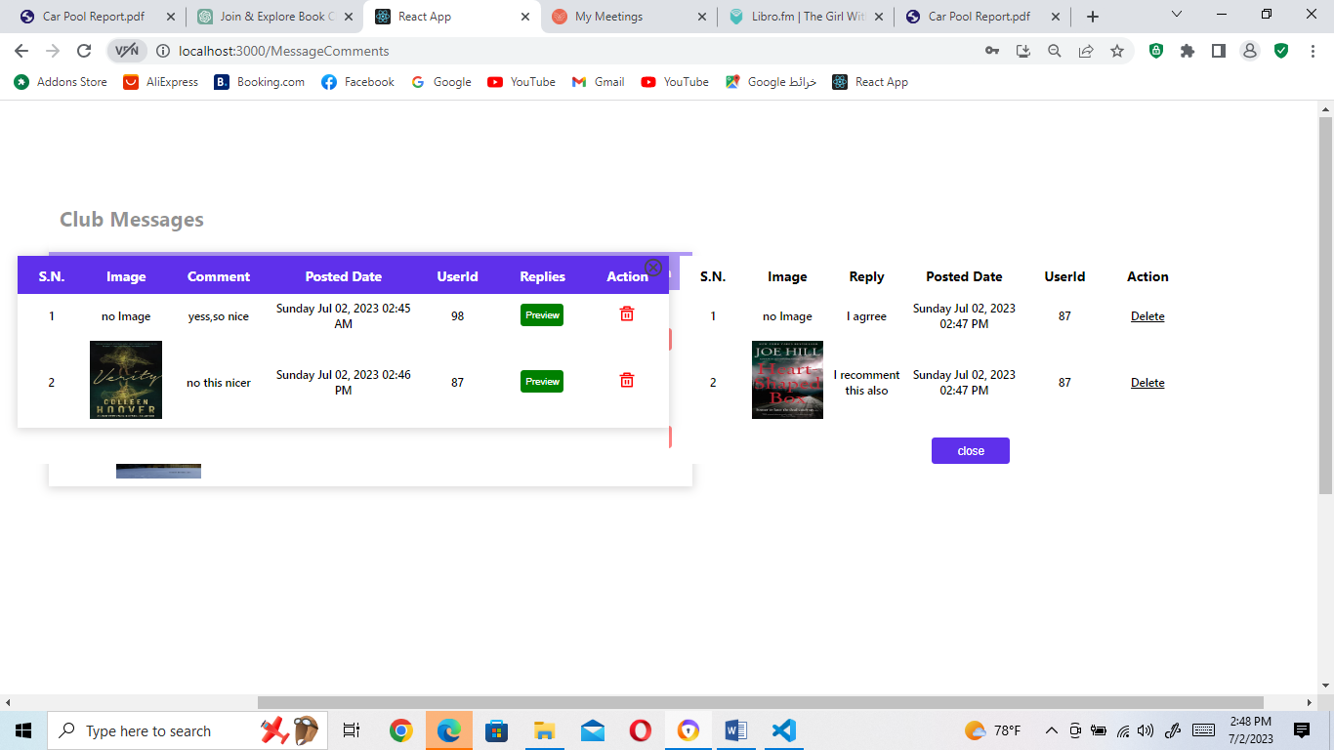

Figure 57: Preview all replies on a Comment

In the "Manage Message Posts" page (the 3 figures above), the admin can view all the club messages in a table format. The table includes columns that provide information about each message, such as the message content, date posted, and other relevant details.

Comments Button: Within the "Comments" column, there is a button labeled as "Preview" for each message. When the admin clicks on the "Preview" button for a specific message, it triggers an action that displays all the comments associated with that message.

Action Column for Messages: The table also includes an "Action" column that allows the admin to take specific actions on each message. This column includes a delete button for each message. By clicking on the delete button associated with a particular message, the admin can initiate the deletion process for that message. This feature enables the admin to remove any inappropriate or unwanted messages from the platform.

Comments Table: When the admin clicks on the "Preview" button for a message, it opens a separate table that displays all the comments related to that specific message. This table includes columns for the comment content, date posted, and other relevant details.

Reply Button: Within the comments table, there is a column called "Reply" that includes a "Preview" button for each comment. By clicking on the "Preview" button for a specific comment, the admin can view all the replies associated with that comment.

Action Column for Comments: The comments table also includes an "Action" column that allows the admin to take actions on each comment. This column includes a delete button for each comment. By clicking on the delete button associated with a comment, the admin can delete that particular comment if it is deemed inappropriate or violates the club's guidelines.

Replies Table: When the admin clicks on the "Preview" button for a comment, it opens a separate table that displays all the replies related to that specific comment. This table includes columns for the reply content, date posted, and other relevant details.

Action Column for Replies: The replies table includes an "Action" column that allows the admin to take actions on each reply. This column includes a delete button for each reply. By clicking on the delete button associated with a reply, the admin can delete that particular reply if it is deemed inappropriate or violates the club's guidelines.

By providing these features in the "Manage Message Posts" page, the admin has the ability to monitor and moderate the club messages, comments, and replies. This ensures that the platform maintains a respectful and engaging environment for all club members.

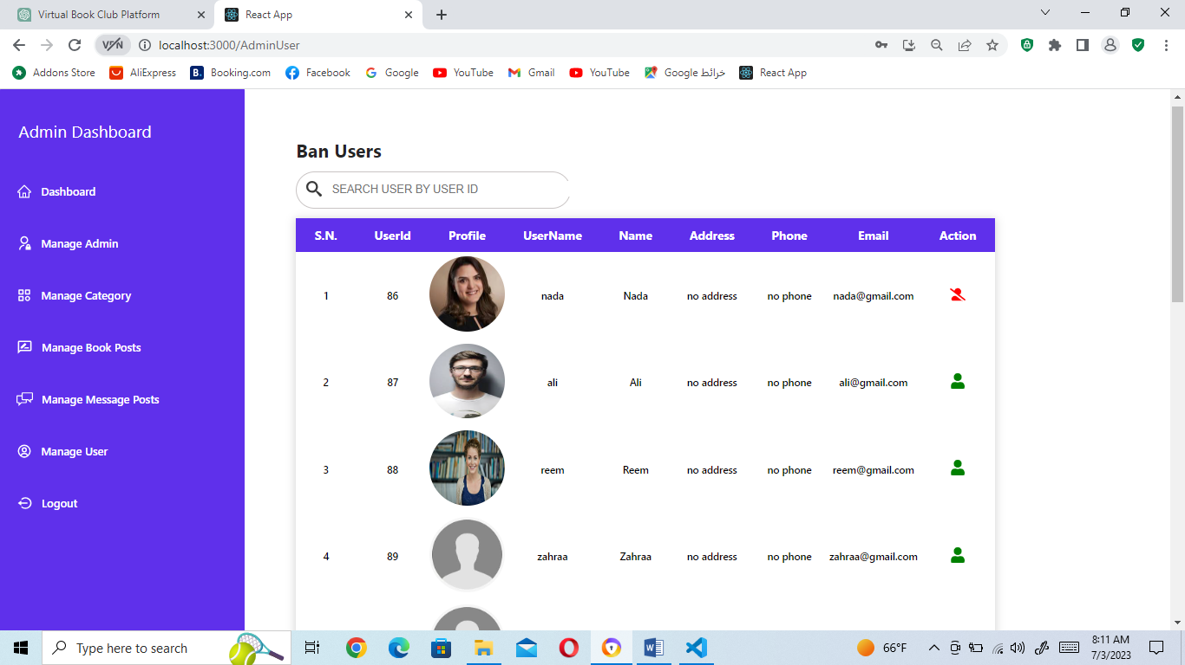

Figure 58: Manage User

In the "Manage User" page (the figure above), the admin has the ability to search for users by their ID and perform actions such as banning or unbanning them based on their behavior within the platform.

Search User: The admin can input the user's ID into a search field to quickly find and access the user's profile.

Ban User: If the admin identifies a user whose behavior is deemed inappropriate or violates the platform's guidelines, they can choose to ban that user. When a user is banned, they are restricted from performing certain actions within the platform.

Restricted Actions: A banned user is not able to make book reviews, post new books, create meetings, create messages, leave comments, or reply to comments. If they attempt to perform any of these actions, they are redirected to a page that notifies them about their account being banned.

Figure 59: Banned User Notification Page

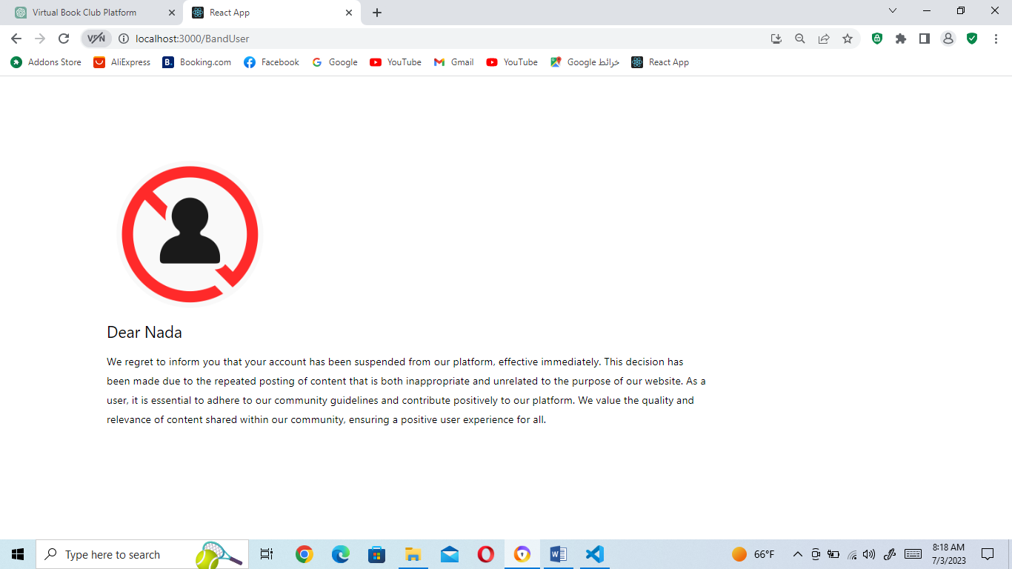

Unban User: If the admin believes that a previously banned user has rectified their behavior or deserves another chance, they can choose to unban that user. By unbanning the user, they regain access to all the functionalities of the platform.

Banning Explanation: When a user's account is banned, they are typically provided with a clear explanation of the reason for the ban. This explanation could include information about their repeated posting of inappropriate content or content unrelated to the purpose of the website. By providing a specific explanation, the admin reinforces the platform's commitment to maintaining a respectful and relevant community.

Through the "Manage User" page, the admin plays a crucial role in enforcing community guidelines and ensuring that all users adhere to the expected behavior. By taking appropriate actions such as banning or unbanning users, the admin maintains the integrity and quality of the platform's user base.

**General Conclusion and Future Recommendations**

In conclusion, the project aimed to address the challenges faced in creating an online virtual book club platform, encompassing a website and a complementary chat mobile app. Throughout the development process, several obstacles were encountered, including designing a user-friendly interface, implementing interactive features, and ensuring seamless functionality across platforms. However, these challenges were overcome through diligent planning, development, and testing.

The website and mobile app successfully provide a platform for book enthusiasts to connect, share their reading experiences, and engage in meaningful discussions. Users can explore a wide range of books, view detailed book information, leave reviews, participate in meetings, and interact with other club members.

In the process of developing the platform, user feedback and testing played a crucial role. User's Tests were conducted to evaluate the usability and performance of the website and mobile app from the user's perspective. Admin Tests were also carried out to assess the functionality and effectiveness of the admin panel.

Based on the findings from these tests, valuable insights were gained, leading to improvements in various aspects of the platform. Usability enhancements, bug fixes, and performance optimizations were implemented to ensure a seamless and satisfying user experience.

Looking towards the future, there are several recommendations for further improvement and expansion of the platform. These include:

1. Enhanced social features: Introduce more interactive features to encourage collaboration and discussions among club members. This could include real-time chat functionality, book recommendation systems, and the ability to form book clubs or reading groups.

2. Personalized recommendations: Implement an intelligent recommendation system that suggests books based on users' reading preferences, previous activities, and user-generated content. This can enhance user engagement and satisfaction.

3. Integration with external platforms: Explore partnerships or integrations with popular book-related platforms, such as e-book providers, online libraries, or book review websites. This can broaden the platform's reach and provide users with a comprehensive reading experience.

4. Mobile app enhancements: Continuously improve the mobile app's performance, user interface, and compatibility with different devices and operating systems. Regular updates and feature additions can keep the app relevant and engaging for users. Also we suggest implementing a feature that allows users to create their own chat groups, each focused on a specific topic or theme. These user-created chatrooms will provide a space for like-minded individuals to gather and engage in more specialized book discussions. By naming the groups according to the topics they'll cover, users can easily find and join conversations that align with their interests. This enhancement will foster even deeper connections among our book club members and create a more personalized and diverse chat experience.

5. Community engagement: Foster a sense of community and active participation among users by organizing virtual events, author Q&A sessions, or book-related contests. This can further strengthen the bond among club members and promote a thriving literary community.

In conclusion, the project successfully tackled the challenges of creating an online virtual book club platform. Through continuous improvement and future enhancements, the platform can provide an even more immersive and enjoyable experience for book enthusiasts, fostering a vibrant community of readers.